

A usability-led development of a web-based health and fitness application

Final year project



Lauren Mather

BSC. Hons in computer science

Liverpool John Moores University

Abstract:

The purpose of this report is to develop a health and fitness application, with the focus being on the level of usability the application provides above all other aspects. Various test subjects and potential users will be involved throughout the development of this application. Various usability tests will be conducted, and the application will be developed in 4 stages iteratively: The initial requirements capture, low-fidelity prototype, medium-fidelity prototype and finally a high-fidelity prototype. Following the development of each version of the application tests will be conducted and the test subjects will determine what direction the development will take based upon the most popular answers. These questionnaires will then be analysed and based upon the results the respective changes will be made to the application to ensure that the usability and the satisfaction the user has with the application is of the highest possible quality.

# Acknowledgements:

I would like to thank Andy Symons for his wonderful support throughout the development of this project. The support and determination you provided is appreciated immensely. I wouldn’t have been able to make this project possible without you.

I would also like to thank my amazing friends and family for everything they have done for me throughout my time studying at LJMU, without all of your love and support none of this would have been possible.

# **Table of Contents**

Acknowledgements: 1

Table of Contents 2

Table of Figures 5

1 Introduction 7

2 Background Research 8

2.1 Human-Computer Interaction and Usability 8

2.1.1 A brief history of HCI 9

2.1.2 Human 9

2.1.2.1 Communication between Human’s and Machines 10

2.1.2.2 Vision 11

2.1.2.3 Hearing 12

2.1.2.4 Touch 13

2.1.2.5 Thinking, Reasoning and Problem Solving 14

2.1.2.6 Individual differences 17

2.1.3 Computer 17

2.1.3.1 Text entry devices 18

2.1.3.2 Positioning, Pointing and Drawing 19

2.1.3.3 Display devices 20

2.1.3.4 Computer Memory 20

2.1.3.5 Processing and Networks 21

2.1.4 Interaction 22

2.1.4.1 Models of interaction 23

2.1.4.2 Ergonomics 24

2.1.4.3 Interaction styles 25

2.1.4.4 The WIMP interface 26

2.1.4.5 Interactivity 29

2.1.4.6 HCI design approaches 30

2.1.5 Usability and the Science Of 31

2.1.5.1 Usability testing 32

2.1.5.2 Pros and cons of usability testing 34

2.2 Web-based Application Development 34

2.2.1 Web-based applications 35

2.2.1.1 The evolution of the web 36

2.2.2 Server-Side Technologies 37

2.2.3 Client-Side Technologies 38

2.2.4 Data model technologies 39

2.2.5 Software development Process Issues for Web-Based Applications 40

3 Analysis 40

3.1 Background Analysis 41

3.2 Analysis of Existing Health and Fitness Applications 42

3.2.1 Web-based applications 42

3.2.2 Mobile (Native) applications 42

3.2.3 Hybrid applications 43

3.2.4 Overview of current health and fitness applications 43

3.2.4.1 MyFitnessPal 43

3.2.4.2 Calm 44

3.2.4.3 8fit 45

3.2.4.4 Sleep Better – Sleep tracker 46

3.2.4.5 The 7-minute workout (Johnson & Johnson) 46

3.2.4.6 Fitbit 46

3.3 Development Strategy 47

3.3.1 Usability issues 48

3.3.2 Process issues 48

3.3.3 User inclusion (User involvement) 49

4 Iteration 1: Requirements capture 49

4.1 Initial requirements specification 50

4.2 Initial usability specification 50

4.2.1 User 51

4.2.2 Functional 51

4.2.3 Non-functional 52

4.2.4 Requirements verification 52

4.2.5 Results: Desired functionality for the app 52

5 Iteration 2: Interaction design. 53

5.1 Low-fidelity prototype 53

5.2 Evaluation 59

6 Iteration 3: Mid-fidelity prototype 60

6.1 The design 60

6.2 Evaluation 65

7 Iteration 4: High-fidelity prototype 65

7.1 The design 66

7.2 Evaluation 70

8 Results and evaluation 70

8.1 Questionnaires 70

8.1.1 Initial requirements capture questionnaire 71

8.1.1.1 Question 1: 71

8.1.1.2 Question 2 71

8.1.1.3 Question 3 72

8.1.1.4 Question 4 72

8.1.1.5 Question 5 73

8.1.1.6 Question 6 74

8.1.1.7 Question 7 75

8.1.1.8 Question 8 76

8.1.1.9 Question 9 77

8.1.1.10 Question 10 78

8.1.1.11 Overall evaluation of initial requirements capture questionnaire 79

8.1.2 Low-fidelity prototype questionnaire results 81

8.1.2.1 Question 1 81

8.1.2.2 Question 2 82

8.1.2.3 Question 3 82

8.1.2.4 Question 4 83

8.1.2.5 Question 5 84

8.1.2.6 Question 6 85

8.1.2.7 Question 7 85

8.1.2.8 Question 8 86

8.1.2.9 Question 9 86

8.1.2.10 Overall evaluation of results 87

8.1.3 Mid-fidelity prototype questionnaire results 88

8.1.3.1 Question 1 88

8.1.3.2 Question 2 88

8.1.3.3 Question 3 89

8.1.3.4 Question 4 89

8.1.3.5 Question 5 90

8.1.3.6 Question 6 90

8.1.3.7 Question 7 92

8.1.3.8 Question 8 92

8.1.3.9 Overall evaluation of results 93

8.1.4 High-Fidelity prototype questionnaire results 94

8.1.4.1 Question 1 94

8.1.4.2 Question 2 95

8.1.4.3 Question 3 95

8.1.4.4 Question 4 96

8.1.4.5 Question 5 96

8.1.4.6 Question 6 97

8.1.4.7 Question 7 97

8.1.4.8 Question 8 98

8.1.4.9 Overall evaluation of results 99

8.2 Developer evaluation. 99

9 Conclusion 100

10 References and Bibliography 103

Appendix A: Project Specification and Monthly Reports 105

Appendix B: Copy of Questionnaires and handouts 112

10.1 Initial requirements capture questionnaire 112

10.2 Low-fidelity prototype questionnaire 116

10.2.1 Questionnaire handout 119

10.3 Mid-Fidelity questionnaire 121

10.4 Questionnaire handout 125

10.5 High-Fidelity questionnaire 129

Appendix C: Web application code 131

10.6 Log in page 131

10.7 Create a new account page 132

10.8 Main Menu page 135

10.9 Exercise tutorials page 137

10.10 My progress page 141

10.11 My account page 143

10.12 Meal diary page 145

10.13 Help page 147

10.14 Website style CSS 148

# Table of Figures

Figure 1 12

Figure 2 44

Figure 3 44

Figure 4 45

Figure 5 45

Figure 6 53

Figure 7 54

Figure 8 55

Figure 9 55

Figure 10 56

Figure 11 57

Figure 12 58

Figure 13 59

Figure 14 60

Figure 15 61

Figure 16 61

Figure 17 62

Figure 18 62

Figure 19 63

Figure 20 63

Figure 21 64

Figure 22 64

Figure 23 66

Figure 24 67

Figure 25 67

Figure 26 68

Figure 27 68

Figure 28 69

Figure 29 69

Figure 30 71

Figure 31 72

Figure 32 73

Figure 33 74

Figure 34 75

Figure 35 76

Figure 36 77

Figure 37 78

Figure 38 78

Figure 39 82

Figure 40 82

Figure 41 83

Figure 42 83

Figure 43 84

Figure 44 84

Figure 45 85

Figure 46 85

Figure 47 86

Figure 48 87

Figure 49 88

Figure 50 89

Figure 51 89

Figure 52 90

Figure 53 90

Figure 54 91

Figure 55 91

Figure 56 92

Figure 57 93

Figure 58 94

Figure 59 95

Figure 60 95

Figure 61 96

Figure 62 97

Figure 63 97

Figure 64 98

Figure 65 98

Figure 66 105

Figure 67 106

Figure 68 107

Figure 69 108

Figure 70 109

Figure 71 110

Figure 72 111

Figure 73 112

Figure 74 113

Figure 75 114

Figure 76 115

Figure 77 116

Figure 78 117

Figure 79 118

Figure 80 119

Figure 81 120

Figure 82 121

Figure 83 122

Figure 84 123

Figure 85 124

Figure 86 125

Figure 87 126

Figure 88 127

Figure 89 128

Figure 90 128

Figure 91 129

Figure 92 130

# Introduction

This paper is a collective report of the research and development that is required to build a web application that’s priority is to ensure that the application provides the highest level of usability for it potential users.

To correctly understand what knowledge is required to produce a usability led development of an application, you must have the knowledge of various subjects such as the various factors of Human Computer Interaction (HCI), Usability and Web application development. These subjects are discussed in much more depth in section 2 “Background Research” in which you can gain the knowledge required to produce a highly usable product.

Based upon the background research an analysis (Section 3) will be produced which discusses contains an overall discussion of the information and informs you at to what information is the most relevant when producing an application of this variety, as well as discussing how the factors will be included throughout the development to ensure that it is usability-led. The analysis will also contain a discussion analysing other health and fitness applications that a currently available on the application market. From the analysis a development strategy will be developed, and this will be implemented throughout the production of this application.

Following the analysis, a proposed interface design will be produced. In the case of developing this application it was determined that an initial requirement capture questionnaire would be a useful way to gain an insight into what the user would like from a health and fitness application. This is further discussed in iteration 1 (Section 4).

A low-fidelity prototype will be produced, which is basically a wireframe design of the application, based upon the results of this initial questionnaire and the results of all of the questionnaires are analysed and discussed in section 8 “Results and evaluation”. Following the development of the low-fidelity prototype a questionnaire will be handed out which again will ask the users to provide their insights and opinions based upon this design, they are also able to offer their own personal opinions and provide recommendations for any improvements they believe would be useful. The low-fidelity prototype is further discussed in iteration 2 (Section 5).

Based upon the results of the low-fidelity prototype questionnaire, a mid-fidelity prototype will be developed, this version of the application is focused upon providing the user with a concept as to how to complete product will “look and feel”. Again, a questionnaire has been produced and the user is asked a variety of questions based upon the colour scheme, font style and location of components on the web application. The mid-fidelity prototype is further discussed in iteration 3 (Section 6).

Following the mid-fidelity questionnaire, the final high-fidelity prototype has been produced. This design is a close to the final product as possible, without the functionality that is granted with the inclusion of a database. The user’s that have been included during the testing period of the prototypes have determined how the products layout will appear and will include some functionality to allow the users to have a more realistic version of the application to test. A final test will be conducted in which the test subjects will be required to perform a variety of tasks which will support the developers in determining the level of usability that the web application provides. This is further discussed in iteration 4 (Section 7).

All of the results of the questionnaires are located in section 8 “Results and evaluation”, the questionnaires and handouts that were provided to the test subjects are also located in Appendix B. The results and evaluation section will depict the results and discuss the decisions that will incur and any changes that will need to be made in the application. This section also includes graphical representations of the results for each of the answered questions, where relevant, to make them easier for you to clearly understand.

Finally, a developers evaluation will be conducted in which the developer will give provide their insight into how the application development and testing has gone and provide a discussion based upon the results.

# Background Research

In this section of the report we will discuss the background based upon work that has been produced by other authors and is related to the development of a successful web-application. The information contained within this section is based upon other people’s work that has been researched extensively to provide you with a sufficient understanding of the subjects that are crucial to be aware of to produce a web-application that will be focused mainly upon the factors of usability and the users themselves.

In section 2.1 we will introduce the subject of Human Computer Interaction (HCI) and usability. HCI is the study of how humans interact with computers and to what extent the current computing technologies are or are not developed for successful interactions with human beings. Usability is also an important concept to understand, as it is the measure of a products potential to complete the goals of the user. When considering usability, within computer technology, we often relate it to software applications and websites, but it can also be used in relation to various products that the user has employed to accomplish a task. Some of the factors that are used to determine a products usability is the products ease-of-use, visual consistency, and a clear and defined process for the evolution.

In section 2.2 we will introduce the subject of web-based applications. We will discuss in-depth the development of web-based applications, including client-side and server-side technologies. Web-based applications are computer programs that utilize web browsers and web technologies to perform tasks via the internet. These subjects will be discussed more in depth in the sub-sections below.

## Human-Computer Interaction and Usability

Human-Computer Interaction (HCI) is the study of how people interact with computers and to what extent the computer is or isn’t developed for successful interaction. Computer technology began to rapidly evolve during the 1980’s since the introduction of the idea of a computer for an individual. This evolution has also seen the interface to the computer change physically and become predominantly visual. This is discussed further in the sub-section “A brief history of HCI” below.

Initially we will focus on the individual human users. Users will form differing conceptions or mental models of how they interact with computers and their way of learning, storing knowledge and skills will differ from one another. User interface technologies are rapidly and frequently changing, which offers new interaction possibilities to users which past research findings may not apply to, furthermore user preferences will eventually change as they gradually become acquainted with new interfaces. This is discussed further in the sub-section “Human” below.

Secondly, to understand how humans, interact with computers, we will require an understanding of both parties involved in the interaction (the Human and Computer). The previous section focuses on exploring the different aspects of human capabilities and behaviours which we will need to be aware of in order to fully understand the concept of HCI. This chapter will focus on the computer and its associated input and output devices, and we will cover how the technology can influence the nature of an interaction and the way an interface is styled. In this section we will focus our research on the concept of a traditional computer, we will also include various types of devices which are available and how they allow for better interaction. This is discussed further in the sub-section “Computer” below.

Thirdly, we will explore the concepts behind interaction. In the previous two sections we have focused on both the human and the computer, however in this section we will be focusing on how the user will communicate their requirements to a computer and how they use a computer as a tool to simplify, support or perform a task. Interaction models are used to help us with understanding what interactions are occurring between the human and computer. They are used to address the translations between what the user wants and what the system can perform. This is discussed further in the sub-section “Interaction” below.

Finally, we will focus a section on the concepts of usability and the science that it involves. Usability is part of a broader term which encompasses the user’s experience and refers to the ease of access and/or use of a product or website. Usability is the measure of a products potential to accomplish the goals of the user. Usability also refers to the methods used to improve the systems ease-of-use during the design process. The usability evaluation stage of a project in development is an effective method which enables the software development team in charge of a project to discover and establish positive and negative aspects of each prototype which they release to users. Usability testing, is the process of assigning users with certain tasks, in an effort to allow the developmental team of an application to understand and measure the products ease-of-use, task time and the user’s perception of the whole experience. Usability is a core concept of a human-centred approach to the development of computer systems. The aims of which are well defined under Alan Dix’s 3 U’s of Computer System Success. We will further discuss usability and its concepts in the sub-section “Usability and the science of” below.

### A brief history of HCI

The term Human Computer Interaction, otherwise known as HCI, is an area of research and practice that has only been in widespread use since the 1980’s but has its roots in more established disciplines, initially it was a speciality area in computer science which embraced cognitive science and human factors engineering. The systematic study of the performance of humans initially began at the beginning of the 20th century within factories, with the emphasis on manual tasks. During the Second World War each side sought to produce a more effective weapon system, this provided the propulsion in the study of the interaction between humans and machines. From this led the formation of the Ergonomics Research society in 1949, originally ergonomists where concerned primarily with the physical components and characteristics of machines and systems, and how these affect the user’s performance.

### Human

In this section we will introduce the Human. The human is the central character when discussing interactive systems, as the human is the one whom the computer systems are designed to assist. Therefore, the requirements of the human user should be our initial focus when designing an application. In this section we will consider the human psychology, which comes under the general banner of cognitive psychology. Before we can develop something for someone, we must understand the user’s capabilities and limitations. Humans are very limited in their capacity to process information; therefore, it is crucial that we are aware of any areas that user’s may struggle to complete and find difficult. From this we will be able to determine what the users find easy and how we can support them by encouraging these factors into the developmental process, which will, in turn, improve the functionality of an application. Users may often share capabilities; however, each user will have their own individual differences, which will have to be taken into consideration. We will consider the different aspects of cognitive psychology, and how this will ultimately affect the way in which a computer system will be used. This includes, how humans can store, process and solve problems, how they perceive the world around them, and how they physically manipulate objects around them. We will restrict the information provided within this section, to only that which relates to the concept of HCI.

#### Communication between Human’s and Machines

A human’s interaction with the outside world occurs through information being received from a stimulus and information being returned from the user, and vice versa. When a user is interacting with a computer, they will receive information from the computer, which is referred to as its output, the user will then respond to this stimulus by providing the computer with their output – therefore the user’s output will become the computers input and vice versa.

It is sometimes possible for this type of interaction to be nearly impossible for some users to complete, due to such things as physical impairments.For example, a user with a degenerative illness such as, MS (Multiple Sclerosis) may be unable to use and manipulate physical devices like a mouse or keyboard to communicate their input to the computer. Some devices have been created that will allow a user to use the gaze of their eyes to manipulate what they will input into a computer, this can be performed with a device such as an eye-gaze system. This type of device provides users, that have physical impairments, with the ability to fixate or gaze at certain points on a screen, and perform tasks, that they may have otherwise been unable to do on their own before.

Input within the human occurs mainly by using their different senses, and their output is controlled by their motor functions. There are 5 main senses that are used to receive information: sight, hearing, touch, taste and smell. With sight, hearing and touch being the most influential to HCI. Whereas, taste and smell are not currently playing a consequential role in HCI, and it has still not been fully explored whether these senses can be used to good advantage, although with a constant demand for new and exciting technologies, it could possibly be explored to use these senses to the advantage of specialized systems such as AR (Augmented Reality) systems, which would allow the users to explore an environment using all their 5 senses, but as of yet this is not a reality. Ultimately, vision, hearing and touch are the central focus of HCI in current times. There are also several effectors, including the human’s limbs, fingers, eyes, head and voice. When interacting with a computer, the fingers will play the primary role of communication with the computer, as we use them as a means of inputting information into the computer, by typing on a keyboard or using the mouse control, with the use of some voice, eye, head and body position being involved.

#### Vision

Human vision is a complex activity with a range of physical and perceptual limitations, yet it is, for the average user, their primary source of retrieving information. A user’s vision is a crucial sense when considering computer systems, as the humans vision is what enables them to view and receive the system output and is used when the user inputs information into the system, as they will need to visually see what information they are inputting and how they are manipulating the system. We can divide the concept of visual perception into two different stages: the physical reception of the stimulus from the outside world, this is affected due to the physical properties of the eye and the physical system, which will cause the human to be unable to see certain things, and the processing and integration of that stimulus. The interpretive capabilities of visual processes are what allows images to be constructed for incomplete information. It is very important that we understand both stages, as they are what influences what the human can, and cannot perceive visually. This is what ultimately affects the way in which we will be able to design a computer system. We will further discuss the various factors involved with human vision in the sub-headings below.

Visual perception and the Human brain

Visual perception can be defined as the ability to interpret the information that our eyes receive. Our ability to interpret the information we have received is totally dependent on our own cognitive processes and any prior knowledge we may have. Visual perception is a process that initially begins with the human eyes. As discussed in the previous section we use our eyes to retrieve information from the world around us and then this information is processed in our brains. Our visual perception is controlled by the cerebral cortex area of the brain and the electrochemical signals that travel through the optic nerve and via the thalamus (another area of the brain) to the cerebral cortex. The optic nerve also passes additional data to two other areas of the brain.

The first area is the pretectum, this is where the movements of the pupils in the human eye is controlled, and it also adjusts the size of the pupil based upon the intensity of the light that we are being exposed to. The second area is the superior colliculus. In this area of the brain, it controls the motions of the human eye, which is not actually a smooth motion which you may perceive it to be, but it is rather a series of short, jerky movements that are known as saccades. The reason for these jerky movements is to allow for us to “reset” the condition of the information that we are perceiving and eliminate any blurring of the image. Otherwise, if the eye moved in a smooth motion, rather than in a series of jerky movements, this would create motion blur which would make it difficult to perceive the information correctly.

In the thalamus area of the brain, the images from the retina are processed in the lateral geniculate nucleus. This is what separates the outputs from the retina into two different streams. The first stream is what handles our perception of colour and fine structure and this is sent to our primary visual cortex, which is also known as visual area 1 (V1). This is located in the back of the brain, as shown in figure 2.2 below. The visual cortex has a variety of cells whose focus is to calculate where objects are in space that is relative to us. The signal that is received by the brain is mapped on a 2-D map to help us to determine the overall placement of an object, and then the third dimension will be added when the information that is received by both eyes has been triangulated from every point in the image, which allows us to calculate and perceive the depth and size of the image. The second stream is what is used to handle the contrast and motion of an image that we have perceived.

There are other areas within the central cortex that further help with our ability to process images: Visual area 2 (V2), Visual area 3 (V3), and Visual area 4 (V4). V2, which is also known as the prestriate cortex, is what helps to control our perception of colours by helping us to separate the colour and an object from the colour of ambient light. V3 and V4 are what we use to handle face and object recognition, however, these areas of our central cortex can be “tricked” with the use of optical illusions. All the information that has been collected and processed in these areas of the brain, will be combined over and over again throughout a given day, and will this combination of information will support us when making sense of what we have seen.

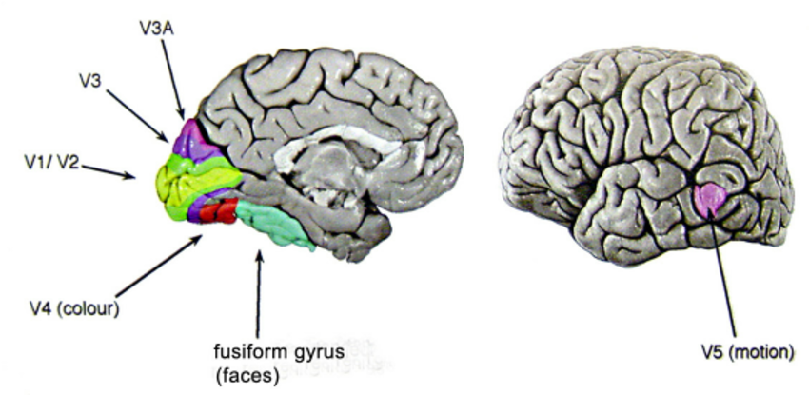

Figure

#### Hearing

The second sense we will discuss is hearing. The sense of Hearing is typically considered as the secondary sense when compared to the importance of sight. As humans we often underestimate the amount of information that we can receive through our ears. Hearing begins with sound waves (vibrations in the air). The ear receives these vibrations and transmits them, through various stages, to the auditory nerves. The ear consists of three main sections, commonly known as the outer, middle and inner ear. The outer ear is the visible part of the ear that consists of two areas: the pinna, which is the connective tissue which attaches the outer ear to the side of the head, and the auditory canal, which is used to pass sound waves down to the middle ear. The outer ear provides protection from outside elements which can cause damage to the sensitive middle and inner sections of the ear.   
 The auditory canal contains ear wax which prevents dust, dirt and insects from entering the sensitive areas of the ear, and it also maintains a consistent and constant temperature. The pinna and auditory canal provide the ability to amplify some sounds. The middle ear is a small cavity which is connected to the outer ear by the tympanic membrane (ear drum), and it is attached to the inner ear by the cochlea. Sound waves are passed along the auditory canal and cause vibrations in the ear drum which in turn will vibrate the ossicles, which transmit the vibrations on to the cochlea, and then on to the inner ear. This relay is required to occur in this manner, as unlike the outer and middle ear which is filled with air, the inner ear is filled with a dense cochlean liquid. If this relay did not occur and the sound waves were passed directly from the outside source to the inner ear, the quality of the sound would be poorer. By transmitting the sound via the ossicles the sound waves are concentrated, therefore more amplified.

#### Touch

The third, and final relevant sense that we will discuss is the sense of touch. The sense of Touch, otherwise known as Haptic perception, is provided by our skin through a myriad of nerve endings which span all over our body. Touch is the first of the five senses that develop during human development while in the embryo. Our skin provides us with the ability to touch and feel the environment around us, and to feel sensations that our environment may cause us, such as, pain, heat or cold. The bottom layer of skin, known as the dermis, will send messages to our brain that will then cause us to react to the way the sensation makes us feel. Therefore, the sense of Touch is an important means of feedback in response to something that is in our environment, and the importance of this sense is no less so when it is in use with computer systems. It is also important for us to consider that although the sense of touch is typically considered the secondary source of information for the average person. There are however, users who will have visual impairments, whose sense of touch will be their primary source of inputting and receiving information. For users who are visually impaired, there are interfaces available that will incorporate the use of braille, to allow the user to be able to interact with the interface using their sense of touch as their primary source of information during the interaction.  
 The structure of our sense of touch differs from that of hearing and sight, this is due to the sense of touch not being localised to just one area of the human body, as it generally spans over every section of human skin on the body. There are however exceptions for people who, for example, may suffer with nerve damage that will affect their ability to feel sensations on a certain area of their body.

Our skin contains three different types of sensory receptors. This includes thermoreceptors, these are used to respond to heat and cold, nociceptors that are used to respond to intense pressure, heat and pain, and finally mechanoreceptors, that are used to respond to pressure on the skin. When relating the sensory receptors to HCI we will only need to concern ourselves with the mechanoreceptor receptor. There are two different types of Mechanoreceptor that are used to respond to different types of pressure. Rapidly adapting mechanoreceptors respond to immediate pressure that typically occurs when the skin is being indented. These receptors can react quickly when we are exposed to increasing amounts of pressure being applied to the skin. Whereas, our slowly adapting mechanoreceptors respond to pressure that is being continually applied to the skin. While the vast majority of the human body will contain these types of receptors, there are some areas that will be much more sensitive than others.   
 Another aspect of haptic perception that you should be aware of is kinesthesis perception, this is the term used to describe our awareness of the position of our body or limbs. This is caused by the receptors in the joints. There are also three different types of receptors in the body to collect this information. Firstly, the rapidly adapting receptors, these are used to respond to the particular direction that we move our limbs. Secondly, slowly adapting receptors, which respond to both movements that are in occurring and static (still) positioning. Thirdly, positional receptors, these are used to respond only when a limb is in a static position. Our perception of touch affects both our overall performance and comfort.

Movement

In this section we will consider motor control and how the way we can move our bodies can affect the way we are able to interact and the type of interaction we are able to make with computers. For example, the simple action of just clicking a button in response to a stimulus on a computer will involve many stages. Initially the information will be received by our sensory receptors, and then transmitted to our brain. This information is then processed, and a valid response will be generated. Our brain will then cause the appropriate muscles in our bodies to respond. Each of these stages can take a varied amount of time, depending on the type of task, but the time it takes can simply be divided into movement time and reaction time.  
 Movement time is totally dependent on the physical characteristics of a human being, such as their age and current fitness level. Alternately, reaction time can vary according to the sensory channel through which the stimulus is received. A human being is typically able to react to a visual signal in 200 ms, physical pain in 700 ms, and a visual signal in approximately 150 ms.  
Although, if all of the signals were combined, this would result in a quicker response time. Factors such as a person’s skill range or the amount of practice they have underwent can reduce reaction time, whereas suffering from fatigue can increase it.   
 A secondary measure of our motor skills is accuracy, which is totally dependent on the type of task that they are required to perform, and the individual capabilities of the users. In some cases, an interface may require an increased reaction time for its users, but this can reduce the accuracy of the task. Studies have been conducted on keyboard operators and have shown that, although the faster operators will run twice as fast as the other operators, the slower ones typically made 10 times more errors of the latter.  
 Speed and accuracy are crucial to consider when designing interactive systems, primarily in terms of the time it may take to move a certain target on the screen. For example, the target may be a button, a menu item or an icon. The time taken to hit a target is a function of the size of the target and the distance that must be moved. This is formulized by “Fitts law”.

Fitts law theorises that the amount of time required to be able to move a pointer to a target area is a function of the distance to the target divided by the size of the target. Therefore, the bigger the distance and the smaller the size of the target is, will cause the interaction to take a longer period of time. The law is applicable to rapid, pointing movements, not continuous motions, such as drawing. Such movements will typically consist of one large ballistic movement followed by fine adjustments to acquire the target. This law has importance when designing a visual interface, or any interface that involves pointing. By following Fitt’s law, standard interface elements, such as a short drop-down menu, have been successful in minimizing the distance that the user will need to travel when using a mouse, or similar pointing device, to select an option. This will reduce the amount of time it will take to complete a task and increase the interfaces productivity.

#### Thinking, Reasoning and Problem Solving

We as human beings, can use information that we have been provided with to reason and solve problems. The human thought process is conscious and self-aware; while it is not always possible for us to be able to identify the processes that we use, we are able to identify the product of these processes, which are our thoughts.

Thinking can require varying amounts of knowledge. Some thinking activities can be direct, and the required knowledge is constrained. Other thinking processes, however, may require a vast quantity of knowledge from different domains. For example, to perform the task of writing and sending an email will require a small amount of knowledge, whereas understanding news headlines will require knowledge of politics, social structures and current world events.

Reasoning is a process in which we use our knowledge to support us with drawing conclusions or infer some new information regarding a domain of interest. There are different types of reasoning which are, deductive, inductive and abductive. It is very common for us to use these types of reasoning in our everyday lives, however they do have significant differences from one another.

Deductive reasoning

Deductive reasoning is a logical process in which we will draw a conclusion based upon the concordance of multiple premises that we have assumed to be true. Deductive reasoning begins with a general statement, that is what we assume to be true, and examines what the possible outcome will be. It usually follows steps. First, there is a premise, then a second premise, and then finally an inference. A common form of deductive reasoning is syllogism, this involves two statements which are, a major premise and a minor premise, and these are used to support us in reaching a logical conclusion.

It is sometimes possible for us to come to a logical conclusion even if the generalization of the information is untrue. If the generalization of the premises is incorrect, the conclusion may be considered logical, but it may also not be true. For example, the argument “All people with ginger hair are from Scotland. Suzie has ginger hair. Therefore, Suzie is from Scotland.” This statement can be considered logically valid, but we are able to determine that this statement is untrue as there is evidence to provide that ginger hair is caused by the correct combination of genetics and is not a factor upon where you are from. Deductive conclusions can be valid or invalid. Valid arguments will obey the initial rule of the statement. To decide the validity of a statement, whether the initial statement is true or untrue is not considered. Therefore, valid conclusions do not need to be true, and invalid conclusions may be true. When a conclusion is valid and true, it is considered sound. However, when it is a valid statement, but untrue, then the resulting conclusion is considered unsound.

Inductive reasoning

Inductive reasoning begins with observations that are specific and limited in scope, and from this information will produce a generalized conclusion that is likely, but not always certain. It draws inferences from our observations and past experiences to make generalizations. This allows us to deduce information about cases that we have not seen. For example, if every tiger we have seen has a striped pattern in their fur, we will deduce that all tigers will have stripes on their fur. However, this inference is considered unreliable and cannot be proven to be true; it can only be proven to be false. We can simply disprove this inference by presenting a tiger without any stripes on their fur. However, we are unable to prove this statement true because, no matter how many tigers we have seen that have stripes on their fur, the next one that we encounter may not have any. Therefore, the best way for us to support our inductive inference is to gather evidence that will prove the eligibility of our claim.

Inductive reasoning is inherently uncertain; however, it is still a useful process that we use constantly when learning about our environment. We will never be able to see all of the tigers that have ever lived or that will live, but we have a specific knowledge about tigers that we are prepared to trust for all practical purposes, which has largely been inferred by induction. We are also better at using positive, rather than negative evidence to disprove or prove the eligibility of our claims.

Conclusions that we reach using the inductive method are not logical necessities as no amount of inductive evidence can guarantee the conclusion. This is because it is not possible for all of the related evidence to be gathered, and that there is no further evidence that is unobserved, that may invalidate our conclusion. As inductive conclusions are not logical necessities, inductive arguments are not considered simply true. Rather, they are considered generally convincing, relevant, the evidence appears to be complete, and the conclusion is therefore probably true.

It is a crucial difference in comparison to that of deductive reasoning that, while inductive reasoning it not able to generate an absolutely certain conclusion, it can actually increase our knowledge and understanding of the world. It is also able to make predictions regarding future events or currently unobserved instances.

Abductive reasoning

Abductive reasoning typically begins with an incomplete set of observations and will process to the likeliest possible explanation for the instance. Abduction reasons from a fact to the action or state that caused it. This is the method that we to derive explanations for the events that we have observed. Unlike in deductive reasoning, the premises of abduction do not guarantee the conclusion. For example, suppose we know that Mark will only ride his bicycle to work the week before his pay day. If we see Mark riding his bicycle to work, we will infer that it is the week before his pay day. However, this is an unreliable conclusion as there may be another reason as to why he is riding to work on his bicycle: his car has broken down, for example.

Despite its general unreliability, it is common for people to deduce conclusions in this way, and they will hold onto these conclusions until they have evidence to support an alternate reason.

Problem solving

If reasoning is the means of inferring new information from what we already know, problem solving is the process of finding a solution to a task that is unfamiliar to us, by using the knowledge that we have attained throughout our lives. Human problem solving is characterized by our ability to adapt the information that we have to support us when faced with new situations. However, solutions are often seen as original and creative.

There are various theories as to how people may solve problems. The original theory dates back to the early 20th century and is known as the Gestalt theory. Gestalt psychologists answered the original claim, made by behaviourists, that problem solving is a matter of reproducing our known responses or trial and error. The Gestalt school considered this claim to be insufficient to account for human problem-solving behaviour. Whereas, they claimed that problem solving is both productive and reproductive. Reproductive problem solving is derived from our previous experiences, alike to the claim initially made by behaviourists, but productive problem solving involves insight and the capability to restructure the problem. However, Gestalt theory does not provide sufficient evidence to support its theories.

Another important theory to consider is the problem space theory. This considers that the human mind is a limited information processor. The proposal of this theory focuses on the problem space. The problem spaces comprise problem states, and problem solving involves the generation of these states by using legal state transition operators. The problem will have an initial state and a goal state, and people will use the operators to move from one to another. An important feature to consider of the problem space theory, is that it will operate within the constraints of the human processing system, and so searching the problem space is limited by the capacity of our short-term memory, and the speed in which we can retrieve information. Within the problem space framework, our experiences allow for us to solve problem with more ease since we can structure our problem space appropriately and choose the operators efficiently.

#### Individual differences

In this chapter we have been discussing humans in general. We have discussed the previous sections based upon the generalized assumption that all humans have similar capabilities and limitations. To a certain extent this claim is considered to be true, as the psychological principles and concepts that we have discussed do apply to the majority of people. However, even though we as humans may share processes in common, we are all individuals and will therefore have differences from one another. These differences may be long term, such as physical capabilities, intellectual capabilities and gender or short term, such as stress and fatigue. Some however, may change over time, such as age. These differences should be taken into consideration when designing an interface. It is crucial for us to consider, for design purposes, if there are any users that may be adversely affected by our decisions. To some extremes it is possible that when designing an interface, a section of our population will be excluded as they may have physical or mental impairments that will prevent them from successfully interacting with an interface.

### Computer

In this section we will introduce the second character in the HCI process, the Computer. In the previous section “Human” we have explored the human’s role within HCI, their limitations, capabilities and behaviours, and how this will affect the way in which they will interact with computer interfaces. A computer system comprises various elements, each of which affects the user of the system.

A typical computer system generally consists of two parts: hardware and software. Hardware is the physical components of a computer. Whereas, software is a set of instructions that are controlled by a program, which will instruct the computer on how it should behave and what actions it should perform. There are many variants between devices. Some of these variations are driven by the different types of hardware configurations. The diversity between these devices reflect on the fact that there are various types of data that may have to be inputted and obtained from a specific system. Also, there are also many different types of users, each with their own unique set of requirements which may affect the style of computer system they will want or be able to use.

In the early stages of computing, information was entered into a computer in a large mass – batch data entry. There was minimal interaction with the machine, as the user would simply place a pile of punched cards onto a reader, press the start button, and then return later once the process has completed. This process continues to this day, although now with pre-prepared electronic files or possibly machine-read forms. Batch processing interactions can take several hours or days to complete. In contrast the typical computer system can conduct interaction within seconds. The field of HCI began to expand due to this change in interactive pace, as humans became more involved with computers, and their interactions would affect what occurred on an interface.

We will focus this section on the computer and its associated devices that can be used for input and output purposes, and we will also discuss the ways in which technology can influence the nature of our interactions and the way that an interface will be styled.

#### Text entry devices

A text entry device is an interface that is to enter text information into an electronic device, such as a computer system, Mobile phone or tablet. The most common means of text entry is the plain keyboard, however there have been several variations on this that have been created: different keyboard layouts and phone key pads.

The alphanumeric keyboard is still one of the most common input devices that are still in use today. It is used to enter textual data and commands. Most keyboards have a standardized layout and are known by the first 6 letters of the top row of alphabetical keys, QWERTY. There are other layouts that have been created that have some advantages over the QWERTY layout, but these have been unable to overcome the vast acceptance and use of the QWERTY keyboard.

The evolution of the phone keypad

Mobile phones are not only used to make phone calls, they can also be used for SMS text messaging and WAP. The phone keypad has become an important means of inputting text in modern society. With the original text input style of phone keypad that consisted of 0-9 numeric keys, rather than a full alphanumeric keyboard, which would have to be clicked several times to produce the correct combination of letters. Most mobile phones will have at least two modes for the numeric buttons on the keypad: one in which they will be recognised as digits, and another in which the keys will be recognised as letters of the alphabet. Some may have additional modes where it will allow us to easily enter accented characters. Also, another mode or setting is required to input capitalized letters, however, some mobile phones may try to reduce this by setting a standard that will automatically capitalize the first letter of a sentence, and letters following a full stop, exclamation mark and question mark.

Whereas, modernised mobile phones, also known as smartphones, now have a touch sensitive screen, that will provide the user with a keyboard with the typical QWERTY layout. The QWERTY layout is considered as more beneficial as it prevents the user from having to repeatedly click the same buttons respectively to complete some written text. Often this type of keyboard on a smartphone will only be made up of letters of the alphabet, the space bar, an enter key and basic punctuation. Numbers and advanced punctuation can be accessed by pressing the “Alt” key and pressing the corresponding button that we wish to use.

Older styles of mobile phones that have a QWERTY keyboard would often hide them behind sliding and flipping mechanisms that would only reveal the keyboard when the user sees it necessary, which will reduce the overall size of the phone. Touch screen mobile phones, however, have a virtual QWERTY keyboard that will allow them to type text on them by touching the keys on the screen of the device.

Users that are more experienced with using devices such as mobile phones, will make use of a highly developed shorthand that supports them in reducing the number of keystrokes they will have to make in order to complete a sentence. With most experienced users developing the skill to quickly type on a phone keypad using only one hand and their thumb to press the buttons.

#### Positioning, Pointing and Drawing

A pointing device is an input interface that allows user to point at something on a screen and manipulate it or perform a specific function. Pointing devices enables the user to point at, position and select items, either by manipulating a pointer on the screen or directly. Many pointing devices can be used for free hand drawing, however the skill to draw with a mouse differs to that of a pencil. The mouse is predominantly the most common pointing device that is used with a desktop computer.

The mouse has become a major component in many of the desktop computers that are still sold to this day. The design consists of a small hand-sized plastic box, that has a wire extending from its back that connects directly to the desktop. Inside of the box is housed a small ball, or sensor, that will move across a surface. The device will then send the relative motion information, via the wire that is connect to the computer, and the position of the pointer on the screen will move respectively. In addition to its ability to detect motion, the mouse will also have 1, 2 or 3 buttons. These are used to initiate an action to occur, or to indicate a selection on the screen. The mouse operates in a planar fashion, moving around the span of the computer screen, and is an indirect input device, since a transformation is required so it can map from the horizontal layout of the desktop to the vertical alignment of the screen.

A touchpad, otherwise known as a trackpad, is a pointing device that features a tactile sensor, a specialized surface that can track the motion and position the users make when using the device, which will then move the cursor onto the relative position on the screen of a computer. They are operated by stroking the finger over the surface of the touchpad, to manoeuvre the cursor to the chosen area on the screen. Touchpads commonly appear on laptop computers and are also used as an alternative to the mouse when surface space is inadequate to fit all the devices on. As trackpads are typically small in size, it may take several strokes of the finger to move the cursor across the screen. This can be improved, simply by changing your acceleration settings in the software that is linked to the trackpad movement. The touchpad pad distance varies by the speed that a user will make strokes, or movement on the touchpad at different speeds. If your finger makes a slow movement, the pad movements map to shorter distances on the screen. Whereas, if your finger makes a fast movement across the pad, then the cursor will travel a larger distance.

Touch-sensitive screens (Touchscreens) are another method that can be used to point and select objects on a screen, but they are a more direct method than the mouse, as they detect the presence of the user’s finger, or stylus on the actual screen of the device. However, a touchscreen is also an input and output device that will also display the information for the user on itself, as well as allowing them to interact directly with what is displayed rather than user a mouse, touchpad, or other similar devices. The increasing popularity in smartphones, tablets, and other similar devices are driving the demand and acceptance of touchscreens, with means these types of devices are commonplace for portable and functional devices.

#### Display devices

The clear majority of interactive computer systems require some sort of display screen, so it can be used properly. A display device is an output device that is used to present information, images and text from a system and transform it into a visual format, or tactile form (a form of electronic display for people with visual impairments).

Virtually all computer displays are based upon some sort of bitmap. The bitmap display is used as to display the output of a computer, the display is made up of a vast number of coloured dots, or pixels in a rectangular grid. The pixels can be limited to black and white, in grayscale, or full colour depending on the type of device. When these pixels are combined, they can produce any image in a rectangular shape. Most modern personal computers and workstations will have a bitmap display, which allow for the efficient use of Graphical User Interfaces (GUI), interactive graphics and a choice of on-screen fonts that the user can change respectively. The colour or, for monochrome style screens, the intensity of each pixel is held on the computer’s video card. More bits per pixel will provide more colour, and intensity possibilities. The set of colours make up a Colourmap, and it is possible to alter the colourmap so that different sets of colours can be produced. The system is therefore capable of displaying many more than the number of colours that are on the colourmap, but not simultaneously.

#### Computer Memory

Similarly, to human memory, we can consider that the computer’s memory is operating at different level, with those that have a faster access usually having a lesser capacity. By analogising with the human memory, we can group these into either short-term and long-term memory. However, a computer’s short-term memory is of a significantly larger capacity to that of human short-term memory that on average can store up to 7 items,

The details depicting computer memory is not a direct interest of interface designers. Although, the limitations in memory capacity and access methods will restrict the type of interface that they are able to design.

Random Access Memory (RAM), is a piece of hardware that is located within a device that will allow information to be stored and retrieved on a computer. As a computer boots, areas of the operating system (OS) and drivers are loaded into memory, which allows for the CPU to process the instructions given to the computer faster and speed up the booting process. After the OS has fully loaded, each of the programs that you will initiate, such as a browser, will be loaded into the memory while the computer is running. Different forms of RAM have differing precise access times, power consumption and characteristics. Most types of RAM are volatile, this is due to its c0ntents only being temporarily stored when the device is powered on, when the device is switched off, all of the contents within the RAM will be lost.

However, many computers also have a small capacity of non-volatile RAM, which will conserve its contents even when the computer has been turned off, sometimes with the aid of a small battery. Non-volatile RAM is more costly than volatile RAM, therefore it is only used when its necessary. In theory, non-volatile RAM could be considered as long-term memory storage, rather than short-term.

For most computer systems, the long-term memory will consist of disks, and in some cases small tapes will also be used to backup information. Backups and the appropriate software used to generate and retrieve the information from them, is a crucial area of user security.

There are 2 main types of technology that are used in disks: magnetic disks and optical disks. Common storage media, such as floppy disks and hard, or fixed disks, are coated in a magnetic material, on which the information will be stored on. Older technologies such as floppy disks gas a capacity between 300 Kb and 1.4 Mb, but as they are removable you can make use of multiple floppy disks to store as much information as is possible. Hard disks are able to store from under 40 Mb to several gigabytes (Gb). Disks have 2 access times that we need to consider, the time that is takes to locate the correct track on the disk, and the time it takes to read the track. Once the track has been successfully located, the transfer rate for this information is very high.

There a various types of long-term storage devices that are available, such as flash drives, media cards, CD-ROMs (CDs) and DVDs. Long-term storage provides us with the ability to store and save information and recall it for later use. A flash drive is a small and portable storage device that, unlike an optical disk or a traditional hard drive, it has no moving part. Flash drives are connected to a computer via a built in USB port where it will derive power from the computer to become operational. The larger their storage capacity, the faster they appear to operate. Optical disks use a laser light to read and write the information that is stored on the disk. There are several high capacity specialist optical devices, with the most commonly used being the CD-ROM, which used the same technology as audio CDs. CD-ROMs have the capacity of approximately 650 Mb, but they cannot be written onto. They are very useful for storing published material, multimedia and software distribution. Whereas, recordable CD’s are a form of WORM device (write-once-read-many) and have more flexibility when it comes to what can be written onto it, but this information can only be written once. They are very useful for backups and for producing secure audit information. There are also fully rewritable optical disks available, however, the time it will take to rewrite over the information already stored on the disk will be substantially longer than the read time, meaning that this type of disk is primarily used for archival, but not dynamic storage. Optical media is of more robustness in comparison to magnetic disks, therefore making it easier to use a “jukebox” arrangement, through which multiple optical disks can be put online automatically when required. This gives us an online capacity of many hundreds of Gb.

#### Processing and Networks

The types of computer systems that are currently in use today are much more powerful to the systems available several years ago, therefore the standard computer is capable of conduction high-performance interactions without seeking support from outside sources. However, it is common in workplace and educational environments that the computers we will use are not standalone devices but are linked together using networks. This is beneficial as it allows for communication between various users, if they are connected to the same network, and users are also able to access data from resources that are remote from itself. These types of networks are substantially more powerful than the individual computers that are used to make up the network. Some networks can operate over large distances, and the transmission of information may take some time, which in turn will affect the response time of the computer and therefore the nature of the interactivity. The delay in the response may be noticeable, and if the user has not been informed that the network is running slow, they may assume that their command has been ignored, or lost, and may then repeat it causing a build-up of information being transferred across the network, which ultimately causes longer delays. To ensure that users do not lack feedback from the network, we can be using the capabilities of the system more sensibly to ensure that users are informed about what is occurring over the network, respective to their personal administrative access.

Computer system do not only can receive input and provide output, they also are able to process this input and produce output respectively. Computer processing is the action, or series of actions that the Central Processing Unit (CPU) in a computer will perform when it is retrieving information. The CPU is considered as the “brain” of a computer system, and it executes the series of instruction that are inputted with software programs that have been installed onto the system’s hard drive and loaded into the RAM. Though advances have very obviously occurred in the past several years, the computer has become much faster and complex than their ancestors, they will still perform the same type of computer processing. The speed of processing can detrimentally affect a user interface. These effects must be taken into consideration when designing an interactive system. There are 2 types of faults that are caused by processing speed: when information is processed too slow, and when it is processed too fast. For activities where a user’s hand-eye coordination is required, delays of even a fraction of a second can be detrimental. Moreover, a style of interaction that may work optimally on 1 machine may run a lot slower on a different machine. For example, mouse-based interfaces are unable to tolerate delays of more than a fraction of a second, that occur between a user’s actions and the feedback they will receive as output.

### Interaction

In the previous two sections we have looked at the human and computer in relation to HCI respectively. However, we are less concerned about them in isolation, but we are interested in how a human user will interact with a computer, and use it as a tool to perform, simplify and support tasks. To do this the user will have to communicate their requirements to the computer.

There are various ways that a user can communicate with a system. At one end of the spectrum is batch input, where the user will provide the computer with all the information at one time, and the system will then be left to perform the task. At the other end of the spectrum there are highly interactive input devices and paradigms, which requires that the user will be providing constant instructions to the system and receiving feedback in the form of output.

Traditionally, the purpose of an interactive system is to aid the user when accomplishing goals from an application domain. The domain defines the area of expertise and knowledge or a real-world activity. Some common examples of domains are authoring and graphic design. A domain consists of concepts that will highlight its important qualities. Tasks are operations that are used to manipulate the concepts of a domain, and a goal is the desired output from the task that has been performed. Task analysis encapsulates the identification of the problem space for the user of an interactive system in the terms of the available domain, goals, intentions and the tasks.

In this section, we will investigate the type of interactions that occurs between the user and a computer in order to communicate information efficiently.

#### Models of interaction

Using models of interaction can support us with understanding exactly what is occurring in the interaction and identify the likely root of difficulties. They provide us with a framework that allows us to compare different styles of interactions and to consider what problems the interaction may have.

The most influential model of interaction is Norman’s execution-evaluation cycle. This type of interaction model, and those that extend from the ideas of Norman’s cycle will describe the interaction in the terms of goals and actions of the user. The user will formulate a plan of action, which they then execute on the computer interface. When their plan, or part of it, has been executed, the user is able to observe the computer interface and evaluate the result of the executed plan, and determine what further actions to take, if any. The interactive cycle can be divided into 2 phases: execution and evaluation. Which can then be further subdivided into 7 stages overall. The stages of Norman’s model of interaction are as follows:

1. Establish the goal.
2. Form the intention.
3. Specify the sequence of actions.
4. Execute the action.
5. Perceive the system state.
6. Interpret the system state.
7. Evaluate the system state with respect to the goals and intentions.

Each stage of this cycle is an activity for the user. Initially the user will form their goal, which is based on their notion of what needs to be performed and is encapsulated in terms of the domain, in the task language. It is likely that the goal may be imprecise, therefore it will need to be translated into a more specific intention, including the actual actions that will fulfil this goal, before the cycle can be initiated by the user. The user will then perceive the new state of the system, once the action sequence has been executed, and from this interprets it in the terms of the user’s expectations. If the system state reflects the user’s goal, then the interaction with the computer has been successful. Otherwise, if the system state doesn’t reflect the user’s goal, then the user will have to create a new goal and repeat the cycle until they receive the result they want.

Norman’s model is a very useful method that supports us with understanding the interactions between humans and machines in a clear and intuitive way. It enables other, more detailed and analytical work to be located within a common framework. However, it only focuses on the system as far as its interface, and wholly on the view the user has of an interaction.

The interaction framework attempts to produce a more realistic description of the interaction by including the system explicitly, and breaking it into 4 main components: input, core, output and task. These represent the 4 major components that are involved in an interactive system – the system, the user, the input and the output. Each component will have their own language. Additionally, there are languages for both the input and output components. The input and output combined forms the interface. The user begins the interactive cycle by formulating a goal and a task that will achieve the goal. The user is only able to manipulate the system through their input, and so the task will have to be articulated with the input language. The input language will be translated into the core language as the operations that the system is intended to perform. The system will then be modified based upon the operations; the execution phase of the cycle is therefore complete, and the evaluation phase will begin. The system is now in a new state, and this must be communicated to the user. The current values of the systems attributes will be rendered into concepts or features of the output. The user will then observe the output and asses the results of the interaction based upon the original goal, if the interaction was successful, then the evaluation phase is complete, and the interactive cycle will end. The interaction framework is used to allow us, as users, to judge the overall usability of an entire interactive system.

#### Ergonomics

Ergonomics (or human factors) is traditionally the study of the physical characteristics of an interaction: how the controls are designed, the physical environment where the interaction will take place, and the layout and physical qualities of the screen. A primary focus is the user’s performance and how the interface will enhance or detract from their performance. Ergonomics is a large and established area of study, which is distinct from HCI, but relative to its concepts. Its contribution to HCI is with determining the restrictions of the way that we can design a system and it suggests detailed and specific standards and guidelines.

In section 2.1.2 we briefly discussed perceptual and cognitive issues that may affect the way that we will present information on a screen and provide control mechanisms for the user to employ. Additionally, the cognitive aspects of the design and its physical aspects are important. The controls and display should be grouped logically to allow for rapid access by the user. The arrangement of controls and displays is of much importance when used for safety-critical application such as power plant control and air traffic control. With these types of application, the user will be under pressure to perform tasks correctly and are usually faced with a vast array of displays and controls. Therefore, it is of upmost importance that the physical layout of these be appropriate. If the components are inappropriately placed, this can lead to inefficiency using the interface. As well as the layout of the controls and display in relation to one another, the entirety of the system’s interface must be arranged in an appropriate fashion based upon the user’s position.

In addition to addressing the physical issues related to the layout and arrangements of the computer interface, ergonomics is also concerned with the actual design of the work environment. This includes where the system will be used, who the system will be used by and whether the user be sitting, standing or actively moving around. This is largely dependent on the domain and will only be of more importance in specific types of control and operational settings, rather than in general computer use. The physical environment where a system will be operational may influence its level of acceptance and possibly the health and safety of its users. Therefore, this must always be considered throughout the design.

We must first consider the size of the potential users, which will vary considerably. When designing the system, we must ensure that the smallest user is able to reach the controls, and that the largest user is not cramped in their environment. It is particularly important that all users can comfortably view important displays over long periods of use, the user should also be seated in a comfortable and stable position. The seating should provide appropriate back support, and alternatively if the user is required to stand, they should have enough room to move around and reach all the controls with ease.

Ergonomics is not only concerned with the physical characteristics of a system, it is also closely related to human psychology, in that it is also concerned with our perceptual limitations. The use of colour in a display is an issue covered by ergonomics. The visual system does have limitations regarding colours, including the number of colours that are distinguishable. A high proportion of the human population will suffer with some sort of deficiency with their coloured vision. This must be considered, so that a suitable system can be designed that will support users with coloured vision problem to view the interface with ease, and as little issue as possible.

#### Interaction styles

Interaction can be considered as the dialog of communication between a computer and its user. The style choices made for the interface can have a profound effect on the nature of the dialog. In this section we will introduce some of the most common interface styles and the impact that they will have on an interaction.

The Command Line Interface (CLI) was the first interactive dialog style that was in widespread use and is often used still to this day. However, it is more commonly used by experienced users as a supplement to menu-based interfaces as it provides accelerated access to the system’s functionality. It is a text-based interface that provides the user with the ability to express instructions to a computer directly by using function keys, single characters, abbreviations or whole-word commands. After the CLI has received the command, it will process it accordingly and will then produce the output on the same screen for the user to view. CLI are very powerful as they provide the user with direct access to the systems functionality, and it can be combined to apply various tools to the same data. They also provide flexibility as commands will often have many options or parameters that will condition the behaviour of the interface differently, and it can be applied to multiple objects at one given time, making it beneficial to use for repetitive tasks. However, this level of power and flexibility increases the difficulty of using this interface, the commands must be remembered in our memory as the CLI doesn’t provide the user with any cues as to what command should be inputted. Therefore, this type of interface is more beneficial to expert users with a broad knowledge of commands, rather than novices with little, to no understanding or experience using this type of interface.

In a Menu-Driven Interface (MDI), a set of available options are displayed on the screen for the user to view and selected by using a pointing device such as a mouse, or by using numeric or alphabetic keys on a text-entry device. This type of interface is more beneficial for novice users as the options are visible and less demanding as it relies on us recognising the options, rather than recalling commands, like with a CLI. Menus often appear in hierarchical order and the required option it not available in the top layer of the hierarchy. The way that menu options are grouped together and named provides the only cue to supporting the user with finding the required option.

In the majority of multimedia systems and web browsers, Point-and-Click Interfaces (PCI) are used as a means to allow users to perform actions with a single click of a pointing device, or with the pressure of your finger touching an option on the screen. The PCI style is very closely related to the style of the WIMP interface. PCIs make use of buttons and may also include other elements used by a WIMP interface. Additionally, the PCI style of interface is not solely based upon mouse-based interface, but also touchscreen devices such as smartphones. Wimp interfaces are the most common and complex interface available. Therefore, we will further discuss WIMP interfaces, and its elements in the sub-section “The WIMP interface” below.

#### The WIMP interface

It is common that many environments for interactive computing are created in the WIMP interface style, which is often referred to as windowing systems. WIMP is an acronym that stands for Windows, Icons, Menus and Pointers, and it is also the most common default interface style that is used by the vast array of interactive computer systems that we currently use, it is especially used for PCs and desktops in workplace and educational environments. The WIMP interface was developed at Xerox Parc in 1973 but was initially popularized when Apple introduced the original Macintosh in 1984. This style of interface improves HCI as it emulates real-world interaction which provides novice users with a better ease of use.

A WIMP interfaces 4 main features are given in its name, but there are also various additional interaction objects and techniques that can also be used alongside this interface, some are designed to fulfil specific purposes, and others are of a more general nature. All of these elements of the WIMP interface are commonly known as widgets, and they will comprise the toolkit for interaction between a computer and its users. We will discuss these elements further in the sub-sections below.

Windows

Windows are areas of the screen that behave like they are independent terminals. A window will usually contain textual information or graphics and can be moved or resized respectively. It is possible to have multiple windows running at one time, this allows for separate tasks to be visible to the user all at the same time. Users are able to direct their attention to different windows as they can switch between one task to another.

It is possible for windows to overlap one another which will obscure the information from the users view, and once the obscured window to the front it will refreshed to ensure the information is valid. Overlapping windows can caused many issues, therefore windows can be tiled, when they adjoin rather than overlapping each other. Alternatively, we can place windows in a cascading fashion in which the windows will be placed slightly to the left and below the original window we were focusing on.

Windows usually have many objects associated with them that will increase its usefulness to the user. Attachments such as scrollbars can be added to a window to allow users to move through the contents of a window horizontally, and vertically to allow users to manipulate the scrollbar and view different areas which will provide information across the window. Additionally, some systems will allow for windows to appear within other windows, a good example of this is Microsoft office applications, each application has its own window and then within which the document itself has a window.

Icons

We can handle windows in 2 ways. By closing the window and losing what was displayed for ever, or by minimising (shrinking) the window to a very small representation. A small image, or icon, is used to represent a closed window. Icon’s typically appear in the taskbar which is typically located at the bottom of the screen on a computer display. By enabling the use of icons, this allows for multiple windows to be available on a screen at the same time, ready to be expanded to their full size by clicking on its respective icon in the task bar. Icons are very beneficial as they save space on the screen, as well as acting as a reminder to the user that these other windows are currently running in the background.

There are various forms that icons can take to represent different aspects of functionality that are accessible to the user on a system. Some icons may provide realistic representations of the object that they stand for, or they can be highly stylized. For example, the recycle bin icon which allows us to discard unwanted files and data into, where you can view what has been discarded and decide if you wish to restore, or permanently remove any of the files within, with the option to delete all at once, or individually.

Menus

A menu is used to presents a user with a choice of operations, functions or services that they can perform with a system at any given time. Menus provide the user with information cues in the form of an ordered listen which will entail the operations that can be performed. It is important that the names that are used to represent the listed operations are informative and meaningful, therefore making it easier for the user to differentiate between options and understand what each one will provide them.

We use pointing devices to indicate what our chosen option is. As a cursor is moved in position above a menu item, this option will usually become highlighted to indicate that this option can be selected. Section usually requires some additional actions to be performed by the user, such as pressing a button on the mouse that controls the pointer cursor on the screen. Menus are considered insufficient when they hold too many items at one time, therefore cascading menus where designed to make use of the space more efficiently. In cascading menus, when a user chooses an item, this will open another menu directly adjacent to the chosen item, allowing for the user to further choose options that will refine the selection, and allow them to discover the desired item, function or option.

The main menu will typically be visible to the user always, as a menu bar and submenus can be dragged down or across the screen from the main menu upon the user’s request. Menu bars are often located at the top of the screen, or at the top of each individual window. Alternatives include menu bars that are located along one side of the screen, or even placed amongst the windows in the main ‘desktop’ area. Websites use a variety of menu bar locations, each of which

Pointer

The last main feature of windowing systems is the pointer, a pointer is what allows us to communicate our interactions with a computer via a pointing device such as a mouse, joystick or track-ball. The pointer is a crucial component of the WIMP interface, since the interaction style that is required by WIMP will rely mostly upon a user pointing and selecting objects on a screen, such as icons. A pointing device, such as a mouse provides us with the capability to successfully interact with the interface and complete any tasks its provides us with.

Cursors will often change shape to allow the user to distinguish between modes. Cursors are also commonly used to provide the user with some information regarding the systems activity, for example if a cursor takes the shape of an hour glass or a watch, this could symbolise that a system is busy, or running slower than expected when completing a function.

Pointer cursors are like icons, as they are both small bitmap images. Additionally, cursors have a hot-spot, which is the location to which they have pointed.

Additional WIMP Features

There are various additional WIMP features that are implored to provide an interface that is not only useful, but also grants the user with a high level of interactivity with the systems interface.

Firstly, dialog boxes are windows that provide a user with information. A system will use dialog boxes to grasp a user’s attention and provide them with information that is deemed important, such as an error or a warning that will pop up to alert a user of a possible issue, and essentially help to prevent them from making an error, or any further errors. Additionally, they can be used to solicit a sub-dialog between a user and the system for a specific task that would typically be embedded within a larger task. A user will be prompted to input information into a dialog box to complete a task. For example, when a user is saving a new Microsoft Word document, a dialog box will appear that requires that they input information such as, the name of the file and the desired location of the document within the system. Once the user has filled in all the required text input areas on the dialog box, the system will store the document respective to the users input. Dialog boxes are used as a means to factor out any supplementary tasks that are threads from the main task dialog.

Secondly, buttons are individual and isolated areas within a display that a user can select to perform a specific operation. Usually buttons will indicate their individual purpose with a textual label or a small icon that is easily recognisable to the user. Buttons are also commonly used to toggle between 2 states, or for selecting options on a website. A button can display its status information by showing some sort of indication that a button is in use or not, such as in a Microsoft word document we can determine whether the current font is underlined or not by simply checking if the underline button is highlighted which will determine if it is currently on, or not. If there are a set of options that are not mutually exclusive, then a set of toggle buttons can be implored to indicate the current on/off status of the available options. Additionally, toggle buttons can be grouped together to provide users with the ability to select 1 option from a set of mutually exclusive options, these are otherwise known as radio buttons.

Thirdly, toolbars function similarly to a menu bar, however, the icons that are displayed within a toolbar are more compacted in size compared to those displayed in a menu bar, so more functions can be displayed at one time. Although toolbars actively appear on many current applications, they are often underused due to a lack of user knowledge relating to what the displayed icons in the toolbar represent. A user may be reluctant to spend time learning the meaning of each icon, and will rather turn to what they understand, the menu bar. In some applications the options held within a toolbar may be fixed, but it is commonality that a user is able to customize it based upon their desired, either by changing what functions they wish to be available, or by choosing a toolbar to be displayed from a list of several predefined ones.

Finally, palettes are a mechanism that is used to make a set of possible modes and the active mode that is visible to the user. A palette it typically a collection of icons that are suggestive of the purpose of the various modes. Some systems enable users to create palettes from menus or toolbars. For example, a user may be able to ‘tear off’ sections of a pull-down menu and transform them into a palette that will display the menu items they have chosen. Many tear-off menus are typically those that are graphically based, such as line-style of colour selections in a paint/drawing package. For many application programs, interaction can enter one of several modes. The defining characteristic of the modes is that the interpretation of actions, such as keystrokes or gestures that are performed with a pointing device, will change as the mode changes. Issues are very likely to occur if the user is unaware of the current mode of the system.

#### Interactivity

Interactivity is the defining feature of an interactive system. Interactivity is the process of communication that takes place between a human and a computer. It is crucial when determining the ‘feel’ of a WIMP environment. All WIMP systems appear to have the same elements: windows, icons, menus, pointers, toolbars, dialog boxes, etc. However, the precise behaviours of these elements may differ both within a single environment and between environments.

In older computer systems, the order of interaction was largely determined by the actual machine itself. You could only begin to perform tasks when the system was ready to do so. However, in WIMP environments the user will take the initiative to begin the interactions, they can choose from a variety of options and typically various applications that are available simultaneously to them. There are exceptions to this, known as pre-emptive parts of the interface, in which the system will seize the initiative from the user, which may be due to a problem or because it needs more information to continue with the task at hand. Interactivity is also a crucial component used to deal with errors.

When considering the context of an interaction, we must understand that in some real-life scenario users will work within a wider social and organizational context. This provides the wider context of an interaction and may influence the task and the motivation of the user. A user’s interactions may be influenced by their social and organizational factors. These are factors that the designer has no power to control, but for the purpose of HCI it is crucial to be aware of such influences so that we an able to better understand the user and the work domain in more depth.

The presence of other people in a work environment directly affects the performance of an individual working on any task. Sometimes it is considered beneficial to be surrounded by peers as this can be used to create healthy competition between peers and increase their overall performance, at least in tasks that they understand. Similarly, the desire to impress their superiors and managers will improve the performance of these tasks. However, when it comes to users acquiring new skills, the presence of these influential people can inhibit their performance as this applies more pressure on the user and will enhance their fear of failure.

A user must be motivated to perform tasks successfully. There are various possible sources of motivation for users, such as fear, allegiance, ambition and self-satisfaction, each of which will affect individual users in different ways. Self-satisfaction is influenced by a user’s perception of the quality of work they produce, which will lead to job satisfaction. However, if a system makes it difficult for a user to perform necessary tasks or is quite complicated to use this will detrimentally affect the user’s overall satisfaction in themselves, and their job.

In addition, the introduction of a new system that does not fulfil the required tasks, will also reduce the user’s performance. However, if the introduction is relevant and fulfils the user’s requirements, this will prove to be motivational to the users, particularly if it is well designed, integrated with the user’s current work, and challenging. If a system provides sufficient feedback to tasks this will also motivate a user, whereas if they receive no feedback while performing a task the user will be frustrated as they will be unaware of what the result of the task was, whether it was successful or not, which will leave them in a state of limbo where they will be unsure as to whether the system is still functionally working.

#### HCI design approaches

There are various types of design approached that we can apply to user interface designs to ensure that we are able to develop a user-friendly, efficient and intuitive experience for the users of the interface. There are 3 main approaches to the design of interfaces that we will consider in this section: The anthropomorphic approach, the cognitive approach, the empirical approach, and the predictive modelling approach.

The anthropomorphic approach to HCI involves use designing an interface that will possess human-like qualities. For example, an interface can be designed to communicate with a user in a human-to-human manner, meaning that the computer will empathize with the user and respond to instances in a respective manner to the user. We can perceive a human’s affordances as potential actions that the user is able to perform with an object. When considering it in relation to HCI, there are various affordances, or human-like features that can be incorporated into an interface design to provide the user with an easy-to-use and useful interface. An example of an affordance is the use of pleasant sounds to indicate to the user that are task has been successfully completed, which allows them to understand that they can continue onto the next step of the process, if there is any. Constraints, or restrictions are useful in combination with affordances as this allows us to pinpoint not only what abilities the user has, but also the limitations a user may have. They can be designed to guide the behaviours of a user non-verbally through an interface and block the user from making errors when using a complicated interface.

The cognitive approach to HCI is the consideration of the abilities of the human brain and sensory-perception when developing a user interface. Metaphors, if they are used accurately, can be used to effectively communicate abstract concepts to the user. Metaphors totally rely on whether the user is familiar with the other concept, as well as their affordances as a human, this helps the users to successfully understand what actions they can perform. It is beneficial to use metaphors as part of our interface design as users who can relate to a metaphor, will be successful in understanding how to use a new system quickly, and with ease.

When designing an interface with this type of approach it is crucial to consider the user’s attention span and the perc,eived mental workload that is involved in completing the task to ensure that the interface is of high usability. This approach also makes use of the Human Information Processing model (HPI), this theory is concerned with how a user will receive, store, integrate, retrieve and use information that has been provided to them. We have briefly covered the concepts of memory, and the functionality ,of the brain in section 2.1.2.

The empirical approach to HCI is very useful to use for examining and comparing the usability of various conceptual interface designs. We can conduct usability tests on each conceptual design prior to the actual development of the interface. Additionally, to conducting qualitative assessments of the user’s preferences for the conceptual design of an interface, we must measure a user’s performance of tasks to determine how intuitive and user-friendly an interface is. Users can be provided with one or several conceptual designs that they will be required to test in a lab environment, the results of these tests will determine the usability of the interface. If not all the design concepts must be highly rated during user testing, it would be advantageous to conduct A/B testing (or split testing in) the post-production of the web-based interface. As a technique, A/B testing is very useful when it comes to testing alternative variations in a web-based interface, for example, we can test different types of buttons, alternative imagery, and headings. It can also be used to evaluate the impact that icons and trade association logos will have on generating the trust of a user.

### Usability and the Science Of

Usability is a sub-discipline of the broader term of user experience design and refers to the ease of access and/or use of an interface. It is the measure of a user’s ability to access an interface, use it easily, and successfully complete the desired task. Usability is a necessary concern for the interface designers as an interface that is difficult to use will be boycotted by users as they will prefer to use alternate methods that they find easier to use. We can measure usability through the developmental process of a project, from the initial wireframe designs (which can be paper-based sketches) to the different level fidelity prototypes, to the final deliverable product. The initial design of an interface is not considered as usable or unusable, so to measure this we must communicate with our potential user’s, understand their goals, requirements and the environmental setting where they will be using this interface, in combination with the design we can then determine its level of usability.

Usability is the core concept for a human-centered approach to the development of a computer system. The aims of usability are well defined by Dix’s 3 U’s of Computer System Success, this means that an interface is only considered a success if it is, as follows:

* Useful - To be considered useful the interface must include: information that is accurate and complete, information that our potential users are interested in, and if the person performs a task, they will receive the expected outcome of the process. To be considered usable
* Usable – To be considered as usable the interface must include: information that can be clearly understood by our intended audience, the information can be accessed in a quick fashion, and the interface is simple enough to grasp that little, to no training is required for users to successfully use the interface.
* Used – Only an interface that is already considered as useful and usable will be freely used on the niche market. Visually engaging interfaces generally attract a higher overall usage.

#### Usability testing

Usability testing is a method that developers use to evaluate how easy their product is to use. The tests will take place with real potential users, and these tests will measure how usable and intuitive a website is and how easy it is for a user to complete their desired goals. Users are requested during the test to complete tasks, typically while they are being observed by a researcher, to see if they encounter any issues or find any of the instructions confusing. From the results of usability tests, the developers can make improvements in areas that have been flagged to enhance the user's overall experience while using the product. The goal of usability tests is to identify any usability problems, collect qualitative and quantitative data and determine the participant’s level of satisfaction with the product. To run an effective usability test, a solid test plan must be developed, willing test participants should be recruited, and once the tests have been completed, the feedback from the tests must be analyzed, and the findings reported.

The key difference between the traditional types of testing (bug testing, acceptance testing, etc.) is that usability testing is conducted with real potential users, rather than members of the developmental team of the product which provides for feedback that is not biased and will be very useful when deciding what improvements should be made, if any are necessary. Whereas, traditional testing is often conducted by the products developmental team.

There are currently only three types of usability testing that can be conducted, which are as follows:

1. Moderated In-Person: A coordinator will be located in the vicinity of the participant or a group of participants, and they will be on hand to answer questions and respond to any feedback. To ensure that the results of the test are genuine, the tests must be conducted in a controlled environment such as a laboratory. This process can be expensive.
2. Moderated remotely: The participants of the test are in the different area to the coordinator. The process can be performed in various ways, such as by using a screen sharing software to computer monitoring software. This is a far cheaper and more convenient method for testing the usability of a product.
3. Unmoderated remote: The coordinator will develop a set of tests that participants will be tasked to complete by interacting with a piece of software. When a participant completes the test, the software will compile, and produce the results in a way that will prove useful to the coordinator. Participants can be in various locations, where they will be provided with the means to interact with the software. A vast amount of data can be collated in quick succession, and in many cases, the coordinator will also have a recording of the participant's screen during the interaction, which allows for a better understanding of how participants will interact with the product. However, the coordinator is unable to simultaneously interact with the participant using this method.

As we have now discussed the different usability testing methods that can be used, we will now focus on the various types of usability tests, each of which will address a different research goal. They are as follows:

* Problem Discovery test: This is the most common type of usability test. The goal of this test is to uncover, and hopefully repair as many usability problems as is possible. Several participants will be tested on their ability to complete several realistic tasks, the results of this test will provide the researchers with the ability to pin-point any issues that the user may have come across. Problem discovery testing is typically conducted using the moderated approach. It is also possible to conduct this test using the un-moderated testing method, in this case, participants will be moderated from a different location, but users will be required to think aloud so that their comments can be recorded, as well as having the actual interaction that they perform on their screen recorded for the purpose of providing the researchers with as much relevant information as possible, so that they may receive useful results.
* Benchmarking and competitive tests: The collection of benchmark data provides researchers with the ability to determine how well their product has performed, and measure how usable the product is prior to any changes in the design. This allows for benchmarks to be set which will be used to compare any future proposals of designs against. Benchmark tests will often require a much bigger sample size so that it is able to get tighter confidence intervals.   
   To provide the researchers with a meaningful comparison they can conduct competitive testing. This is where researchers will instruct the participants to complete several tasks on their current interface, on their previous benchmark, and even, on their competitors’ products. The results of these tests will provide the researchers with information that will help them to determine the pros and cons of your current design, from these issues can be addressed, improvements can be made, and a new, updated design may be proposed to fully repair all the problems faced if any. These types of tests are most commonly conducted by using the un-moderated remote method. Alternatively, this type of testing can be conducted by using the moderated in-person method, but in this case, the researchers will have to commit to the consistent in-person moderation of each individual participant.
* Eye-tracking test: This type of testing can only be conducted in-person as the current software that is available is still limited to only support in-person testing. The software is used to record where a test subject’s eyes will move and fixate upon over a given period. It is common knowledge to developers that where a user will look on a screen, will relate to where they will interact with objects on the interface, but this is not always the case. The analysis of eye tracking tests is difficult, and it can be an expensive process due to the limited software that is available.
* Learnability: Learnability testing is used to support the researchers in understanding how easy it is for participants to learn and understand how to use their product and successfully complete assigned tasks. It can sometimes be difficult to analyze the results of these tests, as each participant taking part in the experiment will have a different level of knowledge and learning speed, in comparison to the other participants.   
  Learnability tests are often split between a moderated in-person approach where the researchers can control the testing environment and the irrelevant variables with ease, or with the un-moderated remote approach, in which the researchers can collect a larger scale of data that will allow them to obtain more precise estimates of their products components.

#### Pros and cons of usability testing

Usability testing is considered very advantageous for a multitude of reasons, which are as follows:

* You receive feedback that is directly from the target audience and will help the coordinators of the test to determine what areas the developmental team should focus upon.
* Any issues and potential problems are highlighted to the researchers, and from this, they can communicate any improvements that must be made before the product can be officially launched onto the technological market.
* Any raised concerns by the developmental team can be resolved by conducting tests that will focus on the specific issue, so we can compile results based upon how users will react to it. If the concern is an issue, then improvements must be made, otherwise, if it is not an issue, the matter will be dismissed.
* A product that has undergone extensive usability testing has an increased likelihood of being used, and users repetitively using the product.
* It minimizes the possibility of the product failing to work properly.

Usability testing does provide us with a multitude of benefits, but there are however a few disadvantages that we may come across when using this style of methodology that should be considered. Firstly, the results of usability tests are not a true representation of the real-life scenarios in which the product will be used, the environments will not be as controlled and there won’t be any persons with an extensive knowledge of the product available at hand to ask for advice and guidance. Additionally, usability testing is mainly focused on quality, meaning that it does not provide the large quantities of feedback in comparison to that of what a questionnaire may attain, but the feedback from these tests can prove to be much more accurate and insightful.

## Web-based Application Development

In this final section of the background research chapter, we will focus on the various concepts relating to web-based application development. Web development is the process of coding/programming that provides functionality to a website while following the requirements established by the owner of the website and its potential users. Web development is a term that broadly refers to the tasks associated when developing websites. The web development process includes web design, web content development, client-side/server-side scripting and network security configuration, among various other tasks.

Firstly, we will discuss web-based applications including eCommerce and eLearning in the sub-section 2.2.1 below. This section will also include the sub-section 2.2.1.2 that is dedicated to the evolution of the World Wide Web (WWW), we will discuss the different versions of the web; Web 1.0, Web 2.0 and Web 3.0.

We will then go on to discuss Server-side technologies in subsection 2.2.2 below, in this section we will cover several server-side technologies and discuss the uses for these technologies. We will then dedicate section 2.2.3 upon Client-side technologies. Both types of technologies are linked together and are often made to coincide with one another. The server-side environment that runs the scripting languages is a web server. A user’s request is fulfilled by running the script directly on the web server to generate dynamic HTML pages. The client-side environment that is used to run scripts is typically a browser. The processing will take place on the end users computer system. The source code is transferred directly from the web server to the users’ computer via the internet and ran directly into the browser.

We will then go on to discuss data modeling and its technologies in the sub-section 2.2.4 below. Data modeling is a process in which complex software system designs are documented, and produce the results as an easily understandable diagram, using text and symbols to represent the ways in which the data will be required to flow. Some of the technologies that we will discuss include: Database Management Systems (DBMS) and Relational Databases.

Finally, in the last sub-section, we will discuss common software development process issues that developers may come across when creating web-based applications, and how we can avoid these issues in the future.

### Web-based applications

A web-based application is an application that can be accessed via a web browser, rather than existing within a device’s memory. Web-based applications often run inside of a web browser. However, some web-based applications may also be client based, this means that a small part of the program will be downloaded to a user’s device, but the processing can only occur over the internet, with the connection to an external server.

There is a multitude of web-based applications that are currently available. However, in this section, we will focus on 3 different types of applications that are commonly used by a large, wide-spread audience. They are as follows: Google, eCommerce, and eLearning.

Google is first, and foremost a technological company. It was initially focused on offering users with an improved search engine that would determine the relevance of a search result based upon the keywords and phrases that the user has entered and filter the contents of the internet to provide the user with results that are as relevant as possible. The search engine can be located on the google website, however, the actual search engine is a Web-Database application. A web-Database application is designed to be managed and accessed through the internet, which in this case it will access the entire contents of the internet and filter them based on the user’s request. Google also provides a multitude of other web-based applications, such as Google documents in which a user can upload, edit and view files. It is a beneficial means of storage and googles own take on online data storage to the masses.

eCommerce, otherwise known as e-Business, is in simple terms, the sale and purchase of services and goods over the internet. It also involves transferring data and currency between 2 or more parties electronically, over the internet. Some common e-Commerce web applications include the likes of Amazon and eBay, which is a consumer-to-consumer eCommerce, this means that the electronic transaction of goods and services are made between consumers, mostly through the 3rd party. The most common types of e-Commerce are business-to-consumer, such as retailing websites that allow users to browse items, add them to their basket, and then input their personal information, such as their chosen delivery address, payment information, their email and their full name. Once this information has been entered, this will be transferred to the retailer, where they will then pass this along with the different sections of their company that is involved in the delivery of customer’s goods.

There are also various other types of e-Commerce available including business-to-business applications in which goods and services are transacted between organizations, consumer-to-business in which goods and services are offered from individuals to organizations, business-to-administration where organizations will provide goods and service to public administrations and consumer-to-administration in which individuals offer services and goods to public administrators.

Finally, e-Learning is a means to deliver educational or training content to its users. It utilizes electronic technologies to access an educational curriculum outside of the traditional classroom, meaning that the information is always accessible to the user if they have an electronic device with an internet connection. Typically, e-Learning refers to a course, program or a degree that will be delivered completely online to the users. It is an interactive platform that will allow users to communicate with their educators, and the other users participating in the course. Some information can be delivered live via a web camera, in this case, users can interact with the educator electronically and asked questions that will be answered live, otherwise, some deliverables will be pre-recorded meaning that interaction with your educator and peers are lessened in this case.

It is a favorable option for those who require more flexibility to fit their education around their every-day lives. The Open University provides users with e-Learning, in this case, users can complete university degrees mainly with the help of e-Learning applications, this allows for them to continue with their every-day lives, and to fit their education into the time they have available.

#### The evolution of the web

The World Wide Web has evolved dramatically over the past few decades. In this section, we will discuss the different versions of the web that have been produced over time. The widely accepted stages of the evolutions include web 1.0, web 2.0 and web 3.0 which is also known as the Semantic web.

* Web 1.0 – The static web

Experts within the field consider the internet prior to 1999 as the “Read-Only” web. The average user’s role was limited only to reading the information which has been presented to them. There are still currently millions of static websites available online that were produced during, what is known as the “dot-com boom”. With this version of the web, there was no possible way for users to actively communicate or flow information to the developers. Users were only able to search for information and read it. However, the level of user interaction and content contribution was next to none. Some of the original e-Commerce websites, such as the first shopping cart applications fall under the category of web 1.0. The intention of these types of applications was to present an organizations goods, and services to potential customers through a website, like how a catalog does. However, making this information available in web format allows for a wider range of potential customers from any respective location across the world to purchase their goods.

* Web 2.0

Due to the lack of active interaction between users and the web, this led to the creation of Web 2.0. In 1999 the Read-Write-Publish era began, with contributions from blogger and LiveJournal. This enabled novice users, with a non-technical background, to actively interact and contribute to the web using blogging platforms. The introduction of this version of the web has drastically changed the landscape of the web and has opened the door to exploring new possibilities with the web. From this, new concepts such as Blogs, Social-Media and Video-streaming websites were introduced to satisfy the users desire to be able to interact with the information contained on the World Wide Web. Web 2.0 was simply an evolutionary step from the original version of the web which can be compared somewhat to a library containing information, as web 1.0 could only mainly provide users with read-only information, and next to none interactivity for the user. We still currently use web 2.0 to this day.

* Web 3.0

Web 3.0 has not as yet been introduced to the public. It is apparently going to be a complete reinvention of the web as we know it, unlike web 2.0 which can be considered as an upgraded version of the original concept. There is still no concrete definition given for web 3.0 currently, and the technologies required to bring us this new version of the internet have not been fully developed. It has been proposed that web 3.0 will provide for a means of searching the internet for relevant information. Currently when searching for information in web 2.0, a user will enter a keyword or a sentence into a search engine, the results of these searches are generally satisfactory, however it is commonality for certain keywords to have multiple meanings which will cause large quantities of irrelevant information to be given to the user, and they will be tasked with filtering through these search results until they find the desired information. However, it has been proposed that web 3.0 will be able to get the context from the user, and from this, it will provide the user with the most significant and beneficial information regarding the subject they entered the search engine.

Web 3.0 can be compared to an artificial intelligence assistant as it is proposed to be able to learn from its user and personalize the contents of the web based upon the information they learn about the specific user.

### Server-Side Technologies

The server-side is concerned only with the back-end of a website, it will create a framework that will grant the website access to its database and all the behind-the-scenes mechanics that are used to organize and power the website. When functions, procedures, calculations or other processing are performed on a server, this is considered as the server-side. A server is responsible for serving web pages depending on the requirements of the end user (client). Web browsers communicate with the web servers using the Hypertext Transport Protocol (HTTP). When a user clicks a link on a web page, submits a form, or runs a search on a search engine, the relative HTTP request will be sent from the client’s web browser to the server.

There are various web servers that are currently available such as Microsoft’s Internet Information Server (IIS), Apache, ASP.NET, and Glassfish. A web server is basically the software that will receive a client request to access a web page. It will then run several security checks based upon the HTTP request the user has made, if the HTTP request is successful the client will be taken to the desired web page, otherwise if the HTTP request fails, the user will be presented with a simple page that states that the process was unsuccessful, it also sometimes provides a brief explanation as to why the request didn’t work. All computer systems that host websites must also have a web server program to successfully gain access to the information.

Originally scripting could only take place on the server-side, however, due to advances in some web browsers, this means that more scripting can take place on the client-side. Some of the tasks are performed better on the client-side, and other are better being carried out on the server-side. Tasks that require information directly from the client-side or require a user’s interaction will be a client-side operation. Alternatively, tasks that require read or write to or from a database should be server-side scripting. There are various styles of scripting languages that are currently available to be used on the server-side, and the choice to use a specific one will be based upon what the product is desired to do. The common programming languages that are used on the server-side include C#, PHP, and Java. For example, in ASP.NET, the server-side code will use the .NET framework and will be written in languages such as C# and VB.NE. The server-side code is granted full access to the server operating system and the developer can decide what programming language they wish to use to fulfill their requirements.

To conclude this subsection, there are 2 recognized standards of gateway application that will provide Database Connectivity. These standards allow for developers to program the systems operating system to recognize a database. These standards are Open Database Connectivity (ODBC) and Java Database Connectivity (JDBC). ODBC programming support is mainly supplied by Microsoft, but ODBC is based upon and closely aligned with the open group standard Structured Query Language (SQL) Call-Level Interface (CLI). The ODBC allows programs to use SQL requests to access databases without the requiring the knowledge of the ownership of the interfaces to the database. ODBC will handle the SQL requests and convert them into a language that will allow the database to fully understand the request.

The Java Database Connectivity (JDBC) API will use the Java programming language to access a database. When a developer is writing a program in Java using a JDBC API, the users can employ software that will create a JDBC-ODCB Bridge that will allow a JDBC interface to access databases through the ODBC interface. A JDBC has 2 levels to its interface, additionally to the main interface, there is also an API from a JDBC manager that will communicate with individual database product drivers, the JDBC-ODBC bridge (if it is necessary), and a JDBC network driver when the Java program is running in a network environment accessing a remote database. Additionally, JDBC will specify a set of object-orientated classes for the developers to use when creating SQL requests.

### Client-Side Technologies

The client-side simply refers to the web browser that a user will acquire to view a website, and it is also where the client-side technologies are unpacked and processed. Unlike a server, which will be in a remote location that can be anywhere in the world, a client has located anywhere that the users are viewing the website.

Client-end scripts are embedded into a website’s HTML mark-up code, which is located on the server in a language that is compatible with or compiled in a way that it can successfully communicate with the web browser. The browser will download the code temporarily, and separately from the server it will analyze, and process the information that the code supplies it.

Client-side scripting and Server-side scripting are required to work together to produce the full website, however, they do have core differences that we must consider. Client-side scripts are often written in scripting languages such as JavaScript, HTML, and CSS. This script will interact directly with a web page’s HTML elements such as text boxes, radio buttons, tables and colour schemes. Scripts are embedded within and interact with the HTML of the website, selecting elements from the code and manipulating it to provide the user with an interactive experience. HTML and CSS are the core components, used to build any website. HTML will dictate the way a website is organized and its contents. Whereas CSS comprises the code that will dictate the graphical appearance of the website. JavaScript is the most widely used client-side script and is fuelled by an array of excellent frameworks that will simplify its contents and provide it with increased agility. Most websites client-side will contain a combination of JavaScript, HTML, and CSS.

There is a multitude of advantages to client-side scripting including faster response times from users, a higher level of interaction on the application, and less overhead on the web server. However, a disadvantage of client-side scripting is that the languages will require more time and effort, and there i,s also the issue that a client’s browser may be unable to support the specific scripting language that has been used to produce the website.

### Data model technologies

Data modeling is the process of documenting complex software system designs in the form of a diagram that will use text and symbols to represent the way that the data will need to flow across the system. The diagram that is produced can be used as a blueprint for the developers to construct the piece of software. It is traditional for data models to be constructed during the analysis and design phases of a project to ensure that all the requirements chosen for the application, are first and foremost achievable if so will provide developers with a better understanding of them.

A database is an application that is used to store and retrieve data in a quick fashion. Firstly, there are Database Management Systems (DBMS) which are a piece of software that allows a computer system to store, retrieve, add, delete and modify data. A DBMS manages the primary aspects of a database, including the management of manipulating data. A DBMS also defines the structure in which the data will be stored in a database. Most DBMSs use SQL language to interact with databases. They are also in control of whom is granted access to the database through authorization, which there are various levels of authorization which can be provided to different users, so they can gain access to only the information within the database that is relevant to them. For example, within an organization, there may be a sales department and a Human Resources (HR) department. Staff members within the HR department will require employees’ personal information, as well as financial information regarding pay-rolls and employee cost, whereas staff members within the sales department will only require access to the areas of the database that holds sales information. In this case, employees from these two different departments will be granted different authentication rights that will only provide them access to what is relevant to them.

Secondly, there are Relational Databases which is a collection of multiple data sets that are organized by tables, records, and columns. They are used to establish a well-defined relationship between database tables. The tables will then communicate and share information, which will facilitate how the data can be searched, how it is organized and the reporting of such data. The standard application program interface that is used by a Relational Database is the SQL language. The SQL statements are used both for interactive queries for the data contained within a Relational Database and for gathering data to produce reports. They organize their data in various ways. Each table is referred to as a relation, which will contain one or more columns. Each table record (or row) will contain a unique instance of data that is defined for the correspondence of the column categories. When creating a Relational Database, we can define the domain of possible values in a data column and further constrathe ints that can apply to the value of the data.

Finally, Structure Query Language (SQL) is the standard programming language that is used to manage Relational Databases and for performing a multitude of tasks which include: modifying database table and index structures, adding, updatin,g and deleting rows of data, and retrieving subsets of information from within the database for transaction processing and analytics applications. Queries and other SQL operations will take the form of commands written as statements. SQL became the standard programming language that is used for Relational Databases (which are sometimes referred to as SQL database) after they were introduced in the late 1970’s and early 1980’s.

### Software development Process Issues for Web-Based Applications

There is a vast amount of issues that can be faced during the development of a piece of software. Some issues are easily repaired; however, others may be almost impossible to do so. It is always best practice to address these issues before the product is released to the users. However, it is not always possible for us to discover all the issues during the testing phases of development as the tests are not a real representation of how the product will perform when in wide-spread use in the real world.

Some of the most common problems that are faced when developing web-based applications are as follows:

* The poorly written code is a common problem that can lead to a host of issues with a web application including inefficient algorithms, memory leaks, and application deadlocks. Additionally, outdated versions of software or integrated legacy systems can detrimentally affect the overall performance of the application.
* A database that is optimized will allow for high levels of performance and security, whereas a non-optimized database can wreck the production of an application. If there are missing indexes within a database this will slow down the performance of the SQL queries which can cause a whole application to error.
* Using default configurations may be an easy way of getting new components to run, however, they do not always provide the appropriate requirements for an application that is in a live production environment. Not all systems are the same, and they must be customized to fully suit the intended functionality of a web application.
* The use of Third-party services for a web application may appear beneficial, but as it is partially reliant on the third-party providing them with services, if there are any issues with their performance, this will in turn affect the performance of the web application also.

# Analysis

This project is a usability-led development of a web-based health and fitness application. This chapter of the report is an analysis of the original project aims against what has been learned and documented in the background chapter above. This culminates in a revised set of remaining aims and a strategy for fulfilling those using HCI and Usability methods/techniques.

## Background Analysis

The original aims, as shown in the project specification in Appendix A: Project Specification and Monthly Reports, for this project are as follows:

1. Research HCI and usability.
2. Research web-based application development.
3. Research existing health and fitness applications.
4. Analyse requirements against research.
5. Develop a strategy for interface development.
6. Develop the interface.
7. Evaluate interface with users (Conduct usability tests.)

The first two of the aims above are research-oriented aims and have been fulfilled in chapter 2 above. Specifically, the research into HCI and Usability has been documented in section 2.1 and web-based application development has been documented in section 2.2.

Regarding the remaining aims, we will document the research into existing health and fitness applications and analyze it within section 3.2. Aim 4 will be accomplished upon the completion of this section, which is section 3 “Analysis”. Aim 5 will be documented in section 3.3. Additionally aims 6 & 7 are inter-related aims and will be fulfilled by implementing the strategy, the strategy will be informed by the methods/techniques that have been outlined within the HCI and Usability section 2.1 which is located within the background chapter 2.

The HCI and usability section 2.1 that has been provided offers an informative discussion of the various factors that play a part in the way that humans will interact with computers. Users will come in various shapes and sizes, with a vast array of differences which will ultimately affect their ability to interact and the type of interactions that they can perform. For the average user, there are various ways in which they can interact with a computer with very few limitations, however, for users that suffer from physical impairments, the interaction may be a of much more difficulty for them. Therefore, these users are provided with specialist software and hardware that they can use to fit their requirements and successfully interact with a computer. Physical aspects of humans are not the only factor that will impact the user’s way of interaction, there are also various psychological, emotional and cultural factors that may also affect the user’s interactions.

The subject of Usability and the sciences behind it have also been discussed in this section. Usability is simply the measure of a user’s ability to access an interface, use it with ease, and successfully complete the desired task. Usability is a necessary concern for web and software developers as an interface that the users find difficult to use will be boycotted as they will prefer to use alternate methods that they find easier to use and already understand.

Finally, web application development has been discussed in section 2.2. There are various styles of applications that can be created for a multitude of purposes, such as e-Commerce web applications which allow users to purchase goods from a retailer via the internet. We have also discussed the evolution of the internet, providing you with the insight into what the initial instance of the web was, what it currently is and what has been proposed for its future, but not currently released to the public. Additionally, the various technologies, both client-side and server-side have been discussed and an explanation has been provided which describes the link between the two, and a list of some of the most common issues that web developers will face during the developmental phase of an application has been provided.

The knowledge provided within the Background section 2 will provide a sustainable understanding into the relevant information regarding the development of a Usabi,lity-led Development of a web-based Health and Fitness application.

## Analysis of Existing Health and Fitness Applications

In this section, we will analyze a variety of existing Health and Fitness applications which are currently available to users on the open market. There are various types of applications which are available to users some of which are focused upon a specific criteria/goal, and those which will provide a more personalized experience for its users. These types of applications can be used on various devices, in the subsections below we will analyze the applications which fall under the relevant categories. These categories are web-based applications, mobile applications, and hybrid applications. Mobile applications are also known as native applications as they only provide the ability to work on either an Android or IOS device. Web-based applications are any program that can be accessed via a network connection using HTTP rather than the device’s existing memory and will instead run within a web browser. Additionally, a hybrid application is a combination of elements from both native and web applications, the key difference is that hybrid applications are hosted within a native application that utilizes a mobile platform’s WebView.

Health and fitness applications are a combination of the increasing popularity of mobile devices with the current trend of fitness. There are thousands of applications currently on the market that are free or offered at a reasonably affordable price. The applications allow for users to set their desired fitness goals, track their activity, gather workout ideas, and share their progress with their friends and family via social media. The applications provide many characteristics which are highly desired by users such as a user-friendly interface, automatic tracking, and security.

There is a multitude of health and fitness applications available, all of which offer to provide the user with a service that is intended for supporting them in making improvements throughout their personal health and fitness. Some of the applications are focused specifically on supporting a single goal or hobby that a user is interested in, however, there are some applications that will provide the user with a broader spectrum to explore.

### Web-based applications

A web-based application is a program that utilizes web browsers and web technologies to perform tasks over the internet. Web applications use a combination of server-side scripts such as PHP and ASP to handle the storage and retrieval of information, and client-side scripts such as JavaScript and HMTL to display this information to the users.

### Mobile (Native) applications

A native application is a program that has been developed for use on a platform or device such as an Android or IOS mobile device. As native applications are written for a specific platform, they can interact with and take advantage of the operating system features, it can use device-specific hardware and software, meaning that native apps can take advantage of the latest technologies the that are available on most modern mobile devices such as Global Positioning System (GPS) and a camera.

### Hybrid applications

A hybrid application combines elements from both native and web applications. We can define a hybrid application as a web application that is primarily built using HTML5 and JavaScript, this application is then wrapped inside a thin native container that provides the application with the ability to access the native (mobile) platform features.

### Overview of current health and fitness applications

This section will contain an overview of several health and fitness applications that are currently available to users on the market. The purpose of the application will be discussed as well as a description as to which category of application (hybrid, web or native) it will fall under, including some screenshots which will show you the appearance of the application.

#### MyFitnessPal

The application “MyFitnessPal”, is consistently ranked as one of the top-rated fitness applications that are currently on offer in the app store on both Apple and Android. It features a huge database in which is contained more than 5 million foods nutritional information, a barcode nutrition scanner and a recipe importer. This type of application makes it easier for users to quickly tan rack and plan their food intake based on the results found within the application database. This application allows users to set their desired goal such as losing weight, gaining weight or maintaining their weight, from this they will be prompted to input their goal weight and the application will provide them with the number of calories that they should be consuming daily to achieve their goal. They will input their current diet and exercises daily into a diary. A vast amount of exercises can be chosen from a list, the user will choose the exercise (or create one if it doesn’t already exist) and input how long they have performed this exercise for, the application will then calculate the number of calories the user has burned by doing this exercise. The users daily allowance of calories is displayed at the top of the diary, as the user inputs what they have consumed during the day, and what exercises they have conducted, the number of calories that they have remaining to consume will be calculated and displayed to them so they are able to have a better understanding of what they are able to consume. The users also can view graphical displays depicting the number of calories they have consumed and burned on a given day, as well as having the option to view their progress while using the application.  
 In combination with exercise, this application is very beneficial to users and can help to support use,rs in sustaining and managing a healthier diet. However, this application does not provide the user with any other health and fitness information such as exercise plans, therefore it must be used in correspondence with other applications. Downloading and running multiple applications at once may be problematic for users as this will take up more storage space within their device, and within mobile devices, this will dramatically affect the devices performance, and the devices battery life.

This application is available both on the internet via the official website [www.myfitnesspal.com](http://www.myfitnesspal.com) or it can be downloaded as a native application on a IOS or Android device. It combines elements from both native and web application providing the user with an application that can be used on various platforms.

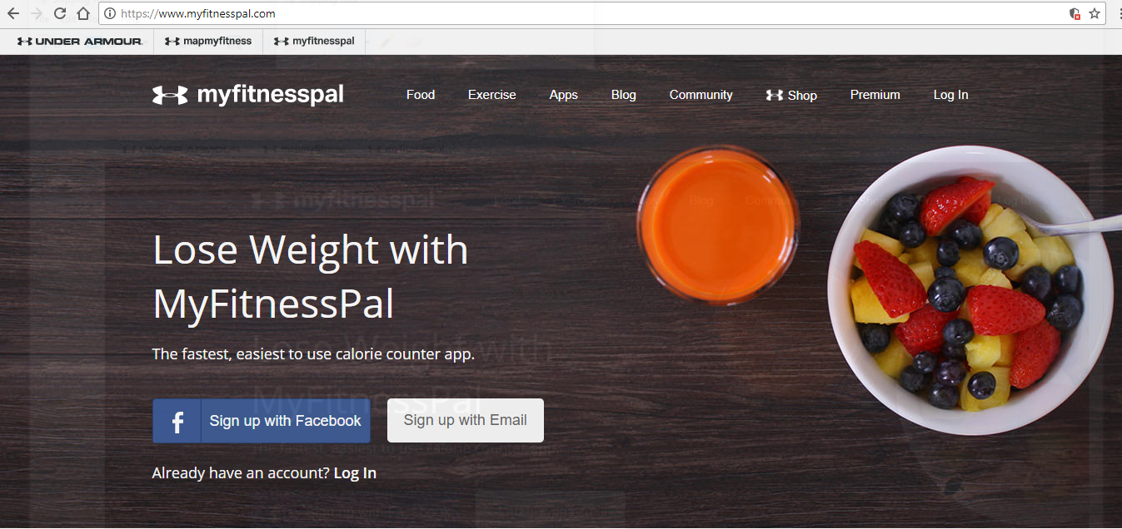

Figure

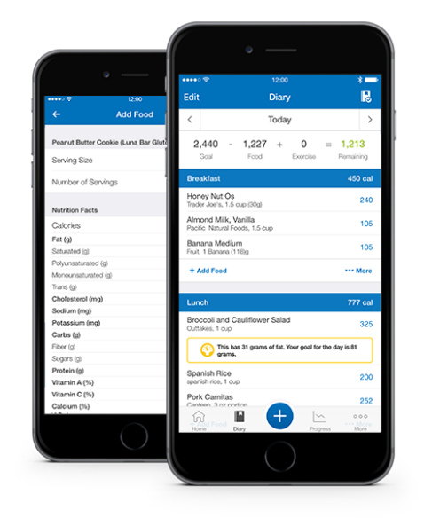

Figure

#### Calm

Another popular hybrid application is “Calm”. This application focuses on improving a user’s mental wellbeing by providing meditation exercises and it is especially useful for novices whom are new to the art of meditation. There are a multitude of guided meditations that are offered to fulfill the specific needs of the user, such as for reducing stress and anxiety. This application does provide a free version which contains a limited number of available options, whereas the premium version of the application will require the user pays a monthly sum for them to receive access to more guided meditations, some of which are comprehensive programs that can last from one week up to three weeks in time. This application is both available via the website [www.calm.com](http://www.calm.com) or it can be downloaded onto a mobile device through the app/play store.

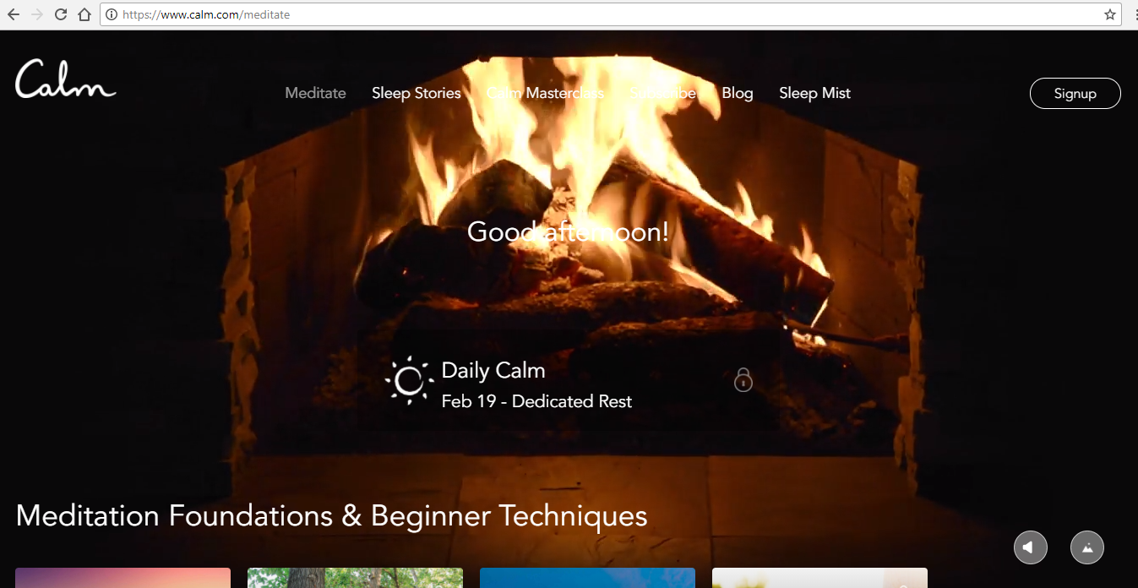

Figure

#### 8fit

8fit is a native (mobile) application that works like that of a personal trainer. When you initially download the application, you will be prompted to fill some information regarding your personal fitness information and your goal, based upon what you have chosen and entered into the required sections the application will tailor an exercise and diet plan to best suit your needs. The application provides over 350 exercises with a variety of levels that the users can progress through, it also provides over 400 healthy recipes that are customized to your personal tastes and allergies all while tracking your progress along the way. The application will support the user in making better decisions with their diet as it also provides foods that they can eat and what they must avoid achieving their goal. The application is available free of charge; however, this version is limited, and the premium paid version will provide the user with exclusive workouts and complete meal plans.

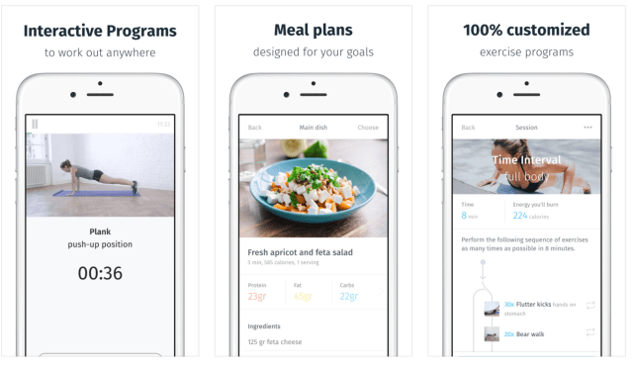

Figure

#### Sleep Better – Sleep tracker

Sleep better is a native application that is used as a tool to support people with tracking and managing their sleeping patterns. The application allows for users to input information regarding their daily habits such as their consumption of caffeine and the duration of their sleep, this information will then be stored within the application where it will be available for the user to view and use to track their sleep cycle and the duration that they sleep for. Additionally, the application also allows the user to monitor their mood and moon phases to see whether it will affect their sleep, as well as providing the users with a dream diary in which they can write about what they dreamt about, the application will produce a percentage of the user’s dreams which are good, bad or neutral. This application can be connected to a user’s social media accounts, so they will be able to share their results with their friends and family online.

#### The 7-minute workout (Johnson & Johnson)

The 7-minute workout is a native application that is available both on IOS and Android devices. This applications focus is to provide users with a range of workouts that are designed to fit their personal schedules by ranging from 7 to 32 minutes. It has a smart workout feature which will gauge the user’s fitness and motivation level and from this create a variety of workouts that will fit them personally. The workout library contains 22 present workouts which vary in intensity and duration, it also includes 72 exercises which can be customized in over 1,000 variations in difficulty. The application will notify the user if they have not been actively using the application as they should, and they are also able to share their workouts on their linked social media accounts. The user also can listen to and control music while using the application.

This type of application is very useful for people whom struggle to find time to spend prolonged periods of time exercising, with providing sustainable exercises that can vary between 7 to 32 minutes, this allows for these users to fit some exercise into their busy schedules. The workout videos provided will allow for novices to be able to learn how to perform the exercises correctly and safely.

#### Fitbit

Fitbit is a hybrid application which can be accessed via a web browser or when downloaded as an application onto a mobile device. Fitbit provides users with personalized workout recommendations which will be adapted to fit the user’s fitness goals. The application provides a vast amount of workout videos which will teach the user the movements and provide step-by-step coaching, motivation, and tips to help them to improve their method of exercising. The application also provides a customizable fitness soundtrack with Fitbit radio which offers a variety of music stations to help motivate users while they exercise. This application is available free to user’s; however, it is also available as a premium version which will provide the users with more exclusive and customized programs that will help them reach their fitness goal.

## Development Strategy

While developing this application we will focus on conducting several usability focused tests and questionnaires iteratively throughout the development of this application to allow us to grasp the user’s opinion and focus our study on providing them with an application which is considered as highly usable and will fit the requirements of the users that have participated in the study.

The development of the prototype will be conducted in 4 phases:

1. The initial requirements capture.
2. Low-fidelity prototype.
3. Medium-fidelity prototype.
4. High-fidelity prototype.

Following each level of fidelity prototype (low, mid and high) that has been developed, usability tests and evaluations will be conducted iteratively to ensure that the focus of this application has been established with the user’s input so to support in providing a higher level of usability for the potential users.

During the initial requirements capture we will conduct the first questionnaire of the project. This initial questionnaire will help us to gain knowledge based upon the participant’s results of the questionnaire. The results will support the choices made when designing the first low-fidelity prototype of the application. This prototype will not include any functionality but will be mainly focused upon the design and layout rather than on its functionality.

Once the low-fidelity prototype has been developed, the focus will then be upon conducting the appropriate usability tests and questionnaires to support the developer with establishing the applications level of usability based upon the way that the participants of the tests have completed the assigned tasks and how they have answered the questions. The tests that will conducted during this phase of the development will mainly be focused upon the way that the layout and basic design features of the application prototype, based upon the results of these tests changes will be made accordingly.

The medium-fidelity prototype development phase will then begin, the required changes (if any) that have been brought to the attention of the developer following the prior usability test results will be assessed and brought into practice to ensure that the application satisfies the users requirements.

The medium-fidelity prototype will contain a limited level of functionality, but it will include clickable areas which will represents the interaction and navigation possibilities of the application. The correct content description will be emphasized. This means that the application will provide the users with a good impression of the application as if it is functioning, which allows the users to derive processes from the range of features that are visible for them. This is considered as the “sense” of the prototype.

Following the development of the mid-fidelity prototype, we will conduct usability tests and evaluations based upon the basic functionality that has been provided. The users will provide us with feedback which is captured through evaluations of the users completing simple navigational tasks and with them answering a questionnaire based on their interactions with the prototype.

The results of the usability tests that have been conducted on the medium-fidelity prototype will support us in understanding the applications level of usability based upon the user’s responses during testing period. Any required changes that have been brought to the attention of the developer will be made, and any issues raised will be determined and amended during the development of the high-fidelity prototype.

Finally, the high-fidelity prototype developmental phase will begin. This level of fidelity refers to the level of detail and functionality that will be built into the prototype. The high-fidelity prototype will be the final product of this project, it will be an interactive representation of what the final design application will resemble in terms of details and functionality.

Following the development of the high-fidelity prototype, a usability test will be conducted in which the test participants will perform simple tasks and conduct an evaluation of the final high-fidelity product. The participants will be monitored while completing a set of interactive and navigational tasks to allow us to gather information that will help us to clearly understand the user’s opinions of the application, as well as the level of its usability. The results of all the usability tests conducted throughout this project will be clearly defined and discussed in section 8 Results and evaluations. The application development iterations as also available from section 4 to section 7 which will provide you with a overall discussion of the processes used to develop each version of the application. All of the relevant questionnaires and documents will be located in Appendix B and the code to create the application will be available in Appendix C..

### Usability issues

Usability issues can vary in priority depending on the type of application that is being developed. Usability is part of the broader term “User Experience”. It refers to the ease of access and the level of use the web application will provide for the user.

A usable interface is expected to have 3 main outcomes:

* The application should be easy for the user to be able to understand and learn to use. Basically, the interface should be well designed, so the user can quickly become competent with the design, as a badly designed application will quickly lose a potential user’s interest as they will struggle to understand how to use it, therefore they will choose not to use the application and it will become unpopular.
* The user should be able to easily complete a task or complete a specific objective by using the website. If they have an issue with performing these tasks the user will not want to use the application. The desired application should guide the user easily through the system, so they can complete any tasks that they desire.
* It should be simple for the user to recall the applications interface and be able to return to it in the future without much struggle to learn how to use it.

### Process issues

Various issues can incur during the process of developing an application. The main issues can incur due to the developers not defining the requirements clearly early on in the design, and during the testing period of the prototype. The requirements that have been created must be specific and detailed in order to successfully implement all of the desired functionality that has been requested of the application.

It is also extremely important that during the development that the requirements are able to be changed to better suit what the users have requested based upon the results of their questionnaires. If the earlier requirements are the ones used in the final project, this may prevent the developers from discovering a more suitable solution to the initial concept.

It is simpler to use a pre-configured installation on a platform that is easy to modify as this creates a more stable platform to develop the application within which will also take into any recent updates which will enable the users to keep gaining access to the application in the future without any major issues. It can also be pre-defined in the code that this web application can appear and fit onto various browsers that’s the users may have downloaded on their computers.

It is also crucial that when developing the application in the future that the database is very well backed up and that all of its security measures are up-to-date. It is of the highest priority to ensure that all user’s data is handled correctly and within the context of the data protection act.

### User inclusion (User involvement)

User inclusion is a widely accepted principle that is often used when developing usable user interface systems. User inclusion, sometimes referred to as user involvements is a vague concept that covers various approaches.

During the early phases of the development of a user interface the users are typically involved, specifically for requirements elicitation and feedback. Involving users throughout the software development cycle is intuitively considered to achieve the user’s overall satisfaction and approval, hence the interface is successful.

It is important to consider that some research literature created around the subject of user involvement has previously had inconsistent results. This is due to methodological problems, confounding effects of the terms “user involvement” and “user participation”, and contingency factors. The phrase “user involvement in software development” is an abstract concept has varied ambivalences.

# Iteration 1: Requirements capture

This section of the report will include all of the relevant information regarding the initial requirements capture that has been conducted prior to the development of the application. The initial requirements specification will be discussed in section 4.1. The user’s requirements are included in section 4.1.1 and these were captured during the initial requirements capture questionnaire. The functional system requirements are contained in section 4.1.2 and the non-functional requirements are discussed in section 4.1.3, these requirements are mainly disclosed by the developmental team who will use the user’s requirements as a basis to solve what the desired system, software and hardware is desired to provide and perform.

The results of the initial requirements capture are discussed in section 8 (Results and evaluation) within the sub-section 8.1.1.

## Initial requirements specification

An initial requirement capture questionnaire was created which was used to understand what a potential user would want an application to offer them. Following the conduction of the initial requirements capture questionnaire, the results will be measured and can then be used to provide the developers with enough information so that they can establish a set of requirements for the system. A requirements specification will keep all members of the developmental team focused on the goals of the design. These requirements will also be used as a reference during the testing phases throughout the development of the application to ensure that the application provides the correct features and functionality that has been designed to support the users, based on their needs and personal preferences.

A requirements specification may include descriptions of the steps of any functional interaction performed by the application, and the order in which they should be followed by the user. It may also list out all the possible error states for a certain form, including all the error messages that should be displayed following a specific instance. A requirements document, on the other hand, will state that the software must handle error states that occur reasonably and effectively, and provide explicit feedback to the users. The specifications will provide methods which will allow the application to meet these requirements.

There are a multitude of different styles of requirement specifications that may be used to provide important information to the relevant member of the developmental team tasked with creating the application, including:

* Data requirements: This helps the developers to understand how data will be gathered and used, so that they are able to plan and build a database with the correct functionality that will support the flow of information.
* Functional requirements: This is a description of the functionality of the features that are provided by the application so that the user’s workflow is supported.
* Usability requirements: The usability requirements for an interface design should support the applications ability to provide the end-user with an application that is efficient to use, intuitive (easy to learn and navigate) and has a low perceived workload.
* User requirements: This is used to define how the application will be used to meet the physical and cognitive needs of the intended end user of the application. The interface should allow users to comfortably and effectively use it to accomplish the goals that is has been created to accomplish.

## Initial usability specification

This section will include the initial usability specification. Specifications are used as a means to direct the development of the application based on the results of the initial requirements capture questionnaire. The usability specification in particular is used to define the different requirements that need to be fulfilled in order to achieve the goals of the desired users.

The following sub-sections 4.2.1 to 4.2.5 that are located below will include the requirements and various other factors that will be included in this application.

### User

1. The text on the application can be changed in size to support users with visual impairments to be able to view the text on the website with ease.
2. The application is secure, as is the storage of the user’s personal information within the applications database.
3. The application is clear and concise and provides the user with useful instructions to support them with using the application correctly.
4. The application should be regularly maintained to ensure that all the information provided is relevant and useful.
5. The application should be easy for users to navigate through and interact with.
6. The application will be free for users to use and will not require any subscription to provide users with a useful health and fitness application that will not act as a financial burden to them or deter them from using it.

### Functional

1. The web application will store the user’s personal data within its database and use this information to certify a user’s credentials are correct and grant them access to their account. Alternatively, the user is able to create a new account in which they will input their personal information, if they have met the guidelines (an email cannot be used for more than one account and the password needs to be over 8 characters), this data will be stored in the database and their credentials can then be used to sign into their own personal account.
2. The application will provide workout videos that are categorised based upon the time that they take to complete, this allows users to customise their workout based upon the amount of time they are able to exercise.
3. The application will calculate a user’s required calorie intake based upon multiple factors including: height, gender, weight, their chosen goal (weight gain or weight loss) and their goal weight. From this information the user can work out how much they have consumed on a given day and eventually over time they can view their progress and whether they are close to achieving their result.
4. The user can input their calorie intake into a food diary, the user can choose items for different meals from a scrollable menu which gets its information from the database, the users can also add their own food to the database if they are unable to locate it with it corresponding calories per serving, this information will then be stored, and other users can then choose this option from the menu.
5. The web application will provide an area that will allow users to store their speed and endurance statistics, this is an optional area for all users as not all will be interested in improving their athleticism. Those who are however will be able to input this information over a period and monitor their progress in a graphical format.
6. The user will receive emails if they have not accessed their account over a period. They will also receive emails if they have made progress on their goal. For example, as when a user who wishes to lose weight has lost 4lbs in a week they will receive an email congratulating them for their progress. This is intended to motivate users.
7. The user can input their weight once a week into their account and this information will be used to track their progress in a graphical format over a certain period (weeks, months and years). This will be focused upon any changes in their weight and their progress towards their current goal. Once their goal has been exceeded they will be prompted to choose a new goal.

### Non-functional

1. The user’s personal information is stored securely within a database.
2. The user’s personal information cannot be viewed by anyone other than those with the correct administrative permission.
3. The web application will be available on multiple web browsers.
4. A large database will be created that can store the vast amount of data expected to be used on this application.

### Requirements verification

Verification is the process of looking through the design of the application and confirming that the proposed application addresses the requirements that have been captured.

The requirements that have been derived from the initial questionnaire have been evaluated and it has been determined following some research that the desired functionality of the application is achievable. Validating that the requirements support verification will provide a basis to estimate verification cost and how the development should be scheduled to reduce verification costs as much as possible. An unverifiable requirement should be removed from the requirements as this cannot be correctly implemented and is considered a “Useless” requirement.

All of the requirements that are listed above are considered verifiable and can be incorporated further into the development and design of the application.

### Results: Desired functionality for the app

The main functionality and features of the application will include:

1. Weight loss and weight gain: The users will choose from a list of pre-determined goals which include weight loss and weight gain.
2. Athleticism: Increasing a user’s athleticism is a similar option to weight loss and weight gain as this is generally a type of exercise which is focused upon increasing endurance and stamina. The users can choose to input extra information regarding their current fitness state, from this they can determine if they make progress with their performance, for example their times per rep when performing a weighted exercise over a period will be monitored and the results show to the user. This is an optional area for users and they are not required to fill in these areas if they are not interested in monitoring their progress in speed and endurance.
3. Workout videos: The application will provide users with useful exercise videos that they can perform in a suitable amount of time which will fit into a user’s schedule. This area will contain videos categorised by the amount of time that they take to perform. This allows users to search for and choose an exercise which is suitable for them.
4. Calorie counting and nutritional information: This area of the application will include an area in which the users can work out the number of calories they should be consuming based upon their weight, gender and height. They can also input their daily calorie intake, they can choose from several options of foods for different meal times of the day, including snacks. They may also add a new food and its corresponding number of calories per serving. This information will be added to the applications database, where it will then be shown as an option to users. With user inclusion the databases contents of foods and their nutritional information will grow, the foods they input will be added to the database and then will be available to all users to choose as an option when inputting their information.

# Iteration 2: Interaction design.

The Interaction design section of this report will contain the relevant information and screenshots to show the usability tests that have been conducted to produce a Usability led design of a health and fitness application. In section 5.1 and its following sub-headings will include screenshots and a short discussion regarding the screenshots of the different levels of fidelity prototype.

## Low-fidelity prototype

This section of the report will contain the low-fidelity prototype. A low-fidelity prototype is a way to create the original design concept for the application. This version of the prototype will not be functional or allow for user interactions. These are helpful as they support early visualization of the design solution based on the requirements that have been derived based upon the results of the initial requirements capture questionnaire (which can be viewed in section 8.1.1).

Below are screenshots of the low-fidelity prototype. This is the first design concept created for the application and a usability test will be created to include the users and ask for their opinion of the design and if any changes should be made to ensure that their requirements are met.

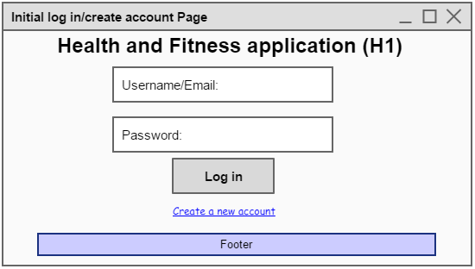

Figure

This is the proposed design for the initial page (Figure 6) that the user is introduced to when they access the web application is the log in page. The user can input their email and corresponding password which if inputted correctly will grant them access to their personal account once they click the “Log in” radio button and they will be forwarded to the Main Menu page (Figure 8). Alternatively, if the user does not currently have an account, they can click the hyperlink “Create a new account” which will forward them to the Create a New Account page (Figure 7).

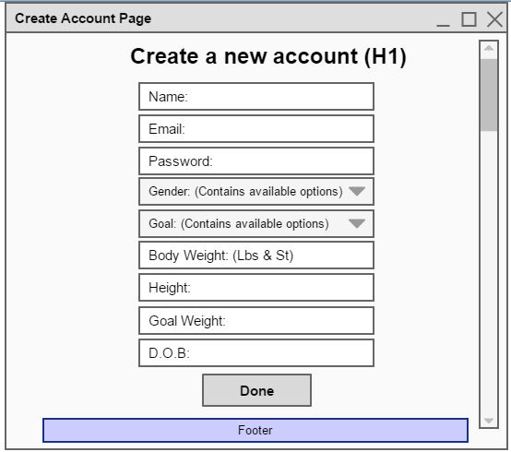

Figure

The user will be prompted to input the information required in each of the input boxes (as shown in figure 7 above). Each of the boxes will be required to be filled in before they will successfully make an account, and an error message will appear to alert them if they haven’t filled in all the required sections.

Once all the required sections have been filled in, the user will click the button “Done” which will store the user’s information into the applications database and create their account.

The user will be able to choose from a scroll down menu what goal they want to fulfil from the pre-determined options: Lose weight, gain weight and maintain weight. The user will also fill in the corresponding Goal Weight input field with the weight they desire to be. The user may also fill the field with 0 if they do not wish to make any changes. This area can be edited at any point while using the setting by going into the user’s account (figure 11) and editing their account details.

The user’s name, email, date of birth, gender and height cannot be edited in the future.

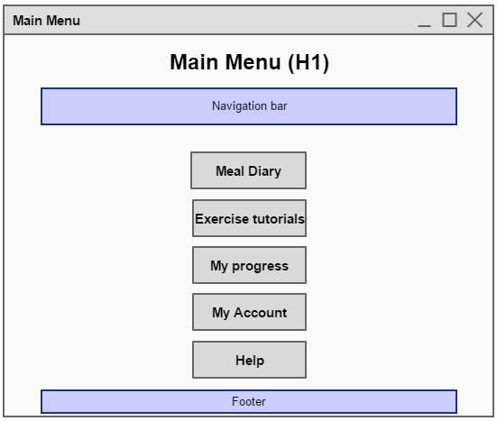

Figure

Figure 8 is the proposed design for the Main Menu page. The navigation bar that is located on the screen will provide the user with links to each of the pages of the application, including a button that allows the user to log out of their account. The buttons that are displayed in the body of the page will forward the user to its corresponding page (e.g. User clicks “My Account” Radio button, they will then be navigated to the “My Account page” Figure 11).

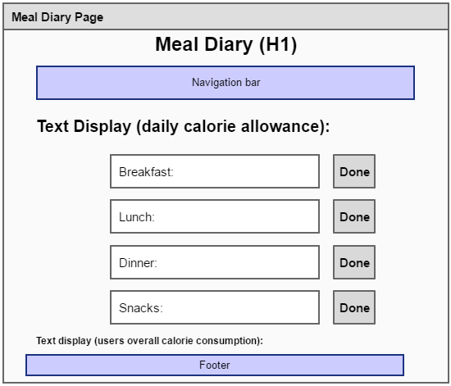

Figure

(Figure 5.3)

If the user chooses to click the Meal Diary button they will be forwarded to the Meal Diary page (Figure 11). The user’s daily calorie allowance will be calculated based upon their goal, gender, current weight and height. This will be displayed at the top of the page so that the user can easily view what their calorie intake is limited to.

The user will choose from the scroll down menu what they have consumed for each meal, including snacks from the corresponding area. The user can choose from the foods that are in this field including the number of calories the food has per serving, if they are unable to locate the food that they have consumed, they have the option to add their own into the applications database.

If the user chooses to add content to the database, they will be prompted to input the name of the food and its number of calories per serving. This information will have to be monitored to ensure that the information is relevant and useful.

The user can choose multiple food options in each of the provided areas, once they have chosen all the relevant options they can click the corresponding “Done” button which will store the number of calories that the user has consumed. This amount is displayed underneath the input fields and is provided to help the user to understand how much they have consumed, and if they are overconsuming or under-consuming their recommended daily number of calories.

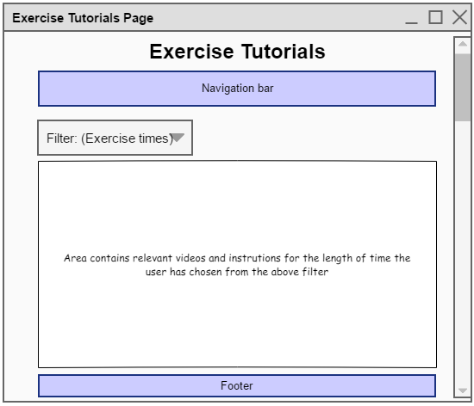

Figure

If the user chooses the “Exercise tutorials” button on the Main Menu page, they will be forwarded to the Exercise Tutorials page (Figure 10). The user will be provided with various exercises all of which are categorised by the amount of time that they will take to complete. A scroll down menu is available to allow users to quickly locate the relevant exercises for time that they want to view.

The tutorials will vary between videos and textual instructions with the relevant pictures so to provide the users with a better understanding of how to perform the exercise safely and in the most efficient way.

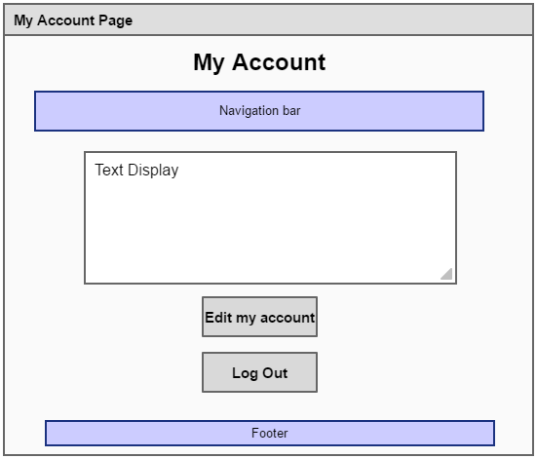

Figure

If the user chooses the “My Account” button on the Main Menu page, they will be forwarded to the My Account page (Figure 11). The user’s personal information is displayed in the Text Display box.

The user can choose to edit their account by clicking the corresponding button on the page, this will prompt the relevant areas to be changed. The user’s name, DOB, height, email and gender cannot be changed; however, they are able to change their goal from the available options and their goal weight.

The user also has the option to log out of their account on this page, they can click the “Log Out” button, or they can alternatively click on the button to log out of their account in the navigational bar.

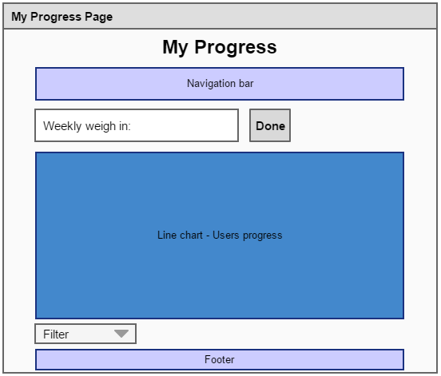

Figure

The My Progress page (figure 12) contains a navigational bar that allows the user to navigate around the web applications various pages with ease. It also contains a Line Chart which will display the users progress over a period.

The user can choose what information is displayed as a line graph from the filter that is located below the line graph. The options available include the user’s calorie intake, and their weight which allows them to determine if they are making any progress towards their current goal weight or are maintaining a healthy weight. The user is required to input their weight once a week into the “Weekly Weight in:” field and this data will be displayed in the form of a line graph to show the user how much their weight has changed over the amount of time that they have had their account.

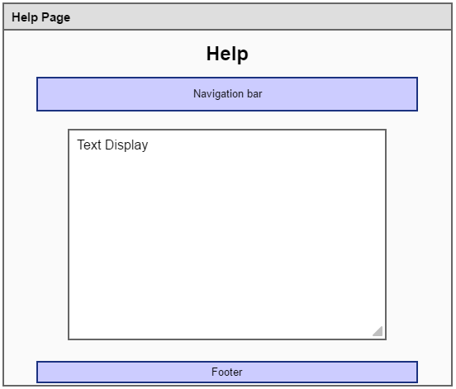

Figure

The Help page (figure 13) includes instructions on how to use the application and other relevant informative information that the user will require.

## Evaluation

The low fidelity prototype was developed based upon the requirements that were established following the analysis of the initial requirements capture results. It was decided that this application should provide 4 main functions:

1. The Meal diary (Nutritional information and calorie amount per portion).
2. Exercise tutorials.
3. Lose and gain weight.
4. Improve athleticism and endurance.

This design is a wireframe solution that incorporates these 4 factors and provides the user with an idea as to how the applications layout and design will appear. The users are asked to complete tasks logically on this design to verify if it makes logical sense to the participants and it is easy for them to comprehend.

This design is varied to change depending on the results of the further questionnaires, the mid fidelity iteration of the application will be used to determine how the layout and the design of application will appear, the prototype will be produced and presented to users in which they will receive a questionnaire in which they will determine the different aspects of the application “look and feel”.

This design is a basic solution and it displays all of the desired functionality in a clear and concise manner that the users can easily understand.

# Iteration 3: Mid-fidelity prototype

The mid-fidelity prototype is developed based upon the results of a questionnaire that is conducted following the low-fidelity design. (These results are locations in section 8).

This mid-fidelity design is basically the low-fidelity wireframe design but constructed using the developing platform NetBeans IDE. The design will stay very simplistic. The original requirements and considered functionality will be included in this version of the prototype.

This version is beneficial as it can support the developers in determining which elements work within the proposed layout, and which specific ones will cause the user issues or confusion. The focus on usability during this development ensures that the user’s opinions are entirely used when making decisions based on functionality and design.

Following the development of this version of the prototype, a questionnaire will be conducted which allow the test participants to evaluate and perform basic tasks using the design.

## The design

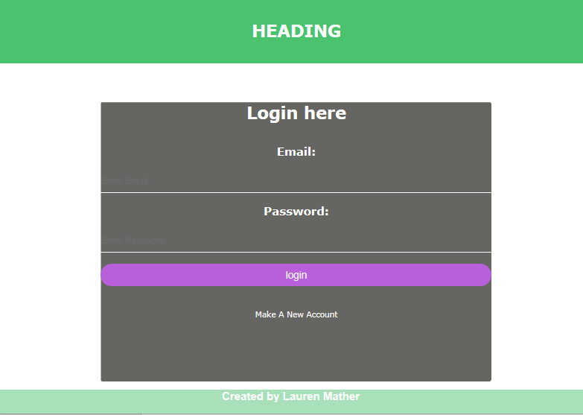

Figure

The Initial page that the user will be greeted with is the Log in page. Here the user can input their Email and Password. If this information is inputted correctly the user can click the “Log In” radio button and they will then be granted accessed to the Main Menu (Figure 3).   
Alternatively, if the user does not currently have an account they can click the “Create a new account” hyperlink which will take them to the Create Account page (Figure 2).

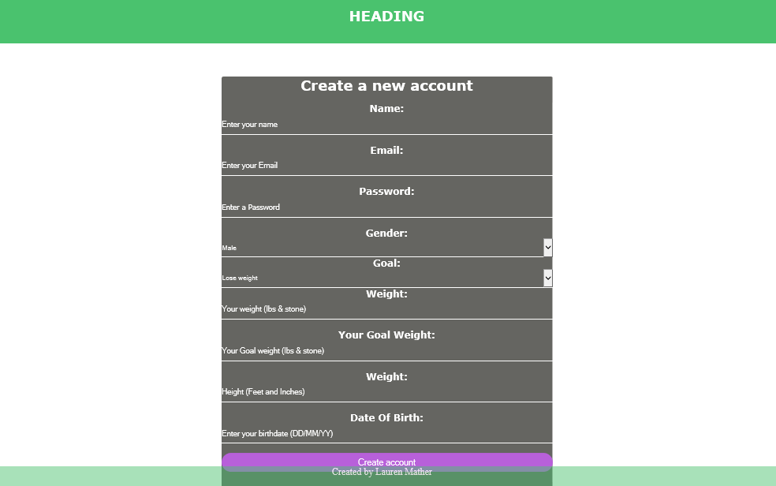

Figure

The user will be required to fill in all the text boxes above before they can click the “Done” radio button. When they have filled all the text input areas before they can click the “Done” button which will save the users information into the Database and log them into their account and navigate them to the Main Menu page (Figure 6).

The alternate version of the create account page uses drop down boxes to allow users to choose from available options in a different manner to choosing radio buttons.

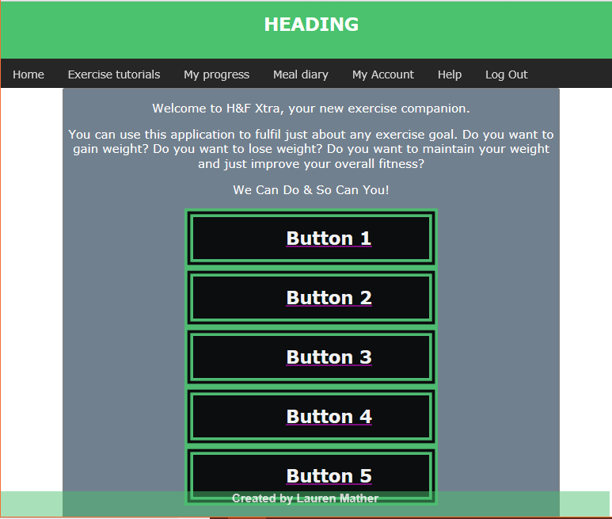

Figure

The Main Menu page provides a navigation bar that is located on the screen which will provide the user with links to each of the pages available on the application, including a button that allows the user to log out of their account. This page also contains buttons to the same pages.

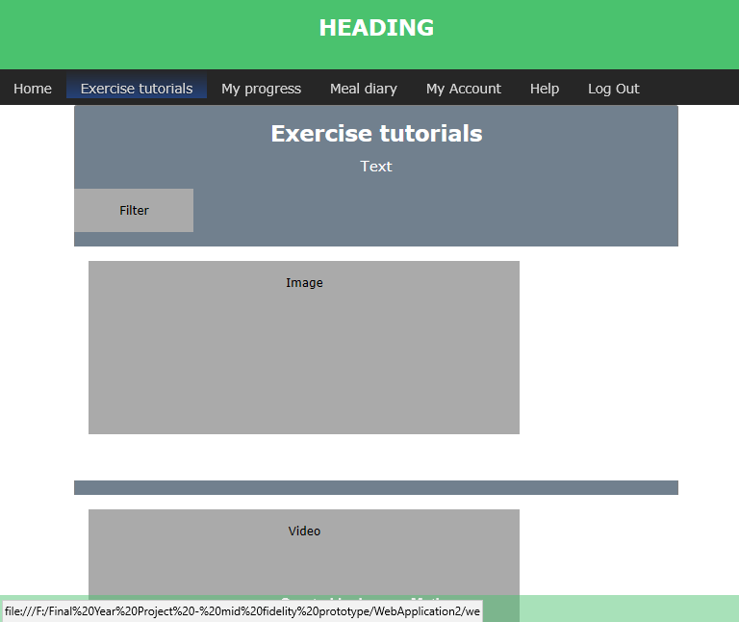

Figure

The Exercise tutorials provided the users with various exercises all of which are categorised by the amount of time that they will take to complete. A scroll down menu is available to allow users to quickly locate the relevant exercises for the amount of time that they desire to view.

The tutorials will vary between videos and textual instructions with the relevant pictures so to provide the users with a better understanding of how to perform the exercise safely and in the most efficient way.

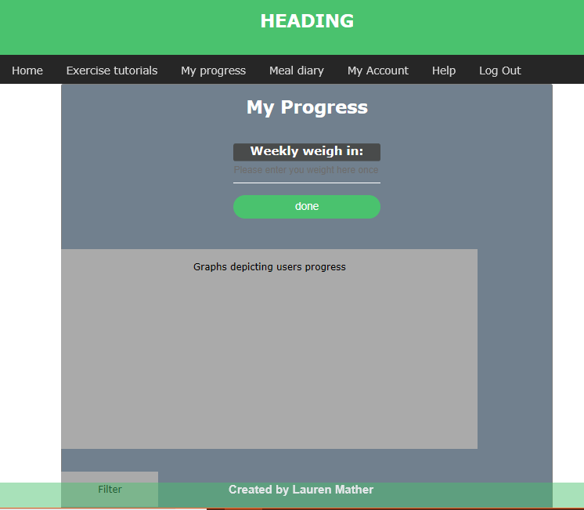

Figure

The My Progress page contains a navigational bar that allows the user to navigate around the web applications various pages with ease. It also contains a Line Chart which will display the user’s progress over a period of time.

The user can choose what information is displayed in the graph from the filter that is located below the line graph. The options available include the user’s calorie intake, and their weight which allows them to determine if they have been making any progress towards their current goal weight or are maintaining a healthy weight. The user is required to input their weight once a week into the “Weekly Weigh in:” field and this data will be displayed in the form of a line graph to show the user how much their weight has changed over the amount of time that they have had their account.

Figure

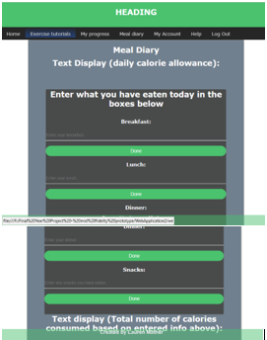

Figure

The meal diary page allows the user to view their daily calorie allowance (which is calculated based upon their gender, height and weight).   
They can either choose a food from the database to fill the text input box, or if the food they have consumed is not available they can add this to the database. They will be required to enter both the foods name and the number of calories per portion. Once a food has been input into the text boxes the user will be required to click each corresponding “Done” button to save this information.

This information can be displayed as a line chart on the My progress page (Figure 18). The amount of calories the user has consumed on that day is also calculated and subtracted from the user’s recommended daily allowance and the remaining amount of calories is displayed towards the bottom of the page.

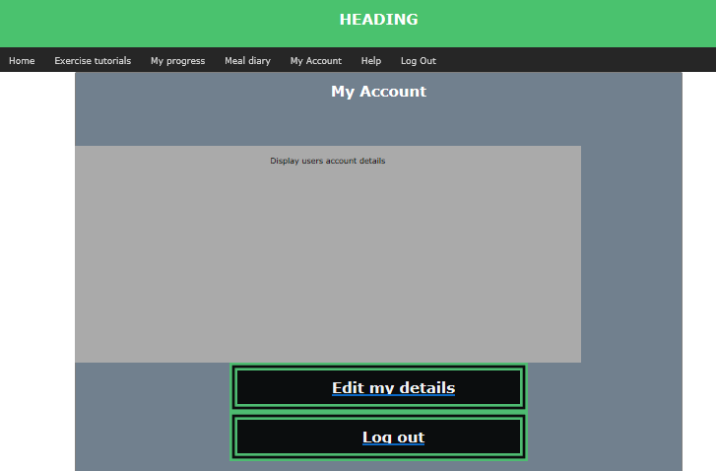

Figure

The My account page allows the user to view their personal information which is displayed in the text display box.

The user can choose to edit their account by clicking the corresponding button on the page, this will prompt the relevant areas to be changed. The user’s name, DOB, height, email and gender cannot be changed; however, they are able to change their goal from the available options and their goal weight.

The user also has the option to log out of their account on this page, they can click the “Log Out” button, or they can alternatively click on the button to log out of their account in the navigational bar.

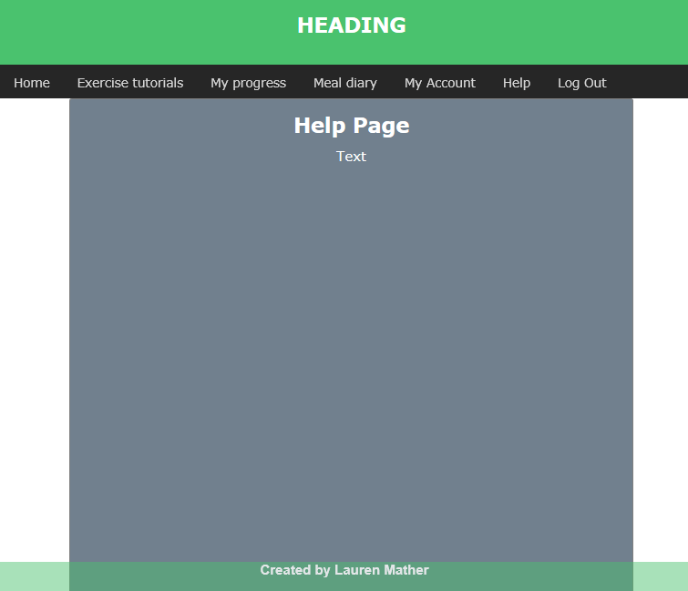

Figure

The Help page contains relevant information such as instructions as to how to use the application correctly and including some information regarding the privacy policy.

## Evaluation

The proposed design is not the definite layout and colour scheme that will be employed on the web application. This design is a general concept that has been designed by the developers. A usability test will be conducted (results available in section 8.1.2) which will ask the user to evaluate the layout provided and they will also be asked to choose from various options regarding the design, including factors such as the colour scheme, if a background image should be used and the style of font that will be used.

This design is not high functional, as any mid-fidelity prototype should not be. The focus of this design is to present a concept as to how to produce the application in a way that satisfies the users desires. The majority voted options will be those implemented on the final high-fidelity design.

No excessive details are used in this prototype, any images and specific functionality is imitated or shown by boxes containing text that describe what is actually intended to be available in the final design.

# Iteration 4: High-fidelity prototype

The purpose of the high-fidelity prototype is to include most of the necessary design assets and components that have been developed and integrated throughout the process of developing the earlier versions of the prototype and while conducting the usability tests and questionnaires. The applications level of functionality is extremely close to that of the desired final product.

This version of the application is created in the NetBeans IDE platform and will perform realistic user interactions and provides as close to the desired end products level of interaction without the inclusion of a database.

Usability tests can be conducted on this prototype which will produce a much more effective collection of the true human performance with this application (this includes matters such as the length of time it takes to complete a task). The user can also evaluate the application based upon its “look and feel”. They can also recommend any further details that can be included in the future design.

We will discuss future goals for the product at the end of this report in the conclusion. The high-fidelity prototype is the final design that will be produced for the purpose of this report.

## The design

This is the initial page that the user will be faced with when first running the application. This is the Log in page. Here the user will input their relevant email and password, if this information is correct they will be forwarded to the main menu, otherwise they will receive a pop up which alerts them that their details are incorrect.

The user can also choose to click the “Make a new Account” hyperlink which will forward them onto the create new account page (figure 24).

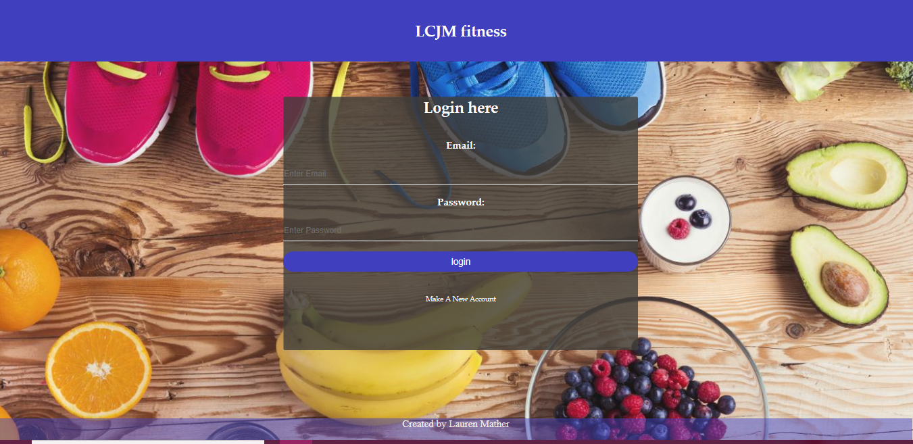

Figure

This is the Create a new account page, here the user will be able to choose their options from a scroll down menu (relating to their gender and fitness goal), and they can also input other relevant information. When all of the required fields are correctly filled, the user will be able to click the “Create Account” button which will store their information into a database and forward them onto the Main menu page (figure 6.8).

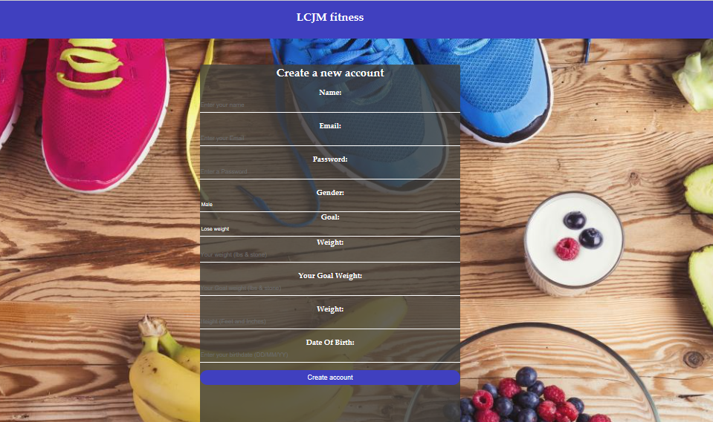

Figure

This is the Main Menu page. On this page there are various links to the pages that are offered by this web application, each providing their own functionality for the users to interact with.

The users can use either the navigation bar along the top of the page or the large buttons in the centre of the page to navigate to where they desire to go.

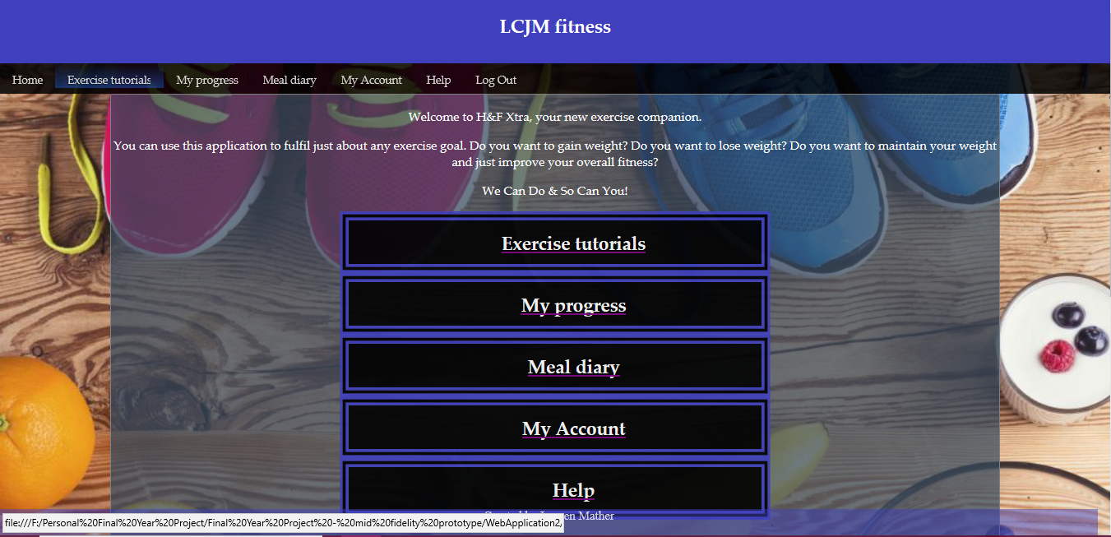

Figure

This is the exercise tutorials page, as of yet there are no real tutorials that have been developed to be displayed on this web application, however the location of the content is represented with the use of boxes and symbols. The drop-down menu located at the top of the page provides the functionality of being able to quickly navigate to a specific part of the page. These sections are separated by the time it takes to complete the exercise tutorials.

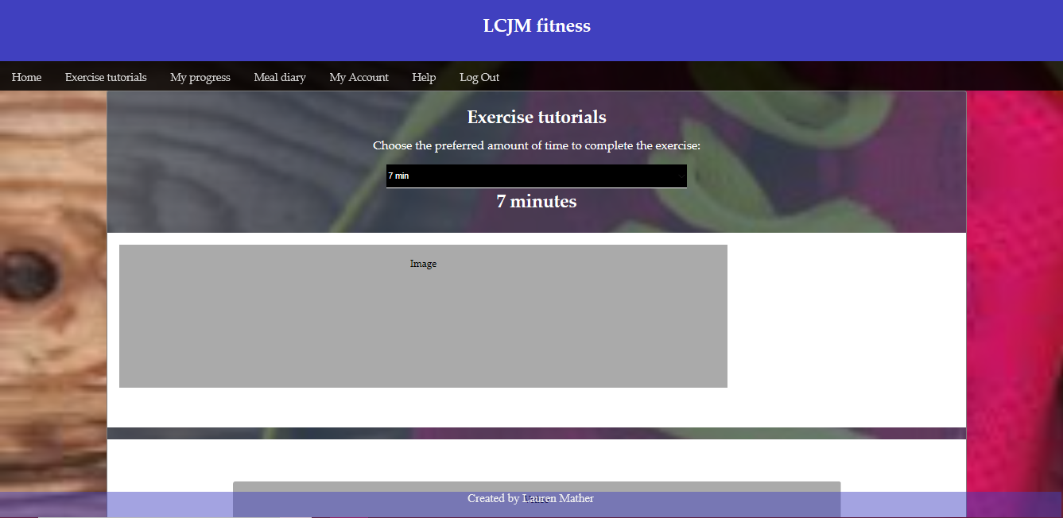

Figure

This is the My Progress page; this page does not offer much functionality as it would require the information regarding the user’s weight over a period if time which is not possible without the inclusion of a database. The idea is that the user will input their weight once a week into the provide text input box and this will be added to their account over a period of time, this information will then be relayed into a graph which is also displayed on the screen. A drop-down menu is available which allows the user to choose from different styles of graphs to show their results in.

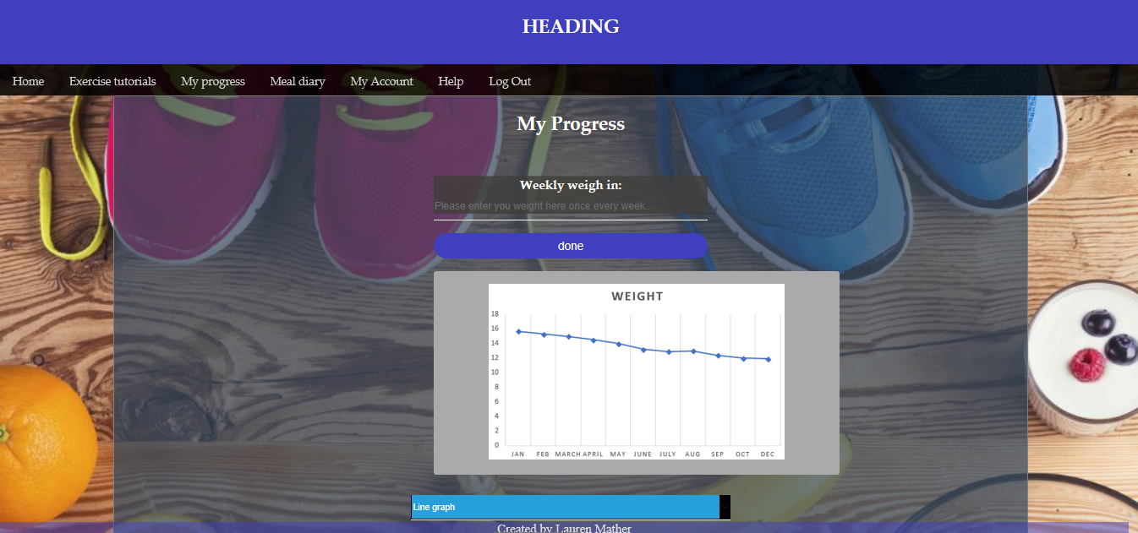

Figure

This is the Meal Diary page, again this page lacks its functionality due to there not being a database in which it can store this information. The idea for this page is to allow users to input what they have consumed on a daily basis for each meal, including snacks. The users will also be able to search for foods that are already in the database for their meals, they also have the ability to add new foods to the database, along with their average calorie amount per portion so others can use this for their meal diary in the future. This will allow the database to grow larger and expand over time to offer a vast array of foods and their nutritional information.

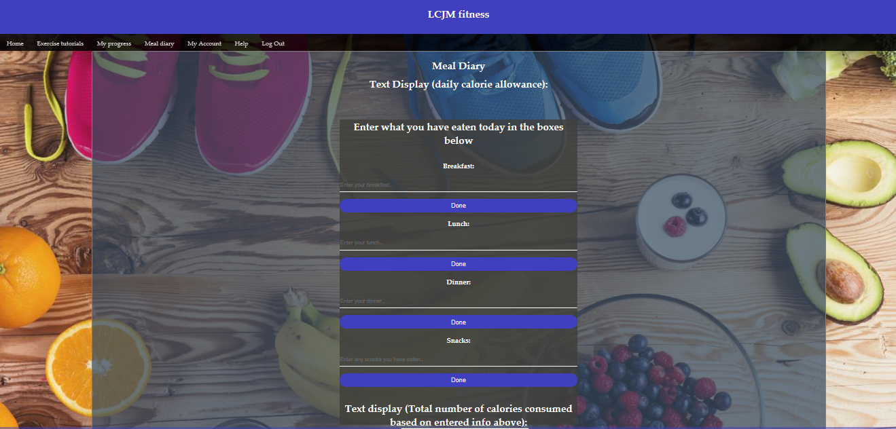

Figure

This is the Help page. This page contains simple instructions as to how to use the application and what the purpose of it is.

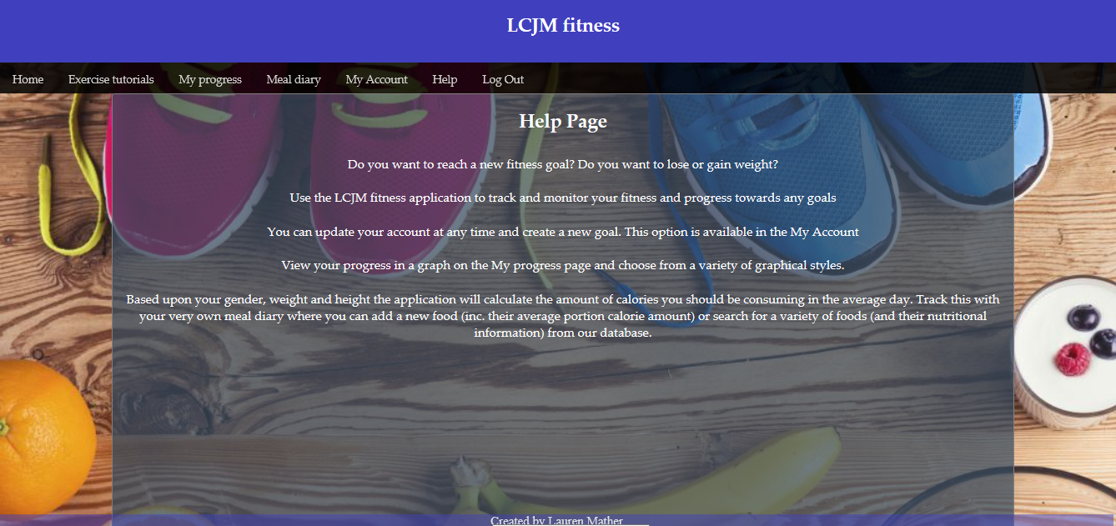

Figure

## Evaluation

The final high-fidelity prototype that has been produced provides the user with a level of functionality that is as close to desired final application, that is achievable without the inclusion of a database.

As the majority of this application will requires the use of a database for the purpose of completing various tasks including: storing, updating and retrieving the user’s account details, storing and calculating the users personalised calorie intake based upon the users height, gender and goal (lose weight or gain weight), the storage of the users meal diary, the various different foods are added into the database also so the users can search through them when choosing an option for what they have eaten for a specific meal, they can also add new foods (including its average calorie amount per portion).

Some simple textual exercise tutorials are available on the web application, these are located on the “Exercise Tutorials” page and a filter is available which can direct the user to a specific section on the page to view based upon the amount of time the exercise will take to complete. This is a factor encompassed by the user’s initial mention of not having enough time to exercise. This should allow the user to quickly locate the section that they wish to view quickly and without needing to scroll. A future goal of this page is to include exercise videos that will be created by a PT in various time scales to fit the user.

In order to correctly test the log in menu some log in details (username and password) will be hardcoded into the system so the user can perform the task of logging in. They will be unable to create an account as this information cannot be stored into a database as the high-fidelity prototype is not required to.

The final evaluation will be conducted in a lab and the users will be asked to complete various tasks and evaluate how much they like they application and if they would be interested in using the completed product. The results and further evaluation is located in section 8 “Results and evaluation”.

Finally, the applications name LCJM fitness has been chosen as this is the developers initials. We tried to avoid breaching any copyright laws therefore we kept the name simple as we can establish this in the future.

# Results and evaluation

This section of the report will include the relevant questionnaires and an evaluation of these results. All of the questionnaires that were handed out to the test participants are located in Appendix B located at the end of this report.

## Questionnaires

Within this section will be included the results of the questionnaires that have been created with the purpose of supporting the development of this project. In sub-section 6.1.1 we have the initial requirements capture, the results of this questionnaire are depicted in the form of graphs, the original copies of the questionnaires are under the due care of the official project supervisor and all participants information is kept anonymous as agreed upon on the corresponding ethical consent forms (which for retaining user anonymity are not available within this paper). All of the ethical consent forms are held by the supervisor of this project.

### Initial requirements capture questionnaire

This initial questionnaire was created with the purpose of capturing requirements, we also intended to get a better understanding of what the user wants when it comes to a health and fitness application. Not only that we wanted to get an understanding of a user’s current lifestyle and see whether this has an overall effect on their willingness to exercise. Below we will include the relevant screenshots of the results for each corresponding question, these results are displayed as a graphical representation, and the results will be discussed. Following the results of this initial questionnaire, the requirements of the application will be established and the relevant design and requirements documentation for the low-fidelity can begin to be developed based upon the results.

A copy of this questionnaire is located within Appendix B.

#### Question 1:

**“What is your age range?”**

The number of participants aged between 22-25 was 70% of the overall study, and 20% of the participants were aged between 18-21.

The overall age range for these results range from 18-25 which means the focus group of this application will be for young adults.

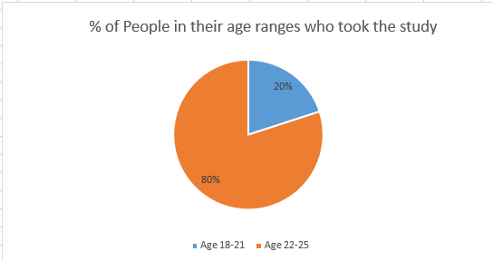

Figure

#### Question 2

**“What is your gender?”**

The participants that took part in the study were all limited to male on the day the questionnaire was handed out, therefore the results of this specific questionnaire will be from the male perspective rather than female. This limits the results and will mean we do not acquire any results from the female perspective.

As we are limited only to male, the way we will determine the focus of the project will be based upon only results from the main results, however we can still assume that the focus of this application will be gender neutral therefore allowing all persons to have the ability to use this application.

Figure

#### Question 3

**“Do you smoke?”**

The smoking results were limited to only 10% of all participants being smokers, therefore they are a minority in comparison to the majority 90% of participants whom do not smoke. This means that the minority smoker’s results will not amount to a considerable difference when determining the results of the study, and it is not a subject which will impact the study in any way.

#### Question 4

**“Do you currently use a Health and Fitness application?”**

The results of this question relay that 50% of the participants are currently using a health and fitness application, and the remaining 50% do not currently use an application. This is an interesting result as we can receive information from users who already have experience using health and fitness applications, and those who are novices or who cannot find an application that currently satisfies their needs. With this range of experience between users, the results will help to give us a differing opinion or allow us to find a mutual focus that we can base our application, so it is able to satisfy the “overall user”.

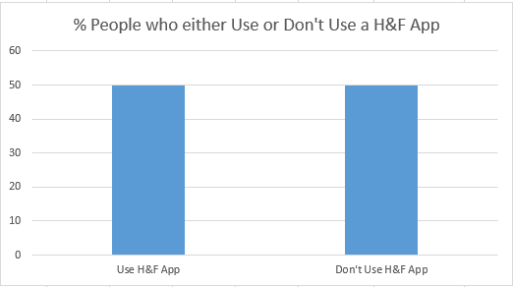

Figure

#### Question 5

**“Under the assumption that you would be interested in using a health and fitness application. What do you believe currently prevents you from achieving your health and fitness goals?”**

The options available for this question are in the key below.

KEY:

LoM = Lack of Motivation

LoT = Lack of Time

SC = Self-Conscious

LoE = Lack of equipment

LoR = Lack of results

M = Money (financial) related issues

LoK = Lack of knowledge

N/A = Non-applicable

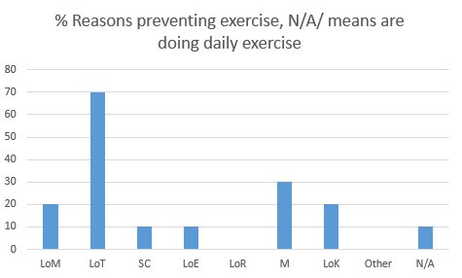

Figure

Based upon the results of this questionnaire we can clearly determine that the main reason that currently affects users from exercising is due to the user’s lack time able to spend focusing on exercising, the second highest rated reason is money, and joint third is lack of motivation and lack of knowledge. Joint fourth are self-conscious, lack of equipment and non-applicable. The N/A option stands for users who have no reason that is preventing them from exercising, and in the case of the results only one user chose this option and their feedback revealed that they also exercise daily.

#### Question 6

**“When you are considering using a health and fitness application, what would you consider being an important factor that should be incorporated within the application?”**

The participants of the test were asked to rate several features typically offered by health and fitness applications from number 1 – 9 (1 being the most important feature, and 9 being the least important feature in their opinion). Below a graph has been created to represent the features that have been voted as the number 1 priority the most. As the results show, the most important features are counting calories and nutritional information, weight loss/gain, improving athleticism and workout videos. The test participants did not view mental wellbeing, hobby related, diet plans and the ability to share their progress online as their number 1 feature at all.

From these results we can now focus on developing an application that will incorporate these features and provide the potential users with an application that will satisfy their needs.

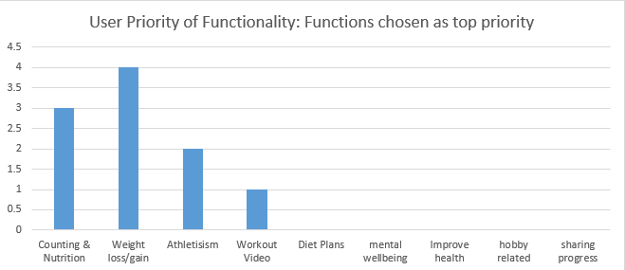

Figure

#### Question 7

**“Choose from the available option which best describes your current lifestyle.”**

The corresponding options are in the key below.

KEY:

Red = Never exercise

Orange = 1 – 2 times per week

Yellow = 2-3 times per week

Purple = 3+ per week (intense level)

Blue = Every day (intense level)

This question asks users to describe their current health and fitness lifestyle, based upon the amount of times that they will exercise per week. 10% of the participants voted that they never exercise at all, and 10% also stated that they exercise every single day. 20% of the participants exercise 3+ times per week at an intense level. Whereas, 30% of the test participants have stated that they exercise 1-2 times per week, and the remaining 30% exercise 2-3 times per week. This allows us to a work out that the average user will make the effort to exercise between 1 – 3 times per week.

We can attempt to focus on making a way that we can support users with improving on their level of exercise per week and incorporate a factor such as daily notifications to alert the user that they have not exercised, this could be used as a helpful reminder that they need to focus on their health and fitness.

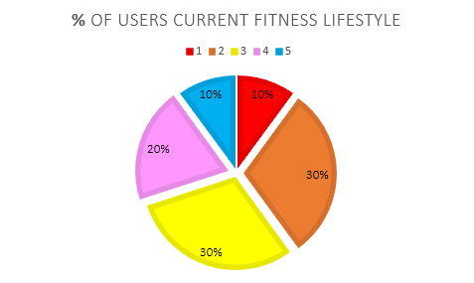

Figure

#### Question 8

**“How important is your health and fitness to you?”**

The corresponding options for this question are in the key below.

KEY:

1 = Extremely

2 = Very

3 = Moderately

4 = Slightly

5 = Not at all

This question is asking participants to choose from the options 1 – 5 (explained in the key provided) which will best describe their opinion of how important their personal health and fitness is to them.

As can be viewed in the graph below, all users do consider their health and fitness to be of some level of importance. Most participants (50%) share the opinion that their personal health and fitness is of moderate importance to them. 40% of participants have voted that it is of higher importance to them, with half voting extremely and the remaining voting very important.

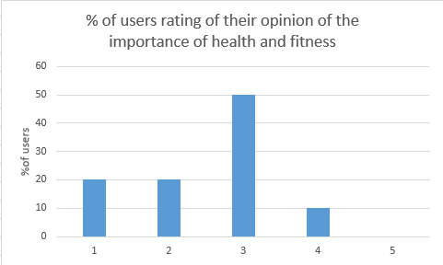

Figure

#### Question 9

**“What would motivate you to achieve your goals?”**

The options for this question are in the key provided beneath the pie chart below.

This question was focused upon asking users to choose from a list of options (including the ability to choose other and input their own) to vote for what would motivate them to achieve their health and fitness goals when using an application. The users were able to tick as many, or as few options as they pleased. The results of this question have been depicted in the pie chart below.

As can be viewed from the pie chart, over 90% of the participants questioned have stated that their biggest motivation would be to be able to view physical results from using the application, 2nd most popular is the participants “feeling better” both physically and mentally, 3rd is having fun while using the application, and last at 20% is from receiving praise and rewards.

It is important that we take advantage of these results and incorporate these factors into the functional requirements of the prototype.

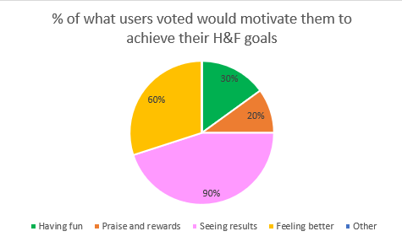

Figure

#### Question 10

**“Would you be interested in using an application that will provide you with a unique and sustainable plan based upon your specific goals and interests?”**

The final question of the questionnaire was asking users to vote whether they would be interested in using a health and fitness application that will provide them with a personalised experience based upon their goals. As can be viewed from the pie chart below which depicts the results we can see that the majority 90% have voted that yes, they would be interested in using this type of application. The remaining 10% have stated that they are not interested in using the application. The user who voted no also provided a comment stating why, this simply said that “I don’t like using applications”, this opinion is very different to most participants however this gives us an idea that there are a minority of people who simply do not enjoy using applications to fulfil their health and fitness requirements.

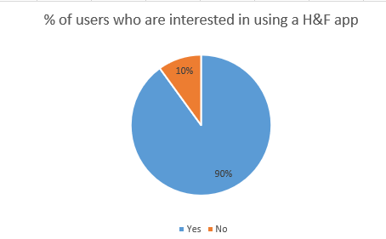

Figure

#### Overall evaluation of initial requirements capture questionnaire

Following the results of the requirements questionnaire we are now able to establish what the system requirements will be so that the potential end-user’s desires will be fulfilled.

Question 1 (section 6.1.1.1) asked the users to state their age group, the results show that the results are limited to users aged 18-21 and 22-25. There we can determine that the desired end-user will be aged 18 and over.

Question 2 (section 6.1.1.2) asked the participants to state their gender. Based upon the results it can be determined that all the participants who took part in the study were male. However, we can determine that the general focus of the application will be to provide a service for both male and female users. This just means that the results are from the male perspective rather than female.

Question 3 (section 6.1.1.3) asked participants whether they smoked, with an extended area where they can state the number of cigarettes they smoke on the average day. Only 1 participant of the study was a smoker, so their results would not make a considerable difference as they cannot be useful to producing a focus group as their results will be their individual opinion, and it cannot be studied whether this is a shared opinion of those who smoke as there is not a larger group of participants who smoke that can be studied.

Question 4 (section 6.1.1.4) asked participants if they currently use a health and fitness application to support them with their current lifestyle. From the results it can be determined that exactly half of the participants currently use a health and fitness application and the remaining half do not. This is an interesting result as the opinions are from users with a varied level of experience and skill when it comes to using these types of applications. The participants have provided results which support a varying opinion. This result can also be used to establish if the users would be interested in using an application that fulfils their goals, while supporting them in the areas that may be currently preventing them from using a H & F application.

Question 5 (section 6.1.1.5) asked participants to choose from several options (including the option of other where they can write their own reason, no participants chose this option) what may be currently preventing them from exercising. As can be viewed in the corresponding bar chart the most voted reason is “lack of time”. The second highest voted reason is “money”, and joint third is “lack of motivation” and “lack of knowledge”. From these results we can determine that we are required to provide the users with an application that will work around their current schedule to allow them to find the time to exercise, the application will also be free to users therefore relieving the financial burden of purchasing an application (or month/yearly subscription). The application will also be required to motivate the user and provide them with useful knowledge to support them in correctly and safely performing exercises.

Question 6 (section 6.1.1.6) asked the users to rate currently popular features commonly incorporated within health and fitness applications based upon their personal preferences. From these results the features with the most 1 rating were discovered, the results show that the most important features are counting calories and providing nutritional information, weight loss/gain, improving athleticism (speed and agility) and workout videos.

The features that will be incorporated within the application have been filtered down to 4, and the 4 that have been chosen directly corresponds with the results from question 5 in which users claimed lack of knowledge stunted them from exercising.

The main categories the applications include:

1. Weight loss and weight gain: The users will choose from a list of pre-determined goals which include weight loss and weight gain.
2. Athleticism: Increasing a user’s athleticism is a similar option to weight loss and weight gain as this is generally a type of exercise which is focused upon increasing endurance and stamina. The users can choose to input extra information regarding their current fitness state, from this they can determine if they make progress with their performance, for example their times per rep when performing a weighted exercise over a period will be monitored and the results show to the user. This is an optional area for users and they are not required to fill in these areas if they are not interested in monitoring their progress in speed and endurance.
3. Workout videos: The application will provide users with useful exercise videos that they can perform in a suitable amount of time which will fit into a user’s schedule. This area will contain videos categorised by the amount of time that they take to perform. This allows users to search for and choose an exercise which is suitable for them.
4. Calorie counting and nutritional information: This area of the application will include an area in which the users can work out the number of calories they should be consuming based upon their weight, gender and height. They can also input their daily calorie intake, they can choose from several options of foods for different meal times of the day, including snacks. They may also add a new food and its corresponding number of calories per serving. This information will be added to the applications database, where it will then be shown as an option to users. With user inclusion the databases contents of foods and their nutritional information will grow, the foods they input will be added to the database and then will be available to all users to choose as an option when inputting their information.

Question 7 (section 6.1.1.7) asks users to choose the option that best describes the amount of exercise that they currently perform in the average week. As can be viewed from the relevant pie chart 30% of users have stated that they work out between 1-2 times per week, and another 30% workout 2-3 times per week, when combined this means that 60% of participants typically exercise between 1-3 times per week. 20% of users exercise 3+ times at an intense level per week, 10% exercise every single day and the final 10% do not exercise at all. The participants of this questionnaire do vary in their current level of health and fitness; however, the majority do commit to some sort of exercise per the average week which means that most users are currently active therefore this application can be a means of providing them with a better schedule to fit in their exercise and knowledge on how to perform exercises properly.

Question 8 (section 6.1.1.8) asked for users to rate their opinion of how important their personal health and fitness is to them. The bar chart displays that 50% of users voted that they consider their health and fitness is of moderate importance. 20% of users rated it very important, and 20% rated it extremely important. This means that the majority (90%) of user’s opinion point to the conclusion that the user’s health and fitness is of moderate, or more importance to them on a personal level, therefore this may improve their willingness to actively use an application if one be provided to them that fulfils their requirements.

Question 9 (section 6.1.1.9) asks for users to choose what would motivate them to continue using an application. As can be viewed on the relevant pie chart, the clear majority (90%) of users believe that seeing physical results will motivate them, another 60% voted that an improvement in their general health (feeling fitter and healthier) would motivate them to continue to exercise regularly and use an application to its full potential. 30% believe having fun will motivate them and 20% believe praise and rewards will.

The physical results and improvements in health can be recorded under the users personal account, this will include the users physical measurements (height, weight, body measurements) and health status such as their diet can be inputted and recorded so that graphs can be produced which will depict the users progress (if any has been made) in a graphical way that will be easier for the user to grasp and understand.

The final question (section 6.1.1.10) simply asked users to state whether they would be willing to use an application under the premise that it provides them with a health and fitness plan that would fulfil their personal goal. As can be depicted from the pie chart 90% of the participants have agreed that they would use this type of application. However, the 10% of participants that voted that they would not be interested also commented that they are not interested in using the application as they do not like to use applications and would prefer to just attend the gym.

### Low-fidelity prototype questionnaire results

The low-fidelity questionnaire will be conducted on the low-fidelity wireframe that has been developed based upon the results of the initial requirements capture. This questionnaire will support the developers in determining if the design is suitable for the user and if the context is easily understandable. If any of the results show that the user finds the content difficult to understand, changes must be made to solve these issues.

#### Question 1

**“What is your age range?”**

The general age range for the test are aged between 18 and 25. The questionnaires were handed out within the 7th and 6th floor labs in the Byrom street campus. The results will show the opinions of this specific age group, generalised as young adults.

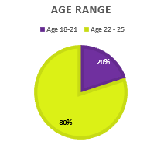

Figure

#### Question 2

**“What is your gender?”**

The test was completed by 40% female participants and 60% male participants. This test will allow us to grasp a better insight into how to produce an application that can be used by anybody of any gender.

We can also see if the male and female perception differs in any of the questions and discuss this further where relevant.

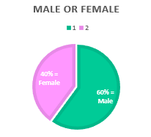

Figure

#### Question 3

1. **“Do you use any of the following applications?**

As can be see in the pie chart below, 50% of the overall test subjects do not use any type of application, 30% use the MyFitnessPal application, 10% use the application Calm and the remaining 10% use FitBit. These applications and other similar applications have been analysed for the purpose of understanding what type of application potential users are most likely to want to use, and we can also look at these current applications as a basis to provide a better service to the user that will better fulfil their needs.

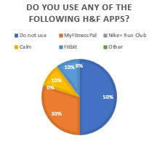

Figure

1. **“If you have chosen “other”, can you please write what this application is called..”**

None of the test subjects chose the other option and did not fill in this section of the questionnaire.

#### Question 4

**“How often do you use this application?”**

As can be seen in the bar graph below. 20% of the test subjects use their current application one or more times per month, 10% use theirs twice a week, 10% once a week, 10% daily and most users 50% do no use an application at all.

We want to produce an application that the user’s will want to actively use on a regular basis. We will take into account any of the users’ opinions and attempt to achieve an application that will not only satisfy what the users want, but to create an application that they want to use repeatedly.

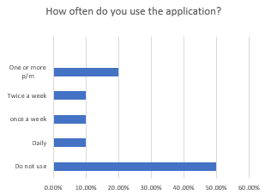

Figure

#### Question 5

1. **“Can you navigate from the initial Log in page to the My progress page? Perform the task as if you are an existing user.”**

As can be viewed in the pie chart below, 100% of all of the test participants have completed the task correctly. Therefore, no changes need to be made for this portion of the web application as the users can easily grasp how to navigate through the application.

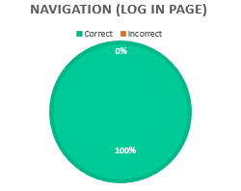

Figure

(Figure 8.6)

1. **“Which radio button will the user click on the Main Menu page to find the page that displays their progress?”**

As can be viewed from the pie chart below, 100% of the test participants have again been able to clearly understand how to navigate to the My Progress page simply. The use of important key words makes it easier for the user to quickly understand what will be located on each page and they can swiftly choose which page they want to view without much difficulty.

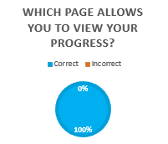

Figure

#### Question 6

**“On which page does it allow you to log out of your account?”**

As can be shown in the pie chart below, 100% of the test participants were able to understand from the design documentation provided alongside this questionnaire, which page they will be able to log out of their account on.

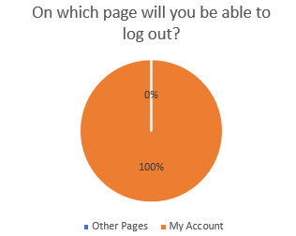

Figure

(Figure 8.8)

#### Question 7

**“Is there any content or information in the application that is unclear to you?”**

As can be viewed in the pie chart below, 100% of all of the test participants have answered that none of the content in the application is confusing to them. This tells us as the developer that all of the content included in the website up to this point does not have to be altered in any way as the design is successful in providing the user with a layout that they can clearly understand.

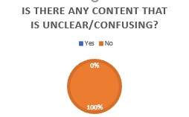

Figure

#### Question 8

**“Would you be interested in using this application based on the currently proposed design and description provided?”**

As can be viewed in the pie chart below, 70% of all of the test participants have said that they would be interested in using the application in the future once it is completed. Whereas, 30% of the test participants have stated that they would not be interested in using this application. The opinions of those who chose the option “No” all shared the same opinion that they are just simply not interested in using an application to monitor their health and fitness as they would much rather attend the gym and monitor it themselves.

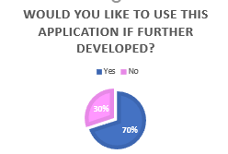

Figure

#### Question 9

**“Do you have any recommendations as to how to improve the proposed application?”**

All of the test subjects (100%) have not provided any recommendations as to how to improve the design or functions included within the application. This can be seen as a positive as this appears to say that the application is of a high quality and satisfies what the users have been asking for from a health and fitness application.

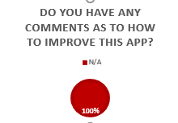

Figure

#### Overall evaluation of results

In this test we were able to get both female and male participants to take part in the questionnaire. The number of male participants still outweigh the amount of females taking part so far through the study, however the input of the female participants in this questionnaire will provide us with the ability to establish the perspective of both female and male potential users.

In the analysis (section 3.2) we looked at various other health and fitness applications that are currently available on the market, we wanted to establish if any of our test subject currently use any of these applications and how often they use it, if they do. Overall, 50% of the applications do no currently use a health and fitness application. From the remaining 50% that do use a health and fitness application My Fitness Pal is the most popular with 30% of the participants currently use this application. The participants vary in their level of usage of the applications with 10% stating the use their application daily, once a week and twice a week. The remaining 20% one of more times per month.

The test participants were then asked to look at the design documentation that was provided alongside the questionnaire (both available in Appendix B) and answer both questions 5 and 6 as to how they would logically solve these tasks. Questions 5 and 6 results show that all of the participants of the test have answered them correctly which means that the users are able to easily understand how to use this application and navigate through it.

Question 7 asked the participants if there is any content in the design that is unclear to them, the results show that all are in agreement that there is no content that they find confusing or unclear therefore we will not be required to change any of this information as of yet as it appears that the proposed solution is easy for the users to comprehend.

Finally, the users were asked if they would be interested in using the application when it is fully developed, the results show that 70% of the overall participants said they would be interested in using the application, whereas the remaining 30% stated that they were not interested in using the application. An area was available in which the users could comment as to why they do not wish to use the app. To summarise these comments the users are either satisfied with the application they are currently using, or they just do not like using applications in general for exercise purposes.

To conclude, the overall results show us that the proposed design is a good solution to continue with along the development as 100% of the test participants were able to complete the tasks with ease which helps us to determine that this solution is highly usable. This design will be used as the basis for developing the mid-fidelity prototype.

### Mid-fidelity prototype questionnaire results

The mid-fidelity questionnaire is conducted following the development of the low-fidelity prototype based upon the requirements that have been captured during the initial questionnaire.

The sub-sections below will include a discussion of the results for each of the questions and any changes that will be made based on them.

A copy of this questionnaire is located in Appendix B.

#### Question 1

**“What is your age range?”**

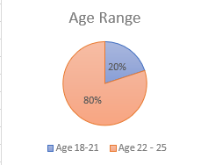

Figure

The results show that the results of this questionnaire will be based upon the opinions of potential users between the ages of 18 to 25.

#### Question 2

**“What is your gender?”**

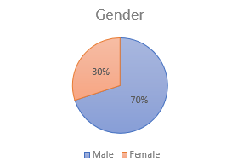

Figure

The results show that 70% of the overall participants of this questionnaire are males and the remaining 30% are female.

#### Question 3

**“Choose from the options below your preferred colour scheme for the website”**

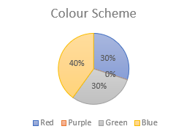

Figure

The results of this question show that the largest majority of participants have voted that the colour scheme of the application will be blue.

#### Question 4

**“A typical navigation bar is located along the top part of a website. However, they can also be presented in different areas of the webpage.”**

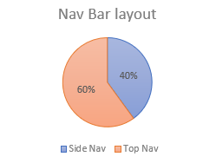

Figure

The results of this questionnaire have determined that most participants prefer the navigation bar to be located along the top of the screen. This is the most common location of navigation bars on most websites and web applications. This shows that users prefer to use layouts that they interact with on the majority of websites that they visit.

#### Question 5

**“Do you prefer the user of radio buttons to choose the options or a drop-down filter that allows you to choose from the available options.”**

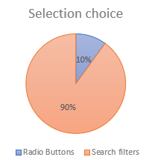

Figure

The majority of participants have chosen that search filters are their preferred way of choosing an option over the alternative of using radio buttons. Therefore, search bars will be used to ensure that the users preferred means of choosing options is satisfied.

#### Question 6

1. **“Do you believe that a background image would be suitable for this website?”**

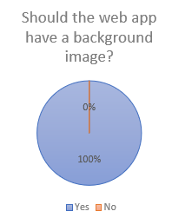

Figure

All of the test participants have agreed that a background image is preferable above the option of just having a plain background colour. Therefore, the background image option with the majority vote will be used as the background of the web application.

1. **“**I**f no please skip this question and continue with iii and iiii, otherwise if yes please choose from the images below which you believe would be most suitable for this website and skip iii and iiii.”**

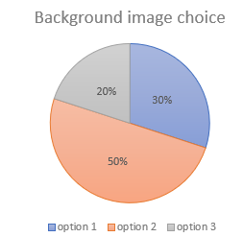

Figure

The majority have chosen background image option 2. This image will be used as the background for the high-fidelity prototype. (Please refer to appendix B to see the available options.)

1. **“Do you believe the application should have a background colour?”**

No results as no participant filled in this section.

1. **“) If yes, can you please recommend a colour that you believe would complement the page”**

No results as no participant filled in this section.

#### Question 7

**“Below are some examples of web friendly text fonts that can be used on this web application. Please choose only one of the options available below.”**

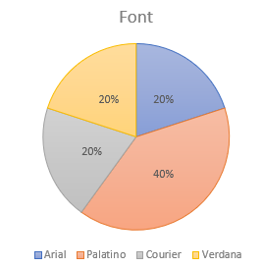

Figure

The majority of participants have chosen the font Palatino as the preferred font for the web application. Therefore, this will be used across the application to ensure the majority of participants are satisfied with the next version of prototype.

#### Question 8

**“Do you have any recommendations as to how to improve the proposed application based upon the mid-fidelity prototype design documentation.”**

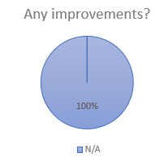

Figure

All of the participants of the questionnaire have answer N/A for this question. No users have provided any recommendations as to how to positively improve the application therefore the layout and available functionality will still be included in further development of the application and the choices made throughout this questionnaire will be implemented based upon what the highest majority of participants have chosen.

#### Overall evaluation of results

This questionnaire is more concerned with the “look and feel” of the web application. The participants again were asked for some basic information about themselves including their age and gender. Like the other questionnaires, all of the participants were ages between 18 and 25, with 30% female participation and 70% male participation.

The participants were asked to choose from a colour scheme for the website, blue had the majority vote with 40% therefore this colour scheme will be employed in the final high-fidelity prototype. Both the red and green colour scheme received 30% of votes each (from the remaining 60%), however no participants were interested in the purple colour scheme at all.

Question 4 asked participants to choose the location of the nav bar, whether it would be located along the top of the web page (the most common location) or down along the left-hand side of the page. The results show that 60% of the participants prefer the most common layout for the navigation bar which is along the top of the web page, and as this is the majority choice this is the layout that will be employed in the high-fidelity prototype.

Question 5 asked the participants whether they would prefer to choose their options using a scroll down menu or by choosing from radio buttons. 90% of the participants prefer the option of using a scroll down menu to choose from their options. The remaining 10% preferred the option of the radio buttons, however, as the majority voted for the scroll down menus, this is what will be implemented in the final high-fidelity prototype.

Question 6 i was concerned with what type of background should be used for the application, whether an image should be used or a block colour. As the results show 100% of participants believed that a background image would be preferable. The users the chose from 3 generic options, option 2 received the majority vote with 50% of the participants choosing this option. This is the image that will be used in the final prototype. Parts iii and iiii of question 6 have been left empty by all of the participants as 100% were in agreement that an image is the best option for the background, rather than a block colour.

Question 7 asked the users to choose from 4 option of web friendly fonts that could be used on the website, Palatino received the majority vote with 40% therefore this is the font that will be employed in the final prototype. The options all received 20% of the votes each.

Finally, The participants were asked to write any recommendations or improvements that should be made in the application, as the pie chart available shows, 100% of the participants were not applicable for this section which is a positive insight as this leads us to believe that the proposed functionality and requirements to this date are sound and satisfy the users desires. Minor changes to the “look and feel” of the web application will be updated/changed to satisfy the choices that the majority of participants have chosen.

### High-Fidelity prototype questionnaire results

The High-fidelity questionnaire is conducted following the development of the High-fidelity prototype based upon the requirements that have been captured during the initial questionnaire. This is the final version of the application that will be produced during this project, and this prototype will encompass all of the factors that have been determined by the users throughout the prior tests.

This test is mainly to check the level of functionality that the web application provides, as well as asking the user to give their own personal evaluation and rating of the overall application.

The sub-sections below will include a discussion of the results for each of the questions.

A copy of this questionnaire is located in Appendix B.

#### Question 1

**“What is your age range?”**

The age range, alike to all of the prior questionnaires is again ranged between the ages of 18 to 25 (those typical of university students). These results mean that we will only gain the insight from the perspective of a young adult.

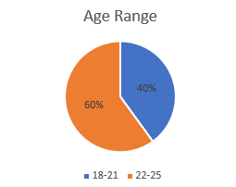

Figure

#### Question 2

**“What is your gender?”**

As can be viewed from the pie chart below, 30% of the participants were female and the majority 70% were male.

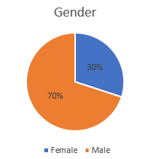

Figure

#### Question 3

**“Did the application alert you that you have inputted the correct username and password?”**

The users were asked to input some log in details to test whether the application will accept this input. The application will alert the users that they have inputted the correct details, and if they input incorrect details it will alert them of that too. As can be viewed from the pie chart below 100% of the participants verified that the application performed this task.

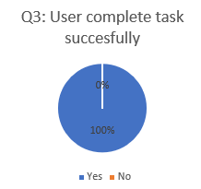

Figure

#### Question 4

**“From the main menu, we ask that you navigate to the exercise tutorials page. On this page you will see a scroll menu. Please choose the option “7 minutes”. By choosing this option, did the page automatically move to the section of the page that contains the tutorials which last 7 minutes?”**

As the pie chart below shows 100% of the participants successfully completed this task.

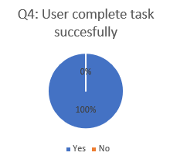

Figure

#### Question 5

**“Now return the main menu, please choose the page “My account”. You will be navigated to this page and here you will see a title, a box which will eventually contain your account details and 2 buttons. Please choose the button “Log out”.**

**Were you directed back to the Initial Log in page?**

As can be viewed from the pie chart below, the results are that 100% of participants were able to easily navigate to the My account page, click the log out button and automatically return to the initial Log in page.

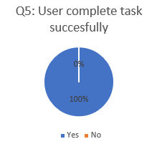

Figure

#### Question 6

**“Please rate the application based upon how much you like its design from between 1 and 10 (1 being that you do not like the application at all, or 10 being that you really like the application).”**

The overall average rating was produced for this application which is 7.3. This rating is well above average and is a positive result which shows that the layout and the application in general is liked by the participants.

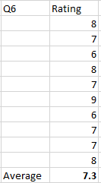

Figure

#### Question 7

**“Is there any content or information in this website that you find difficult to understand?”**

As the pie chart below shows, 100% of the participants were in agreement that there is no content in the application that they find difficult to comprehend.

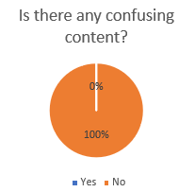

Figure

#### Question 8

**“Based upon the high-fidelity prototype you have been provided with, would you be interested in using this application in the future?”**

As the results show 90% of the participants have stated that they would be interested in using the application if the application was fully developed in the future. The 10% that stated they are no interested in using the application commented that their reason for this is because they have their own personal exercise regime and would prefer to continue with this rather than using an application as well.

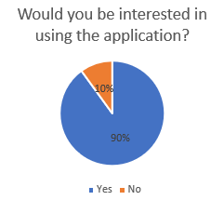

Figure

#### Overall evaluation of results

The results of this final questionnaire show that again the male participation outweighs the number of female participants. 70% were male and 30% were female. These results may be slightly biased as most participants overall throughout the testing of this application has been male, however the inclusion of the females that have participated has shown that both male and females are interested in similar functions to be provided from a health and fitness application, and they also share preferences for certain types of layouts for the application.

This questionnaire was mainly focused on allowing the test participants to get acquainted with the design of the application and better understand how it is meant to perform when fully functional. In this case its level of functionality is extremely limited as the majority of functionality would be provided by a database, which is not included or required for a high-fidelity prototype.

All 3 of the tasks that the participants were asked to perform were completed successfully, this shows that the application that has been developed is usable. Participants were also asked to note if any of the content of the application was difficult for them to understand and 100% of the participants agreed that they can understand all of this content.

The users were asked to rate the application between 1 and 10 (1 being they totally dislike the design and 10 being they love the design), the overall average of the ratings given by the users sums up to 7.3. This is a high rating considering the lack of functionality that the application provides. The participants are clearly satisfied with the end product that has been produced based upon the results from each and every single one of the questionnaires used throughout the development of the different iterations of this projects development.

Finally, the participants were asked whether they would be interested in using the application in the future once it is fully functional and 90% of the participants have stated yes, they would be interested in using application. The 10% of the participants who stated they would not be interested in using the application commented that the design of the application itself it very good however they are just not interested in using applications and are already happy with their current regime.

Overall it appears that the users are satisfied with the final high-fidelity prototype and that the application is also considered as highly usable as the tasks asked of the users have always been successful meaning that the users find it easy to understand how to use the application.

## Developer evaluation.

The development of this application has been entirely usability led. The participants of the questionnaires conducted during each iteration of the development of the application have guided everything from the initial requirements, the desired functionality, the layout and design of the website. There were 4 stages to the development of this application:

1. The initial requirements capture.
2. The low-fidelity prototype.
3. The mid-fidelity prototype.
4. The high-fidelity prototype.

The initial requirements capture was used to gain insight into what the potential users desire from a health and fitness application. This test was slightly biased however as 100% of the participants were male. However, we were able to get female participants in the following 3 questionnaires. From this initial questionnaire, the requirements were depicted from the majority results and the users top 4 chosen functions were established as to what should be provided by this application.

The low-fidelity prototype is a wireframe design of a potential solution to what the participants have asked from the application. A questionnaire was handed out regarding design and the users were mainly asked to complete navigational tasks logical, so we could gain an insight into the level of usability of the design. They were also given the opportunity to offer ideas for improvements, however none of the participants had any recommendations to provide, not only for this version of the application, but for all of the questionnaires.

The mid-fidelity prototype was created using HTML and CSS code in Netbeans. This version of the prototype contains only basic navigation, and no real content will be used. The desired content will be depicted using boxes and symbols to provide the users with a better insight into the “look and feel” of the application. A questionnaire was handed out following the development of this prototype and the focus of it was mainly to determine the colour scheme, background image/colour, font and location of certain aspects on the web pages. Based on the results, it appears that the participants are satisfied with the proposed design of the applications, with the results also changing several different aspects of the web applications layout.

The high-fidelity prototype is the final version of the application that will be produced for this project. This final version encompasses all of the requirements that have been established by the user. The level of functionality that this version provides is limited to that which can be performed without the use of an application. Therefore, the meal diary, exercise tutorials, log in, create a new account and my progress graphs cannot be made functional as they all require the use of a database to provide it with all of this relevant information and allow these aspects to become functional.

A questionnaire was handed out following the final high-fidelity prototype in which the users were asked to complete basic tasks and to evaluate the web application. Based upon the results it shows that the users have been very much included throughout the development of this project as there have been no major usability issues that have occurred during the development of this application, and no changes have needed to be made to the original requirements. The initial requirements capture proved to be a sound questionnaire and it supported the developer establishing a set of clear and concise requirements which have not required any alterations or improvements to fulfil the users’ desires.

This development has been entirely usability led, with the potential users being the central character throughout this project. Every part of this project has been determined by the potential users that took part in the questionnaires. The resulting application satisfies all of the requirements which are possible without a database and based upon the average rating of 7.3 out of 10 during the test, the users are clearly satisfied with this product. In addition, the only reason it was marked down lower was due to its lack of functionality.

# Conclusion

The purpose of this project is to focus on the development of a health and fitness web application with usability as it main objective throughout, the user should also exhibit that the application provides a high level of usability. This report includes research relating to the concepts of Human Computer Interaction (HCI), Usability and web application development. This background research contains critical information that you must have knowledge in when developing this style of project. Also contained in this report is the iterative development of the proposed application. An analysis was also included in which the background research was summarised for this specific application. We also analysed a variety of health and fitness applications that are currently available to the public. By analysing these health and fitness applications we were able to understand what other applications currently offer their users. We can use these applications as a basis for determining the types of functionality that a typical health and fitness application user would desire from this application.

The application has been developed solely upon what the majority of users have collectively chosen during a series of questionnaires. It is very beneficial to create a web application that is usability led as this means that it is solely concerned with how easy the application is for the users to interact with and for them to comprehend. An unusable application will be shunned by potential users and if they find it difficult to navigate or understand this will deter them from using it, whereas an application that is considered highly usable will become more popular with users and is more likely to satisfy the users requirements.

As usability is the main objective of this development it was crucial that users were included throughout. In this case they were the directors of the development. An initial requirement capture questionnaire was handed out in which the users were tasked with answering a series of questions. The answers to these questions would determine what functionalities the application would include, and the requirements were also drawn from these results too.

Following the initial requirements capture questionnaire, a low-fidelity (Wireframe) design was developed as a possible solution for the design of the application, again the users were required to fill out a questionnaire evaluating this version of the application. They were asked to complete a number of tasks logically in the questionnaire based upon the low-fidelity design. All of the users showed positive results and were able to complete the tasks with ease which allowed the development to continue onto the mid-fidelity prototype which was developed in NetBeans using HTML and CSS.

The process was repeated for the mid-fidelity prototype with a questionnaire being handed out again to multiple test subjects, however unlike the low-fidelity questionnaire, this questionnaire was used to determine the “look and feel” of the application. This included the colour scheme and layout of various areas of the applications design.

Following the mid-fidelity questionnaire, the final high-fidelity prototype was developed which is the final version of this application to be developed for the purpose of this report. A final questionnaire was handed out to the test subjects, and in this version, they were tasked with completing various tasks on the application on a computer. If the users were unable to complete the tasks successfully this would show that the application was unusable, but in this case 100% of the users completed all of the tasks assigned to them in all of the questionnaires. This result helps us to establish that the solution that has been developed provides a high level of usability and the users are satisfied with the product.

Future research could be conducted on this application if it goes into further development, in which all of the content and functionality will be included. The users would be able to test and evaluate the full functionality. This application could then be open to the public and we could test how popular the application has become. This could support in establishing if a highly usable application will become more popular as users can not only understand how to use the application, but it also provides them with the various functions which are typically contained in separate applications. This application was developed to provide users with a combination of popular functionalities and it would be interesting to see how users would react to an application of this sort and if it would receive a higher level of popularity above other similar applications. Additionally, we could look into expanding the application, so it can become a hybrid which can be used on both a mobile device and on the web. We could determine its popularity based upon its rating in the app stores (IOS and Android).

The process of developing this application has provided substantial evidence that it is instrumental to incorporate usability when developing an application so that the application will prove to be liked by the users. The users will be satisfied with an application that is deemed highly usable, which in this case, the results of this iterative development of this health and fitness application validate this theory. The majority of users (90%) in the final high-fidelity questionnaire also stated that they would be interested in using this application in the future if it was distributed to the public. This clearly shows that an application that allows the user to be involved throughout the development, will, in the end prove to be popular with users and they will want to use the application.

# References and Bibliography

[1] Alan Dix, “Human Computer Interaction”, 3rd edition. Pearson and Prentice hall. 2004. Pages 9 – 123.

[2] Gyles Seward, 2016. The different types of usability testing. [Online]

Available at: <https://www.elementarydigital.co.uk/the-different-types-of-usability-testing/amp/>

[3] Zhiwei Sun, 2013. “User Involvement in System Development Process”. Atlantis Press. [Online]

Available at: <http://citeseerx.ist.psu.edu/viewdoc/download?doi=10.1.1.823.3265&rep=rep1&type=pdf>

[4] Flat World Business. 2011. Web 1.0 vs Web 2.0 vs Web 3.0 vs Web 4.0 vs Web 5.0 – A bird’s eye on the evolution and definition. [ONLINE]

Available at: <https://flatworldbusiness.wordpress.com/flat-education/previously/web-1-0-vs-web-2-0-vs-web-3-0-a-bird-eye-on-the-definition/>

[5] Margaret Rouse. 2017. Open Database Connectivity (ODBC). [ONLINE]

Available at: <http://searchoracle.techtarget.com/definition/Open-Database-Connectivity>

[6] Carey Wodehouse. 2017. Front-End Web Development: Client-Side Scripting & User Experience. [ONLINE]

Available at: <https://www.upwork.com/hiring/development/how-scripting-languages-work/>

[7] Tim Hinds. 2015. The 10 most common web app performance problems. [ONLINE]

Available at: <https://www.neotys.com/blog/10-most-common-web-app-performance-problems/>

[8] Zhiwei Sun. 2013. User Involvement in System Development Process. [ONLINE]

Available at: <https://www.atlantis-press.com/proceedings/iccsee-13/4536>

[9] Usability First. 2015. HCI Design Approaches. [ONLINE] Available at: <http://www.usabilityfirst.com/usability-methods/hci-design-approaches>.

[10] Preece, J., 2002. *Interaction Design: Beyond Human-Computer Interaction*. 4th ed. England: Wiley.

[11] Figure 1: Cortical areas of the human visual system dedicated to different visual modularities (Adapted from Zeki, 1999). Gabriele Peters, 2011. Published in: [Criteria for the Creation of Aesthetic Images for Human-Computer Interfaces A Survey for Computer Scientists](https://www.researchgate.net/publication/220593037_Criteria_for_the_Creation_of_Aesthetic_Images_for_Human-Computer_Interfaces_A_Survey_for_Computer_Scientists).   
Available at: <https://www.researchgate.net/figure/Cortical-areas-of-the-human-visual-system-dedicated-to-different-visual-modularities_fig12_220593037>

[12] Figure 2 and 3: These images are screenshots of both the web application (available at <http://www.mapmyfitness.com/>) and of the mobile application that is available on the app store (both IOS and Android).

[13] Figure 4: This image is a screenshot of the Calm web application. Available at: [www.calm.com](http://www.calm.com)

[14] Figure 5: This image is a screenshot of the 8Fit application on a mobile device. This screenshot is available at: <http://www.spongecoach.com/best-workout-apps/>

# Appendix A: Project Specification and Monthly Reports

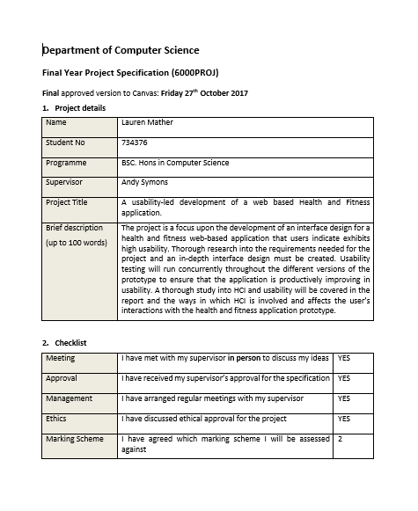

Figure

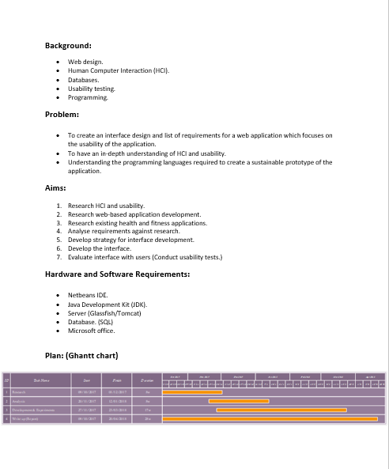

Figure



Figure

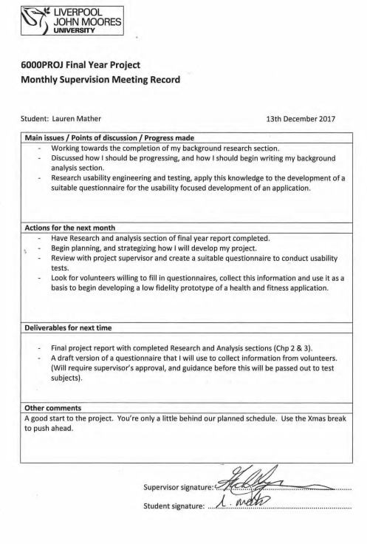

Figure



Figure



Figure



Figure

# Appendix B: Copy of Questionnaires and handouts

## Initial requirements capture questionnaire

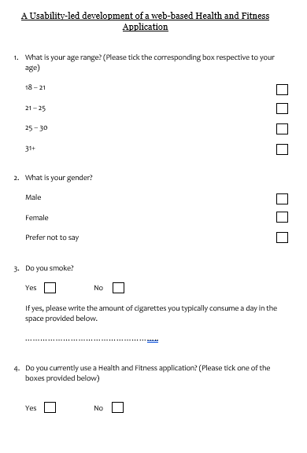

Figure

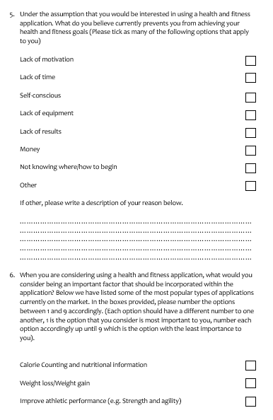

Figure

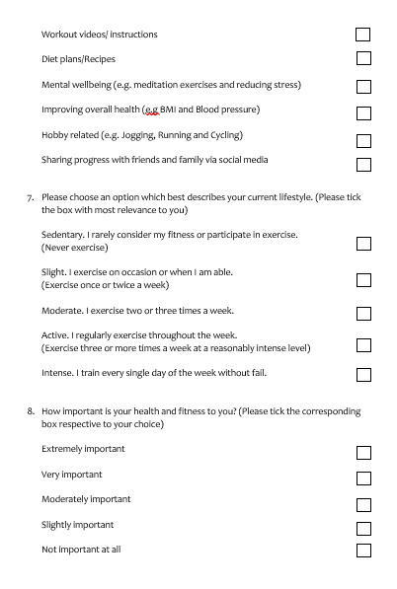

Figure

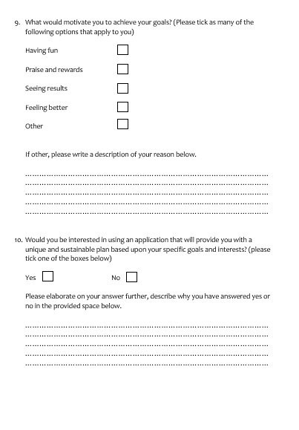

Figure

## Low-fidelity prototype questionnaire

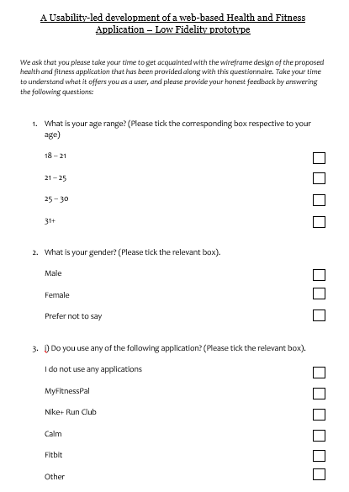

Figure

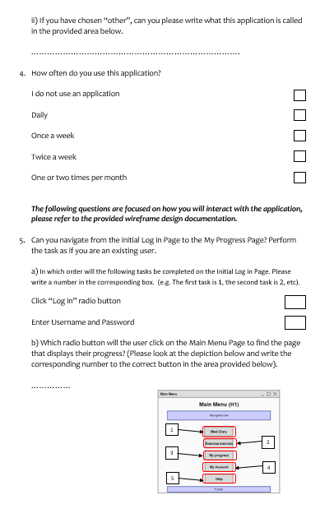

Figure

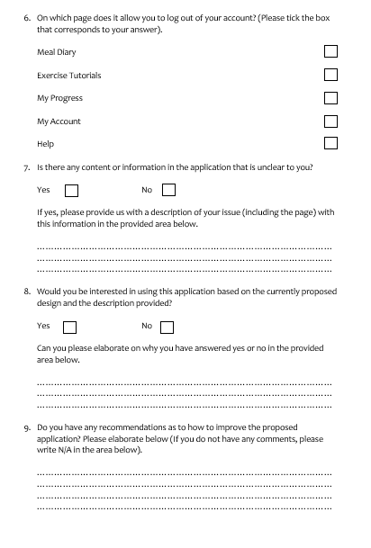

Figure

### Questionnaire handout

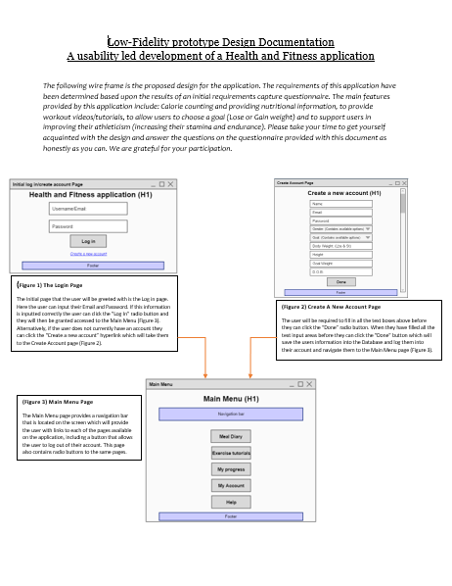

Figure

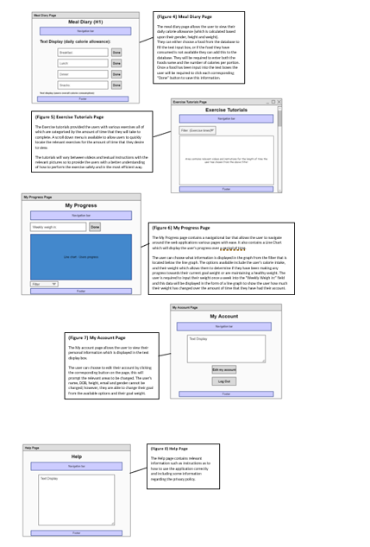

Figure

## Mid-Fidelity questionnaire

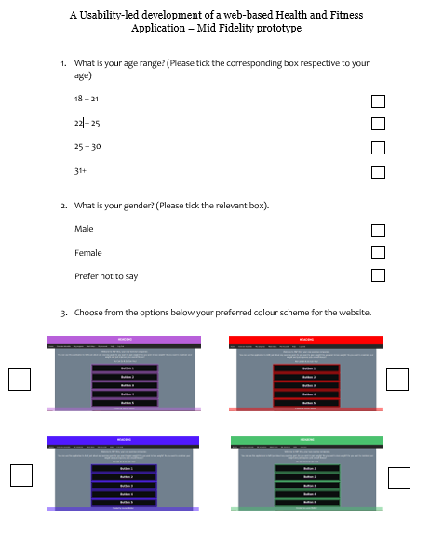

Figure

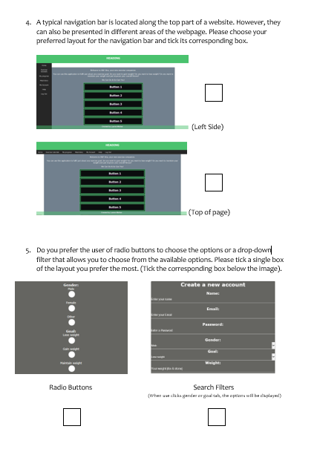

Figure

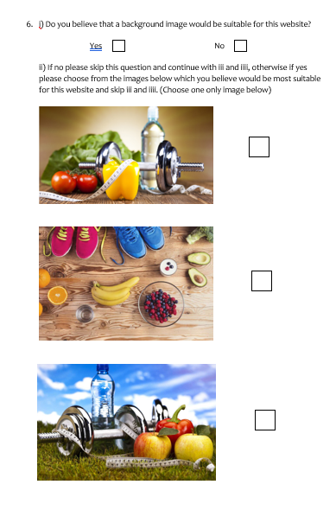

Figure

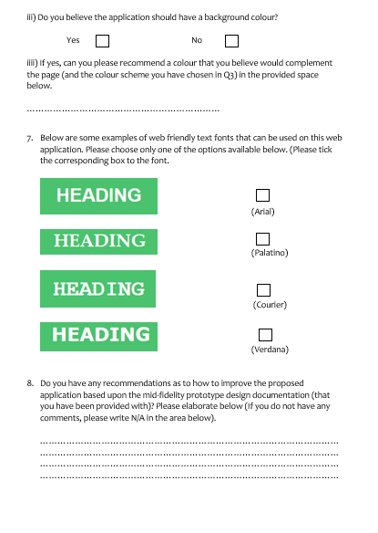

Figure

## Questionnaire handout

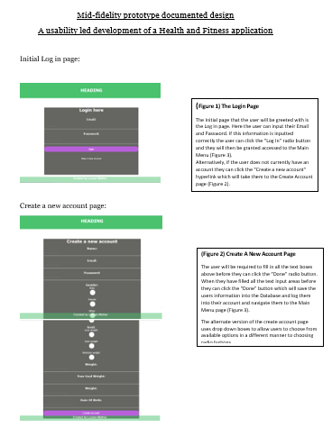

Figure

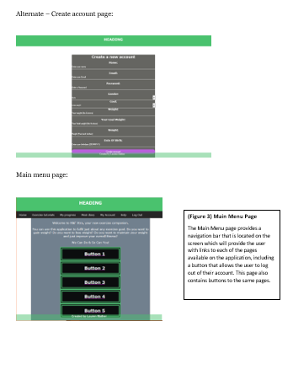

Figure

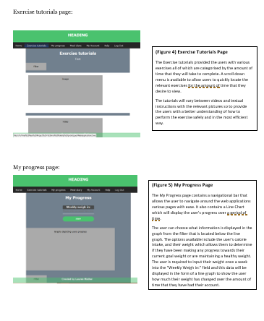

Figure

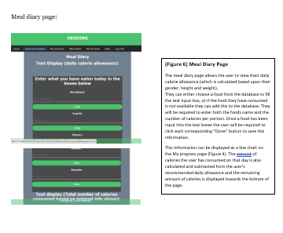

Figure

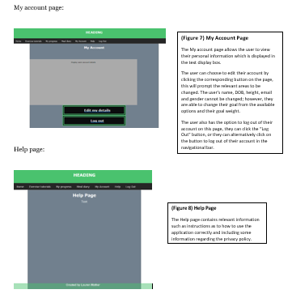

Figure

## High-Fidelity questionnaire

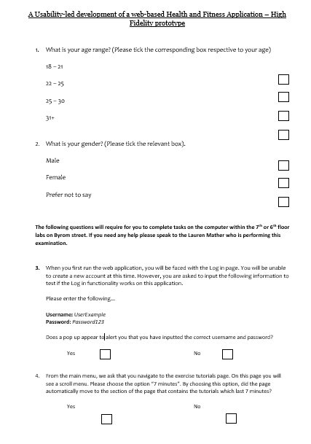

Figure

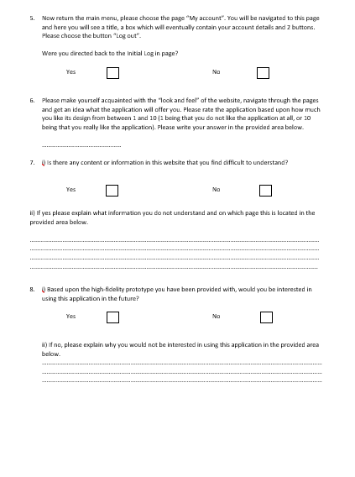

Figure

# Appendix C: Web application code

## Log in page

<html>

<head>

<meta charset="UTF-8">

<meta name="viewport" content="width=device-width, initial-scale=1.0">

<meta http-equiv="Content-Type" content="text/html; charset=UTF-8" />

<link rel="stylesheet" type="text/css" href="CSS/Website_style.css"/>

<!-- This javascript makes an alert occur for when the user enters the correct or incorrect information respectively.

The purpose of this was intended to test a username and password and be directed to another page however this functionality is not working-->

<script language="javascript">

function check(form){

if(form.email.value === "UserExample" && form.password.value === "Password123")

{

alert("You have inputted the correct details!");

window.location= ("web/Main_Menu_Page.html");

}

else

{

alert("The username and password you have entered are incorrect.")

}

}

</script>

<title>Login page</title>

</head>

<body>

<header>

<h1><br>LCJM fitness</h1>

</header>

<div class="login-box">

<!-- The code below creates the log in form -->

<h1>Login here</h1>

<br>

<form id="loginForm" method="post" name="loginForm">

<p>Email:</p><br>

<input type="text" name="email" placeholder="Enter Email"/>

<p>Password:</p><br>

<input type="password" name="password" placeholder="Enter Password"/>

<input type="submit" name="submit" value="login" onclick="check(this.form)"/>

</form><br>

<!-- This hyperlink will direct the user to the create a new account page -->

<a href="Create_Account_Page.html">Make A New Account</a>

</div>

<footer>

<p>Created by Lauren Mather</p>

</footer>

</body>

</html>

## Create a new account page

<html>

<head>

<meta charset="UTF-8">

<meta name="viewport" content="width=device-width, initial-scale=1.0">

<meta http-equiv="Content-Type" content="text/html; charset=UTF-8" />

<link rel="stylesheet" type="text/css" href="CSS/Website_style.css"/>

<title>Create A New Account</title>

</head>

<body>

<header>

<br>

<h1>LCJM fitness</h1>

</header>

<div class="create-account-box">

<!-- The code below creates the create a new account box -->

<h1>Create a new account</h1>

<form>

<p>Name:</p>

<input type="text" name="Name" placeholder="Enter your name"/>

<p>Email:</p>

<input type="email" name="email" placeholder="Enter your Email"/>

<p>Password:</p>

<input type="password" name="password" placeholder="Enter a Password"/>

<!-- This creates a drop down menu for the users to select their gender -->

<p> Gender:</p>

<div class="Gender_Selection">

<select name="Select Gender">

<option>Male</option>

<option>Female</option>

<option>Other</option>

</select>

</div>

<!-- This creates a drop down menu for the users to select their goal -->

<p> Goal:</p>

<div class="Weight_Selection">

<select name="Select Weight">

<option>Lose weight</option>

<option>Gain weight</option>

<option>Maintain weight</option>

</select>

</div>

<p>Weight:</p>

<input type="text" name="weight" placeholder="Your weight (lbs & stone)"/>

<p>Your Goal Weight:</p>

<input type="text" name="goal weight" placeholder="Your Goal weight (lbs & stone)"/>

<p>Weight:</p>

<input type="text" name="height" placeholder="Height (Feet and Inches)"/>

<p>Date Of Birth:</p>

<input type="text" name="DOB" placeholder="Enter your birthdate (DD/MM/YY)"/>

<input type="submit" name="submit" value="Create account"/>

</form><br>

</div>

<footer>

<p>Created by Lauren Mather</p>

</footer>

</div>

</body>

</html>

## Main Menu page

<html>

<head>

<meta charset="UTF-8">

<meta name="viewport" content="width=device-width, initial-scale=1.0">

<meta http-equiv="Content-Type" content="text/html; charset=UTF-8" />

<link rel="stylesheet" type="text/css" href="CSS/Website_style.css"/>

<title>Main Menu</title>

</head>

<body>

<header>

<br>

<h1>LCJM fitness</h1>

</header>

<!-- This is a nav bar -->

<nav>

<ul>

<li><a href="Main_Menu_Page.html">Home</a></li>

<li><a href="Exercise_Tutorials_Page.html">Exercise tutorials</a></li>

<li><a href="My_Progress_Page.html">My progress</a></li>

<li><a href="Meal_Diary_Page.html">Meal diary</a></li>

<li><a href="My_Account_Page.html">My Account</a></li>

<li><a href="Help_Page.html">Help</a></li>

<li><a href="index.html" style="float:right">Log Out</a></li>

</ul>

</nav>

<div class="container"> <br>

<p>Welcome to H&F Xtra, your new exercise companion.</p>

<p>You can use this application to fulfil just about any exercise goal. Do you want to gain weight? Do you want to lose weight? Do you want to maintain your weight and just improve your overall fitness?</p>

<p>We Can Do & So Can You!</p>

<div class="button1MainMenu">

<ol><a href="Exercise_Tutorials_Page.html"><h2> Exercise tutorials</h2></a></ol>

<br>

</div>

<div class="button2MainMenu">

<ol><a href="My_Progress_Page.html"><h2> My progress </h2></a></ol>

<br>

</div>

<div class="button3MainMenu">

<ol><a href="Meal_Diary_Page.html"><h2> Meal diary </h2></a></ol>

<br>

</div>

<div class="button4MainMenu">

<ol><a href="My_Account_Page.html"><h2> My Account </h2></a></ol>

<br>

</div>

<div class="button5MainMenu">

<ol><a href="Help_Page.html"><h2> Help </h2></a></ol>

</div>

<footer>

<p>Created by Lauren Mather</p>

</footer>

</body>

</html>

## Exercise tutorials page

<html>

<head>

<meta charset="UTF-8">

<meta name="viewport" content="width=device-width, initial-scale=1.0">

<meta http-equiv="Content-Type" content="text/html; charset=UTF-8" />

<link rel="stylesheet" type="text/css" href="CSS/Website_style.css"/>

<title>Main Menu</title>

</head>

<body>

<header>

<br>

<h1>LCJM fitness</h1>

</header>

<!-- This is a nav bar -->

<nav>

<ul>

<li><a href="Main_Menu_Page.html">Home</a></li>

<li><a href="Exercise_Tutorials_Page.html">Exercise tutorials</a></li>

<li><a href="My_Progress_Page.html">My progress</a></li>

<li><a href="Meal_Diary_Page.html">Meal diary</a></li>

<li><a href="My_Account_Page.html">My Account</a></li>

<li><a href="Help_Page.html">Help</a></li>

<li><a href="index.html" style="float:right">Log Out</a></li>

</ul>

</nav>

<div class="exercise_container"> <br>

<h2>Exercise tutorials</h2>

<!-- This creates a drop down menu for the users to select the length of time for the exercise tutorial.

When the user selects a length of time the page will jump to the specific section they want to view -->

<p> Choose the preferred amount of time to complete the exercise:</p>

<div class="Exercise_Selection">

<select name="Length of exercise" onchange="location = this.value;">

<option value="#7mins_Section">7 min</option>

<option value="#15mins_Section">15 min</option>

<option value="#30mins_Section">30 min</option>

<option value="#45mins_Section">45 min</option>

<option value="#60mins_Section">60 min</option>

</select>

</div>

<h2>7 minutes</h2>

<div class="card" id="7mins_Section">

<div class="fakeimg" style="height:200px;">

Image

</div>

<p> Some text....</p>

</div>

<div class="card">

<div class="fakevid" style="height:200px;">

Video

</div>

<p> Some text....</p>

</div>

<div class="card">

<div class="fakeimg" style="height:200px;">

Image

</div>

<p> Some text....</p>

</div>

<h2>15 minutes</h2>

<div class="card" id="15mins_Section">

<div class="fakeimg" style="height:200px;">

Image

</div>

<p> Some text....</p>

</div>

<div class="card">

<div class="fakevid" style="height:200px;">

Video

</div>

<p> Some text....</p>

</div>

<div class="card">

<div class="fakeimg" style="height:200px;">

Image

</div>

<p> Some text....</p>

</div>

<h2>30 minutes</h2>

<div class="card" id="30mins_Section">

<div class="fakeimg" style="height:200px;">

Image

</div>

<p> Some text....</p>

</div>

<div class="card">

<div class="fakevid" style="height:200px;">

Video

</div>

<p> Some text....</p>

</div>

<div class="card">

<div class="fakeimg" style="height:200px;">

Image

</div>

<p> Some text....</p>

</div>

<h2>45 minutes</h2>

<div class="card" id="45mins_Section">

<div class="fakeimg" style="height:200px;">

Image

</div>

<p> Some text....</p>

</div>

<div class="card">

<div class="fakevid" style="height:200px;">

Video

</div>

<p> Some text....</p>

</div>

<div class="card">

<div class="fakeimg" style="height:200px;">

Image

</div>

<p> Some text....</p>

</div>

<h2>60 minutes</h2>

<div class="card" id="60mins_Section">

<div class="fakeimg" style="height:200px;">

Image

</div>

<p> Some text....</p>

</div>

<div class="card">

<div class="fakevid" style="height:200px;">

Video

</div>

<p> Some text....</p>

</div>

<div class="card">

<div class="fakeimg" style="height:200px;">

Image

</div>

<p> Some text....</p>

</div>

</div>

<footer>

<p>Created by Lauren Mather</p>

</footer>

</body>

</html>

## My progress page

<html>

<head>

<meta charset="UTF-8">

<meta name="viewport" content="width=device-width, initial-scale=1.0">

<meta http-equiv="Content-Type" content="text/html; charset=UTF-8" />

<link rel="stylesheet" type="text/css" href="CSS/Website_style.css"/>

<title>My Progress</title>

</head>

<body>

<header>

<br>

<h1>HEADING</h1>

</header>

<!-- This is a nav bar -->

<nav>

<ul>

<li><a href="Main_Menu_Page.html">Home</a></li>

<li><a href="Exercise_Tutorials_Page.html">Exercise tutorials</a></li>

<li><a href="My_Progress_Page.html">My progress</a></li>

<li><a href="Meal_Diary_Page.html">Meal diary</a></li>

<li><a href="My_Account_Page.html">My Account</a></li>

<li><a href="Help_Page.html">Help</a></li>

<li><a href="index.html" style="float:right">Log Out</a></li>

</ul>

</nav>

<div class="container"> <br>

<h2>My Progress</h2>

<div class="weigh-in-box">

<form>

<p>Weekly weigh in:</p>

<input type="text" name="weight" placeholder="Please enter you weight here once every week.."/> <input type="submit" name="submit" value="done"/>

</form>

<div class="fakegraph">

<img src="Images/example graph.png">

</div>

</div>

<br>

<br>

<div class="Graph_Selection">

<select name="Select Weight">

<option>Bar graph</option>

<option>Line graph</option>

<option>Pie chart</option>

</select>

</div>

</div>

<footer>

<p>Created by Lauren Mather</p>

</footer>

</body>

</html>

## My account page

<html>

<head>

<meta charset="UTF-8">

<meta name="viewport" content="width=device-width, initial-scale=1.0">

<meta http-equiv="Content-Type" content="text/html; charset=UTF-8" />

<link rel="stylesheet" type="text/css" href="CSS/Website_style.css"/>

<title>Main Menu</title>

</head>

<body>

<header>

<br>

<h1>LCJM fitness</h1>

</header>

<nav>

<ul>

<li><a href="Main_Menu_Page.html">Home</a></li>

<li><a href="Exercise_Tutorials_Page.html">Exercise tutorials</a></li>

<li><a href="My_Progress_Page.html">My progress</a></li>

<li><a href="Meal_Diary_Page.html">Meal diary</a></li>

<li><a href="My_Account_Page.html">My Account</a></li>

<li><a href="Help_Page.html">Help</a></li>

<li><a href="index.html" style="float:right">Log Out</a></li>

</ul>

</nav>

<div class="container"> <br>

<h2>My Account</h2>

<div class="fakeaccountdetails" style="height:400px;">

Display users account details

</div>

<div class="button1MainMenu">

<li> <a href=#><h2> Edit my details </h2></a></li>

<br>

</div>

<!-- This button redirects the user to the log in page.

It behaves like a real log out button and we can see if the user it able to complete this task in the test -->

<div class="button2MainMenu">

<li><a href="index.html"> <h2>Log Out</h2></a></li>

<br>

</div>

</div>

<footer>

<p>Created by Lauren Mather</p>

</footer>

</body>

</html>

## Meal diary page

<html>

<head>

<meta charset="UTF-8">

<meta name="viewport" content="width=device-width, initial-scale=1.0">

<meta http-equiv="Content-Type" content="text/html; charset=UTF-8" />

<link rel="stylesheet" type="text/css" href="CSS/Website_style.css"/>

<title>Main Menu</title>

</head>

<body>

<header>

<br>

<h1>LCJM fitness</h1>

</header>

<!-- This is a nav bar -->

<nav>

<ul>

<li><a href="Main_Menu_Page.html">Home</a></li>

<li><a href="Exercise_Tutorials_Page.html">Exercise tutorials</a></li>

<li><a href="My_Progress_Page.html">My progress</a></li>

<li><a href="Meal_Diary_Page.html">Meal diary</a></li>

<li><a href="My_Account_Page.html">My Account</a></li>

<li><a href="Help_Page.html">Help</a></li>

<li><a href="a" style="float:right">Log Out</a></li>

</ul>

</nav>

<div class="container"> <br>

<h2>Meal Diary</h2>

<h2>Text Display (daily calorie allowance):</h2>

<div class="meal-diary-box">

<h1>Enter what you have eaten today in the boxes below</h1>

<br>

<!-- The code below creates the meal diary form. This form is not currently functional as it requires a DB -->

<form>

<p>Breakfast:</p><br>

<input type="text" name="breakfast" placeholder="Enter your breakfast.."/><input type="submit" name="submit" value="Done"/>

<p>Lunch:</p><br>

<input type="text" name="lunch" placeholder="Enter your lunch.."/><input type="submit" name="submit" value="Done"/>

<p>Dinner:</p><br>

<input type="text" name="dinner" placeholder="Enter your dinner.."/><input type="submit" name="submit" value="Done"/>

<p>Snacks:</p><br>

<input type="text" name="snacks" placeholder="Enter any snacks you have eaten.."/><input type="submit" name="submit" value="Done"/>

</form><br>

<h2>Text display (Total number of calories consumed based on entered info above):</h2>

</div>

<footer>

<p>Created by Lauren Mather</p>

</footer>

</body>

</html>

## Help page

<html>

<head>

<meta charset="UTF-8">

<meta name="viewport" content="width=device-width, initial-scale=1.0">

<meta http-equiv="Content-Type" content="text/html; charset=UTF-8" />

<link rel="stylesheet" type="text/css" href="CSS/Website_style.css"/>

<title>Main Menu</title>

</head>

<body>

<header>

<br>

<h1>LCJM fitness</h1>

</header>

<!-- This is a nav bar -->

<nav>

<ul>

<li><a href="Main_Menu_Page.html">Home</a></li>

<li><a href="Exercise_Tutorials_Page.html">Exercise tutorials</a></li>

<li><a href="My_Progress_Page.html">My progress</a></li>

<li><a href="Meal_Diary_Page.html">Meal diary</a></li>

<li><a href="My_Account_Page.html">My Account</a></li>

<li><a href="Help_Page.html">Help</a></li>

<li><a href="a" style="float:right">Log Out</a></li>

</ul>

</nav>

<!-- This is the text that will be contained in the application for the help page -->

<div class="container"> <br>

<h2> Help Page</h2>

<br>

<p>Do you want to reach a new fitness goal? Do you want to lose or gain weight? <br> <br>

Use the LCJM fitness application to track and monitor your fitness and progress towards any goals <br><br>

You can update your account at any time and create a new goal. This option is available in the My Account <br><br>

View your progress in a graph on the My progress page and choose from a variety of graphical styles. <br><br>

Based upon your gender, weight and height the application will calculate the amount of calories you should be consuming in the average day. Track this with your very own meal diary where you can add a new food (inc. their average portion calorie amount) or search for a variety of foods (and their nutritional information) from our database.</p>

<footer>

<p>Created by Lauren Mather</p>

</footer>

</body>

</html>

## Website style CSS

html{

background-image: url("../Images/BackgroundImage_Op2.jpg");

//background-color: #fff

-webkit-background-size: cover;

-moz-background-size: cover;

-o-background-size: cover;

background-size: cover;

}

body{

margin: 0;

padding: 0;

font-family: Palatino;

}

p{

color: #fff;

margin: 0;

padding: 0 0 20px;

text-align: center;

font-size: 20px;

}

.radio_button1 {

float:none;

color: #fff;

}

.radio_button2 {

float:none;

color: #fff;

}

.radio_button1 p{

float: left;

display: inline-block;

}

.radio_button2 p{

float: right;

display: inline-block;

}

.login-box{

width: 700px;

height: 500px;

text-align: center;

background-color: rgba(63, 62, 58, 0.8);

border-radius: 4px;

margin: 0 auto;

margin-top: 70px;

color: #fff;

}

.create-account-box{

width: 700px;

height: 1270px;

text-align: center;

background-color: rgba(63, 62, 58, 0.8);

border-radius: 4px;

margin: 0 auto;

margin-top: 70px;

color: #fff;

}

.create-account-box p{

margin: 0;

padding: 0;

font-weight: bold;

}

.create-account-box input{

width: 100%;

margin-bottom: 20px;

}

.create-account-box input[type="text"], input[type="password"], input[type="radio"], input[type="email"]{

border: none;

border-bottom: 1px solid #fff;

background: transparent;

outline: none;

height: 40px;

color: #fff;

font-size: 16px;

}

.create-account-box input[type="submit"]

{

border: none;

outline: none;

height: 40px;

background: rgb(64, 64, 191);

color: #fff;

font-size: 18px;

border-radius: 20px;

}

.create-account-box input[type="submit"]:hover

{

cursor: pointer;

background: rgb(0, 255, 236);

color: #fff;

}

.create-account-box a

{

text-decoration: none;

font-size: 14px;

color: #fff;

}

.create-account-box a:hover

{

color: rgb(0, 255, 236);

}

h1{

margin: 0;

padding: 0 0 20px;

text-align: center;

font-size: 30px;

color: #fff;

}

h2{

margin: 0;

padding: 0 0 14px;

text-align: center;

font-size: 30px;

color: #fff;

}

.login-box p{

margin: 0;

padding: 0;

font-weight: bold;

}

.login-box input{

width: 100%;

margin-bottom: 20px;

}

.login-box input[type="text"], input[type="password"] {

border: none;

border-bottom: 1px solid #fff;

background: transparent;

outline: none;

height: 40px;

color: #fff;

font-size: 16px;

}

.login-box input[type="submit"]

{

border: none;

outline: none;

height: 40px;

background: rgb(64, 64, 191);

color: #fff;

font-size: 18px;

border-radius: 20px;

}

.login-box input[type="submit"]:hover

{

cursor: pointer;

background: rgb(0, 255, 236);

color: #000;

}

.login-box a

{

text-decoration: none;

font-size: 14px;

color: #fff;

}

.login-box a:hover

{

color: rgb(0, 255, 236);

}

footer{

margin: 0 auto;

position: fixed;

bottom: 0;

text-align: center;

background-color: rgba(64, 64, 191, 0.6);

opacity: 0.8;

right: 0;

left: 0;

}

header{

margin: 0;

padding: 0 0 20px;

top: 0;

text-align: center;

background-color: rgb(64, 64, 191);

right: 0;

left: 0;

}

footer, header p {

margin-right: 20px;

margin-top: 50px;

color: white;

font-family: Palantino;

}

.footer-text {

color: white;

}

.footer-text:hover {

color: white;

}

.header-text {

color: white;

}

.header-text:hover {

color: white;

}

.container {

width: 80%;

border: 1px solid gray;

height: 1400px;

text-align: center;

background-color: rgba(52, 73, 94, 0.7);

border-radius: 4px;

margin: 0 auto;

margin-top: 50px;

}

.exercise_container {

width: 80%;

border: 1px solid gray;

height: 6000px;

text-align: center;

background-color: rgba(52, 73, 94, 0.7);

border-radius: 4px;

margin: 0 auto;

margin-top: 50px;

}

nav ul {

position: fixed;

margin: 0 auto;

width: 100%;

height: 50px;

background: rgba(0, 0, 0, 0.85);

box-shadow: -2px 2px 4px rgba (0, 0, 0, 0.5);

list-style-type: none;

padding: 0;

overflow: hidden;

// list-style-type: none;

// margin: 0;

// padding: 0;

// width: 10%;

// position: fixed;

// height: 100%;

// overflow: auto;

}

nav li{

float: left;

height: 40px;

opacity: .8;

font-size: 18px;

// text-align: center;

}

nav li a {

display: block;

padding: 15px 20px;

text-decoration: none;

color: #fff;

}

nav li:hover {

background: linear-gradient(top, rgba(33, 105, 243, 0) 0%, rgba(33, 105, 243, 0.5) 100%);

background: -moz-linear-gradient(top, rgba(33, 105, 243, 0) 0%, rgba(33, 105, 243, 0.5) 100%);

background: -webkit-linear-gradient(top, rgba(33, 105, 243, 0) 0%, rgba(33, 105, 243, 0.5) 100%);

}

nav li a:hover {

text-shadow: -1px 1px 1px rgba(0, 0, 0, 0.5);

}

.button1MainMenu {

width: 45%;

height: 70px;

background-color: #000;

opacity: 0.9;

padding-left: 20px;

color: #fff;

border-style: double;

border-width: 15px;

border-color: rgb(64, 64, 191);

text-align: center;

margin: 0 auto;

}

.button2MainMenu {

width: 45%;

height: 70px;

background-color: #000;

opacity: 0.9;

padding-left: 20px;

color: #fff;

border-style: double;

border-width: 15px;

border-color: rgb(64, 64, 191);

text-align: center;

margin: 0 auto;

}

.button3MainMenu {

width: 45%;

height: 70px;

background-color: #000;

opacity: 0.9;

padding-left: 20px;

color: #fff;

border-style: double;

border-width: 15px;

border-color: rgb(64, 64, 191);

text-align: center;

margin: 0 auto;

}

.button4MainMenu {

width: 45%;

height: 70px;

background-color: #000;

opacity: 0.9;

padding-left: 20px;

color: #fff;

border-style: double;

border-width: 15px;

border-color: rgb(64, 64, 191);

text-align: center;

margin: 0 auto;

}

.button5MainMenu {

width: 45%;

height: 70px;

background-color: #000;

opacity: 0.9;

padding-left: 20px;

color: #fff;

border-style: double;

border-width: 15px;

border-color: rgb(64, 64, 191);

text-align: center;

margin: 0 auto;

}

.meal-diary-box{

width: 700px;

height: 900px;

text-align: center;

background-color: rgba(63, 62, 58, 0.8);

border-radius: 4px;

margin: 0 auto;

margin-top: 70px;

}

.meal-diary-box p{

margin: 0;

padding: 0;

font-weight: bold;

}

.meal-diary-box input{

width: 100%;

margin-bottom: 20px;

}

.meal-diary-box input[type="text"]{

border: none;

border-bottom: 1px solid #fff;

background: transparent;

outline: none;

height: 40px;

color: #fff;

font-size: 16px;

}

.meal-diary-box input[type="submit"]

{

border: none;

outline: none;

height: 40px;

background: rgb(64, 64, 191);

color: #fff;

font-size: 18px;

border-radius: 20px;

}

.meal-diary-box input[type="submit"]:hover

{

cursor: pointer;

background: rgb(0, 255, 236);

color: #fff;

}

.meal-diary-box a

{

text-decoration: none;

font-size: 14px;

color: #fff;

}

.meal-diary-box a:hover

{

color: rgb(0, 255, 236);

}

/* Fake image */

.fakeimg {

background-color: #aaa;

width: 70%;

padding: 20px;

}

/* Fake image */

.fakefilter {

background-color: #aaa;

width: 15%;

padding: 20px;

height: 20px;

}

/* Fake video */

.fakevid {

width: 70%;

padding: 20px;

text-align: center;

background-color: #aaa;

border-radius: 4px;

margin: 0 auto;

margin-top: 50px;

}

/* Fake graph */

.fakegraph {

background-color: #aaa;

width: 600px;

padding: 20px;

top: 170px;

text-align: center;

border-radius: 4px;

margin: auto auto;

}

/* Fake account details display */

.fakeaccountdetails {

background-color: #aaa;

width: 80%;

padding: 20px;

margin-top: 80px;

text-align: center;

border-radius: 4px;

margin: 0 auto;

}

/* Add a card effect for articles */

.card {

background-color: white;

padding: 20px;

margin-top: 20px;

}

/* Clear floats after the columns */

.row:after {

content: "";

display: table;

clear: both;

}

.weigh-in-box{

width: 30%;

height: 60px;

text-align: center;

background-color: rgba(63, 62, 58, 0.8);

border-radius: 4px;

margin: 0 auto;

margin-top: 50px;

}

.weigh-in-box p{

margin: 0;

padding: 0;

font-weight: bold;

}

.weigh-in-box input{

width: 100%;

margin-bottom: 20px;

}

.weigh-in-box input[type="text"]{

border: none;

border-bottom: 1px solid #fff;

background: transparent;

outline: none;

height: 40px;

color: #fff;

font-size: 16px;

}

.weigh-in-box input[type="submit"]

{

border: none;

outline: none;

height: 40px;

background-color: rgb(64, 64, 191);

color: #fff;

font-size: 18px;

border-radius: 20px;

}

.meal-diary-box input[type="submit"]:hover

{

cursor: pointer;

background: rgb(0, 255, 236);

color: #fff;

}

.meal-diary-box a

{

text-decoration: none;

font-size: 14px;

color: #fff;

}

.meal-diary-box a:hover

{

color: rgb(0, 255, 236);

}

.Weight_SelectionSelection {

margin: 10px;

}

.Weight_Selection select {

width: 100%;

border: none;

border-bottom: 1px solid #fff;

background: transparent;

outline: none;

height: 40px;

color: #fff;

font-size: 14px;

}

.Gender_SelectionSelection {

margin: 10px;

}

.Gender_Selection select {

width: 100%;

border: none;

border-bottom: 1px solid #fff;

background: transparent;

outline: none;

height: 40px;

color: #fff;

font-size: 14px;

}

.Exercise_SelectionSelection {

margin: 10px;

}

.Exercise_Selection select {

width: 35%;

border: none;

border-bottom: 1px solid #fff;

background-color: #000;

outline: none;

height: 40px;

color: #fff;

font-size: 14px;

}

.Graph_Selection select {

width: 35%;

border: none;

border-bottom: 1px solid #fff;

background-color: #000;

outline: none;

height: 40px;

color: #fff;

font-size: 14px;

margin-top: 400px;

}